**Prelude**

**Greetings & Announcements**

*\*Please stand as you’re able..*

*-Today’s hymns are found in the Blue Hymnals*

**\*Call to Worship (based on Acts 2:1-4)**

All together in one place;

**they heard the rush of a violent wind;**

it filled the entire house.

**Divided tongues, as of fire, appeared and rested on each of them;**

they were filled with the Holy Spirit.

**\*Hymn of Welcome # 322** *Spirit of the Living God*

**\*Opening Prayer**

God most wonderful, Friend most holy, you have fulfilled the Easter season by sending us your Holy Spirit in abundant power.

You have opened the window of opportunity to every race and nation on earth, and created out of dispirit elements the fellowship of the one universal church.

Keep us, we pray, in the unity of the Spirit, that every tongue may tell and every life display the wonders of your love.

Through Christ Jesus, who lives and loves with you in the unity of the Holy Spirit, one God to be praised forever! *Amen!*

**\*Call to Confession**

**\*Prayer of Confession**

Spirit of God, we build walls and barriers. We assume and stereo- type. We devalue diversity and stick with what is comfortable and familiar. Forgive our lack of courage. Embolden us to cross borders and boundaries of difference. Fill us with your Holy Spirit that gathers us together and calls us to build beloved community. Amen.

**Assurance of Pardon**(Acts 2:21)

**\*Gloria Patri #579** *Glory Be to the Father*

**\*Passing the Peace and Greetings**

**Prayer for Illumination (Unison)**

**Prayer Requests**

**Trinity Parish Presbyterian**

Brent McPherson - recovery and strength

Craig Herron - recovery and strength

Sam - recovery

Nick - Jeff’s grandson, for healing and speedy recovery

Kim - joy for good test results

The Lily Family - loss of mother

Brian - diagnosed with cancer

Sam Swoger - recovery and strength

The whole congregation to discern God’s will and find our missions to the community.

All affected by the storms of nature and of life.

All in the paths of floods and other natural disasters

Former President Biden and his cancer diagnosis

**From the Presbytery**

Alan Kosan - recovering at home after surgery.

Scott Miklewicz - awaiting a transplant

Kandy Dunn - the passing of her mother.

Simon Morris - to find the cause of his seizures

Brenda Dunlap - recent surgery

Open our hearts and minds by the power of your Spirit, Holy God, that we might hear and receive the message you intend for us today. Amen.

**Scripture** *Acts 2:1-21*

**Sermon** *Golden Age?* *Rev. Tony DeLucia*

***\**Hymn of Response #319** Spirit

**\*Affirmation of Faith**  (Apostles’ Creed)

I believe in God, the Father almighty, Maker of heaven and earth, and in Jesus Christ his only Son, our Lord; who was conceived by the Holy Ghost, born of the Virgin Mary, suffered under Pontius Pilate, was crucified, dead, and buried; he descended into hell; the third day he rose again from the dead; he ascended into heaven, and sitteth on the right hand of God the Father Almighty; from thence he shall come to judge the quick and the dead. I believe in the Holy Ghost; the holy catholic church; the communion of saints; the forgiveness of sins; the resurrection of the body; and the life everlasting. Amen.

**Call for the Offering**

**\*Doxology #815** *Doxology*

**\*Prayer of Dedication (Unison)**

Most Generous God, you have blessed us with gifts to serve and share. May

the offerings we present today be used to further your Kindom and build your beloved community. Amen.

**Prayers of the People and the Lord’s Prayer**

**\*Hymn of Sending #315** *Every Time I Feel the Spirit*

\***Charge and Benediction**

**\*Response to the Benediction #358***Because He Lives*

**\*Postlude**

***United in Faith, Building Community***

**June Birthdays**

Ryan Herron, 6/

*Let us know when we can celebrate your Birthday/Anniversary with you!!*

**Upcoming Events:**

**Coffee Hour**

June 8, 2025, after worship

**Session Meeting**

June 18, 2025 @ 6:30pm

**Newell Community Dinner**

June 28, 2025

*Hamburger and Hot Dog, Macaroni Salad, Watermelon and Dessert*

**Communion**

July 6, 2025

**Potluck/Cookout**

July 13, after worship

Signups are on the bulletin in the back of the Church

*If interested in reading Scripture during worship, please let Pastor Tony know!*

**Trinity Parish Presbyterian Church**

**342 Carolina Ave.**

**Chester, WV 26034**

[*(304) 387-0600*](tel:(304)%20387-0600)

[*www.trinity-chester.com*](http://www.trinity-chester.com)

**Pastor Tony’s contact info:**

[pastor@trinity-chester.church](mailto:pastor@trinity-chester.church)

(330) 431-4725

*Facebook -* [*www.facebook.com/TrinityParishPC/*](http://www.facebook.com/TrinityParishPC/)

***Church email:***

[*info@trinity-chester.church*](mailto:info@trinity-chester.church)

Today's Scriptures: Acts 2:1-21

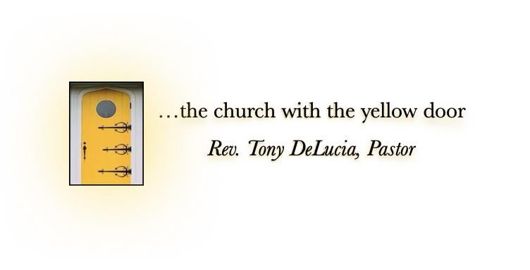



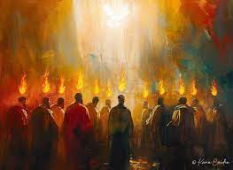



© Kevin Carden, May 18, 2024. Instagram

Trinity Parish Presbyterian Church

United in Faith, Building Community

Day of Pentecost

Sunday Worship

June 8, 2025

Worship 11 am