How to invoice an accountant to your QBO File

Click the gear icon in the upper right corner

Click Manage Users

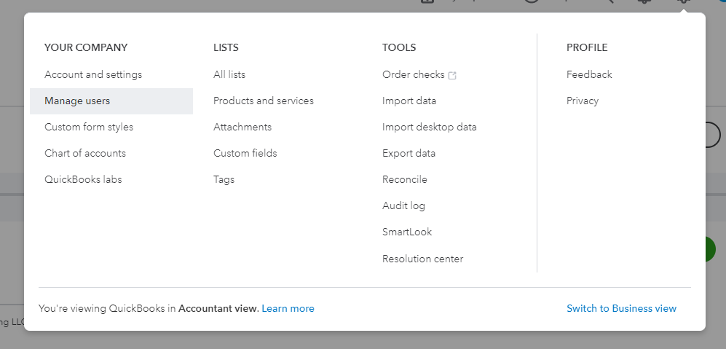

Click Accounting Firms

Click Invite

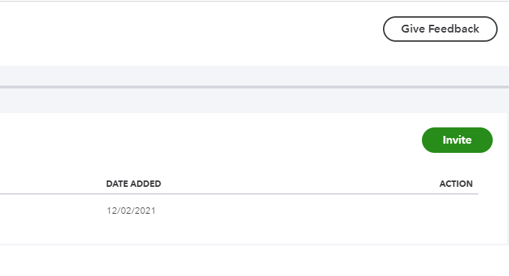

Fill out the information and click send

