|  |  |  |  |  |
| --- | --- | --- | --- | --- |
|  | BREAKFAST | LUNCH | DINNER | SNACK |
| SUNDAY  # of Bowel Movements___  # of ounces of water____  # of hours sleep____  Quality of sleep (poor / ok / great ) | TIME: | TIME: | TIME: | TIME: |
| MONDAY  # of Bowel Movements___  # of ounces of water____  # of hours of sleep____  Quality of sleep ( poor / ok / great ) | TIME: | TIME: | TIME: | TIME: |
| TUESDAY  # of Bowel Movements___  # of ounces of water____  # of hours of sleep____  Quality of sleep ( poor / ok / great ) | TIME: | TIME: | TIME: | TIME: |
| WEDNESDAY  # of Bowel Movements___  # of ounces of water____  # of hours of sleep ____  Quality of sleep ( poor / ok / great ) | TIME: | TIME: | TIME: | TIME: |
| THURSDAY  # of Bowel Movements___  # of ounces of water____  # of hours of sleep ____  Quality of sleep ( poor / ok / great ) | TIME: | TIME: | TIME: | TIME: |
| FRIDAY  # of Bowel Movements___  # of ounces of water____  # of hours of sleep ____  Quality of sleep ( poor / ok / great ) | TIME: | TIME: | TIME: | TIME: |
| SATURDAY  # of Bowel Movements___  # of ounces of water____  # of hours of sleep ____  Quality of sleep ( poor / ok / great ) | TIME: | TIME: | TIME: | TIME: |
|  |  | Send back for feedback to manda@coachingfromthekitchen.com |  |  |

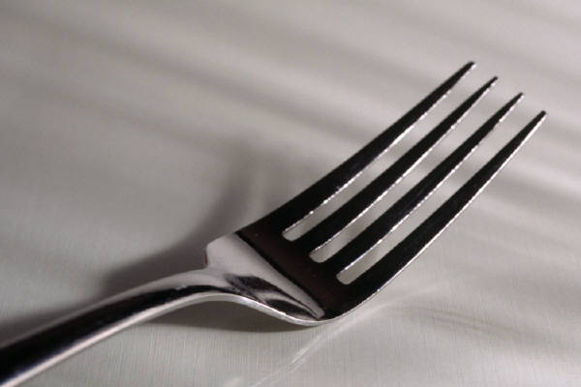

WEEKLY FOOD JOURNAL

Name: