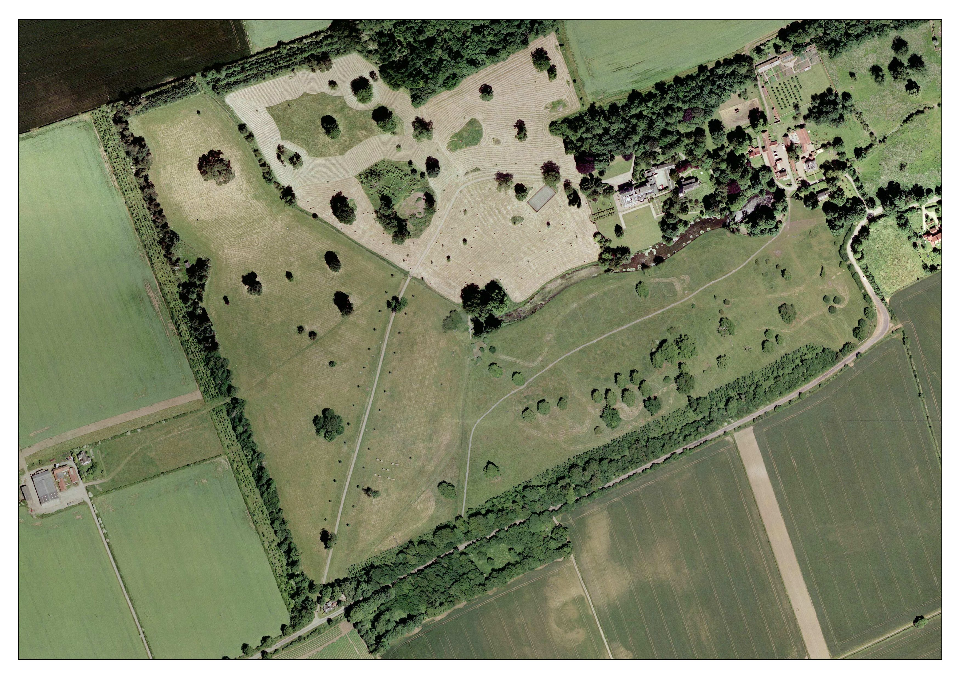

9

7

60cms Green

1 – Roll Top

2 – Palisade

3 – House

4 – Table

5 – Trakehner

6 a/b – Double of rails

7 – Barrels

8 – Rail

9 – Rail

10 – Double of logs

11 – lakeside box

12 a/b – Water

13 – Last Palisade

6

8

12

13

10

11

5

4

Lorry

Park

21

3

1

START

1