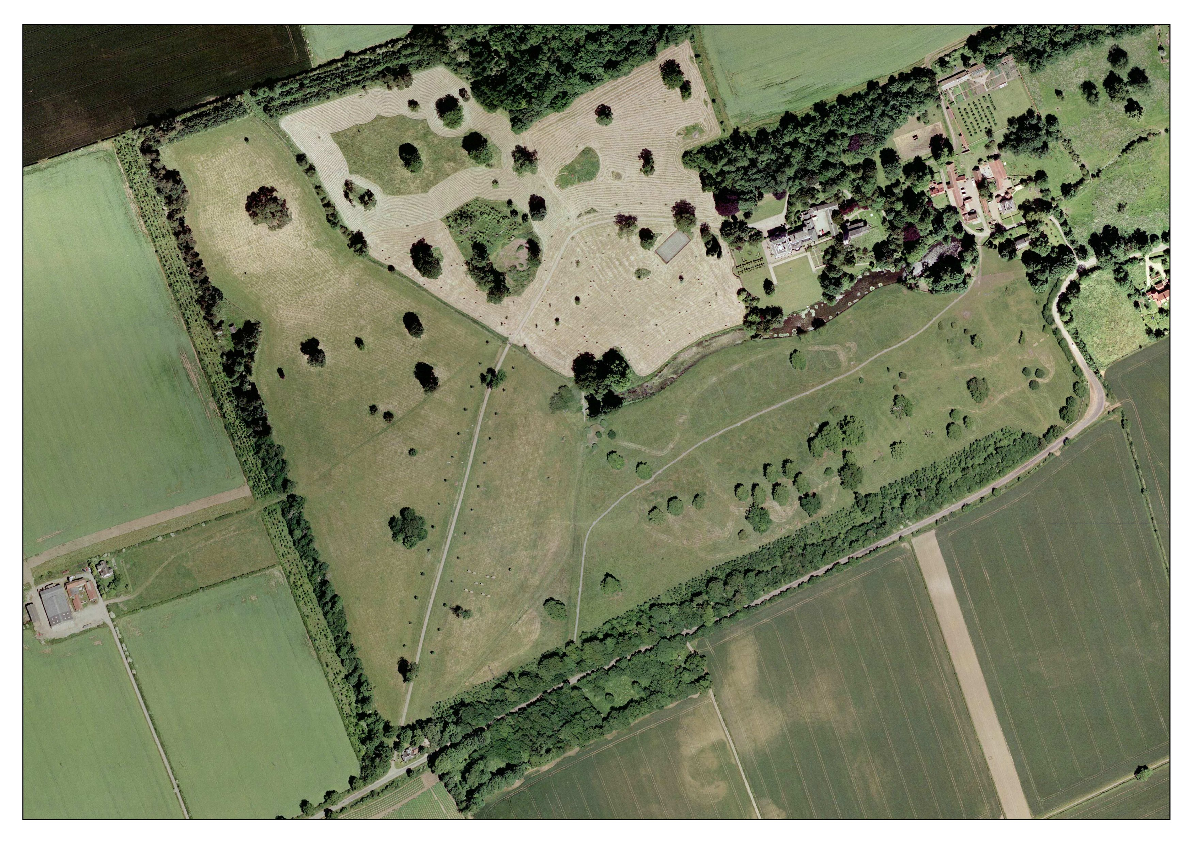

14

13

12

11

10

9

6

7

70cms Red

1 – Roll Top

2 – Palisade

3 – House

4 – Table

5 – Trakehner

6 – Double of Rails (a/b)

7 – Log

8 – Rail

9 – Small Oxer

10 – Rail

11 – Double of logs

12 – Lakeside Box

13 – Water

14 - Last

8

5

4

Lorry

Park

21

3

1

START

1