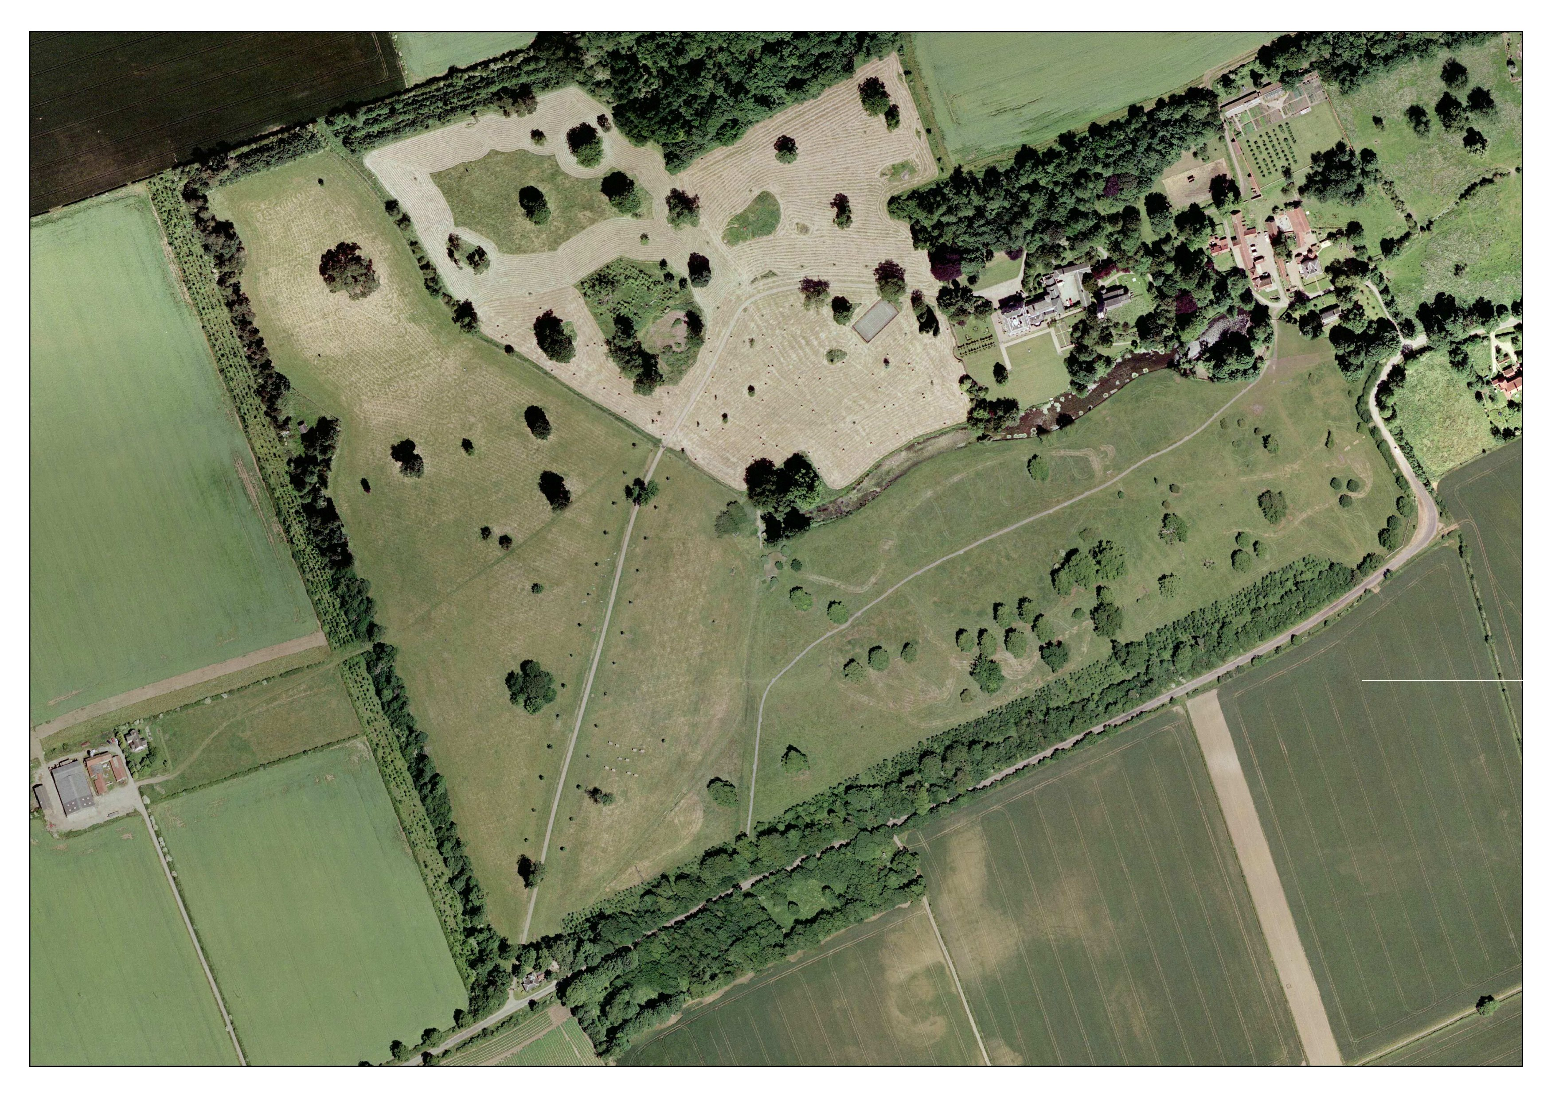

16

15

14

13

12

11

10

9

6

80cms Yellow

1 – Roll Top

2 – Palisade

3 – House

4 – Table

5 – Trakehner

6 – Rail

7 a/b – Ditch-Rail

8 – X fence

9 - sleepers

10 – Small oxer

11 – Rail

12 – Log

13 – Lakeside Box

14 – Pictures

15 – Water

16 – Last palisade

8

7

5

4

Lorry

Park

21

3

1

START

1