DISHES AND THEIR ALLERGEN CONTENT - [INSERT THE NAME OF YOUR FOOD BUSINESS HERE]
DISHES | 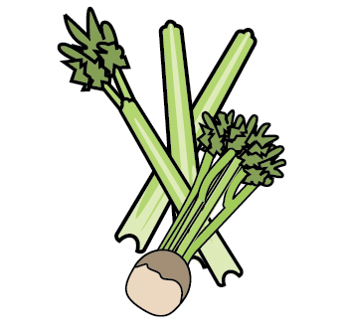 | 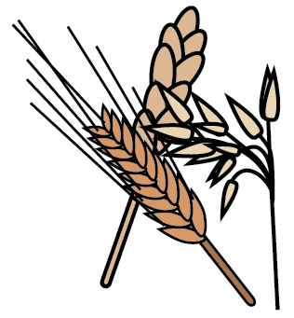 | 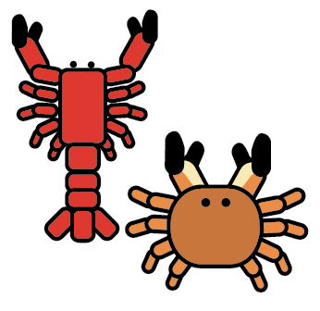 | 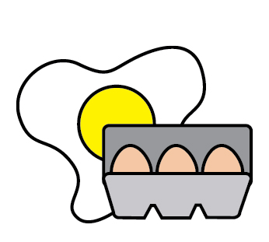 |  | 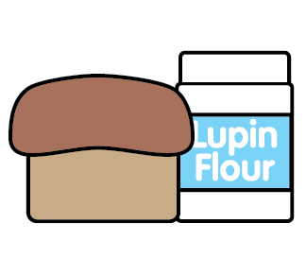 |  |  | 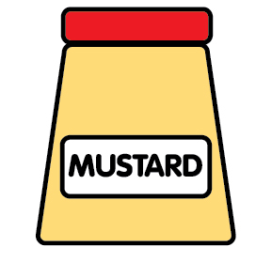 | 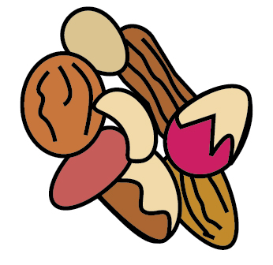 | 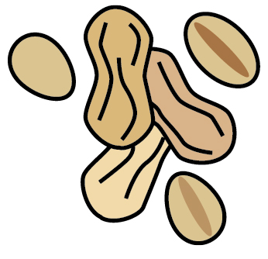 | 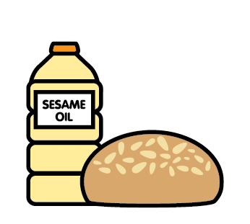 |  | 
 | Celery | Cereals containing gluten | Crustaceans | Eggs | Fish | Lupin | Milk | Mollusc | Mustard | Nuts | Peanuts | Sesame seeds | Soya | Sulphur Dioxide
Miso Soup |  |  |  |  |  |  |  |  |  |  |  |  | ✓
Pumpkin Croquette |  | ✓ |  | ✓ |  |  | ✓ |  |  |  |  |  | ✓
Kaiso Seaweed Salad |  |  |  |  |  |  |  |  |  |  |  | ✓
AgeDashi Tofu |  | ✓ |  | ✓ | ✓ |  |  |  |  |  |  |  | ✓
Veg Gyoza |  | ✓ |  | ✓ |  |  |  |  |  |  |  | ✓ | ✓
Chicken Gyoza |  | ✓ |  | ✓ |  |  |  |  |  |  |  | ✓ | ✓
Aubergine Goma |  | ✓ |  |  |  |  |  |  |  |  |  | ✓ | ✓
Takoyaki | ✓ | ✓ |  |  | ✓ |  |  | ✓ |  |  | ✓ | ✓ | ✓
Yakitori |  | ✓ |  |  |  |  |  |  |  |  | ✓ | ✓ | ✓
Spicy Tofu |  | ✓ |  |  |  |  | ✓Butter |  |  |  |  |  | ✓
Spicy Squid |  | ✓ |  | ✓ |  |  | ✓Butter |  |  |  |  |  | ✓
Edamame |  |  |  |  |  |  |  |  |  |  |  |  | ✓
DISHES
 | Celery | Cereals containing gluten | Crustaceans | Eggs | Fish | Lupin | Milk | Mollusc | Mustard | Nuts | Peanuts | Sesame seeds | Soya | Sulphur Dioxide
Chicken Katsu |  | ✓ |  | ✓ |  |  |  |  |  |  |  |  | ✓
Prawn Katsu |  | ✓ | ✓ | ✓ |  |  |  |  |  |  |  |  | ✓
Wasabi Prawn |  | ✓ | ✓ | ✓ |  |  |  |  | ✓ |  |  |  | ✓
Kataifi Prawn |  | ✓ | ✓ | ✓ |  |  |  |  |  |  |  |  | ✓
Vege Tempura |  | ✓ |  | ✓ |  |  |  |  |  |  |  |  | ✓
Prawn Tempura |  | ✓ | ✓ | ✓ |  |  |  |  |  |  |  |  | ✓
Crab Tempura |  | ✓ | ✓ | ✓ |  |  |  |  |  |  |  |  | ✓
Seafood Tempura |  | ✓ | ✓ | ✓ |  |  |  |  |  |  |  |  | ✓

cdsfd

DISHES
 | Celery | Cereals containing gluten | Crustaceans | Eggs | Fish | Lupin | Milk | Mollusc | Mustard | Nuts | Peanuts | Sesame seeds | Soya | Sulphur Dioxide
Tobiko |  | ✓
Eel/Unagi |  | ✓ |  |  | ✓ |  |  |  |  |  |  |  | ✓
Salmon Panko Maki |  | ✓ |  | ✓ | ✓ |  |  |  |  |  |  |  | ✓
Sweet Tofu |  | ✓ |  |  |  |  |  |  |  |  |  |  | ✓
Sweet Egg |  |  |  | ✓
Teriyaki Salmon maki |  | ✓ |  |  |  |  |  |  |  |  |  |  | ✓
Mix vege Temaki |  | ✓ |  |  |  |  |  |  |  |  |  | ✓ | ✓
California Temaki |  | ✓

DISHES
 | Celery | Cereals containing gluten | Crustaceans | Eggs | Fish | Lupin | Milk | Mollusc | Mustard | Nuts | Peanuts | Sesame seeds | Soya | Sulphur Dioxide
Fried Noodles |  | ✓ |  |  |  |  |  |  |  |  |  | ✓ | ✓
Yaki Udon/Soba |  | ✓ |  |  |  |  |  | ✓can be remove |  |  |  | ✓
Special Fried Rice |  | ✓ | ✓ | ✓ | ✓ |  |  |  |  |  |  | ✓ | ✓
Special Udon/soba |  | ✓ | ✓ | ✓ | ✓ |  |  |  |  |  |  | ✓ | ✓
Chicken Katsu Curry |  | ✓ |  | ✓ |  |  | ✓ |  |  |  |  |  | ✓
Pork Katsu Curry |  | ✓ |  | ✓ |  |  | ✓ |  |  |  |  |  | ✓
Prawn Katsu Curry |  | ✓ |  | ✓ |  |  | ✓ |  |  |  |  |  | ✓
Tofu Katsu Curry |  | ✓ |  | ✓ |  |  | ✓ |  |  |  |  |  | ✓
Teriyaki Sizzling |  | ✓ |  |  |  |  |  |  |  |  |  | ✓ | ✓

DISHES
 | Celery | Cereals containing gluten | Crustaceans | Eggs | Fish | Lupin | Milk | Mollusc | Mustard | Nuts | Peanuts | Sesame seeds | Soya | Sulphur Dioxide
Vege Box |  | ✓ |  |  |  |  |  |  |  |  |  | ✓ | ✓
Chicken Box |  | ✓ |  | ✓ |  |  |  |  |  |  | ✓yakitori | ✓ | ✓
Salmon Box |  | ✓ |  |  |  |  |  |  |  |  |  | ✓ | ✓
Tuna Box |  | ✓ |  | ✓ |  |  |  |  |  |  |  | ✓ | ✓
Mixed Box |  | ✓ |  | ✓ |  |  |  |  |  |  |  | ✓ | ✓
Salmon Don |  |  |  |  | ✓ |  |  |  |  |  |  | ✓
Chirashi Don |  |  | ✓ | ✓ | ✓ |  |  | ✓ |  |  |  | ✓
Roast Duck Rice |  | ✓ |  |  |  |  |  |  |  |  |  | ✓ | ✓
All Donburi Dishes |  | ✓ |  | ✓ |  |  |  |  |  |  |  |  | ✓
DISHES
 | Celery | Cereals containing gluten | Crustaceans | Eggs | Fish | Lupin | Milk | Mollusc | Mustard | Nuts | Peanuts | Sesame seeds | Soya | Sulphur Dioxide
Garden Set |  | ✓ |  | ✓ |  |  |  |  |  |  |  | ✓
Kenji Set |  | ✓ | ✓ | ✓ | ✓ |  |  | ✓ |  |  |  | ✓
Classic Sushi Set |  |  | ✓ |  | ✓ |  |  |  |  |  |  | ✓
Mango Mayo |  | ✓ |  | ✓ |  |  |  |  | ✓ |  |  |  | ✓
Spicy Mayo |  |  |  |  | ✓ |  |  | ✓
Wasabi Mayo |  |  |  | ✓ |  |  |  |  | ✓
DISHES
 | Celery | Cereals containing gluten | Crustaceans | Eggs | Fish | Lupin | Milk | Mollusc | Mustard | Nuts | Peanuts | Sesame seeds | Soya | Sulphur Dioxide
Tuna Salad [example] | ✓ |  |  | ✓ | ✓ |  | ✓ |  | ✓
DISHES
 | Celery | Cereals containing gluten | Crustaceans | Eggs | Fish | Lupin | Milk | Mollusc | Mustard | Nuts | Peanuts | Sesame seeds | Soya | Sulphur Dioxide
Tuna Salad [example] | ✓ |  |  | ✓ | ✓ |  | ✓ |  | ✓
DISHES
 | Celery | Cereals containing gluten | Crustaceans | Eggs | Fish | Lupin | Milk | Mollusc | Mustard | Nuts | Peanuts | Sesame seeds | Soya | Sulphur Dioxide
Tuna Salad [example] | ✓ |  |  | ✓ | ✓ |  | ✓ |  | ✓
DISHES
 | Celery | Cereals containing gluten | Crustaceans | Eggs | Fish | Lupin | Milk | Mollusc | Mustard | Nuts | Peanuts | Sesame seeds | Soya | Sulphur Dioxide
Tuna Salad [example] | ✓ |  |  | ✓ | ✓ |  | ✓ |  | ✓

