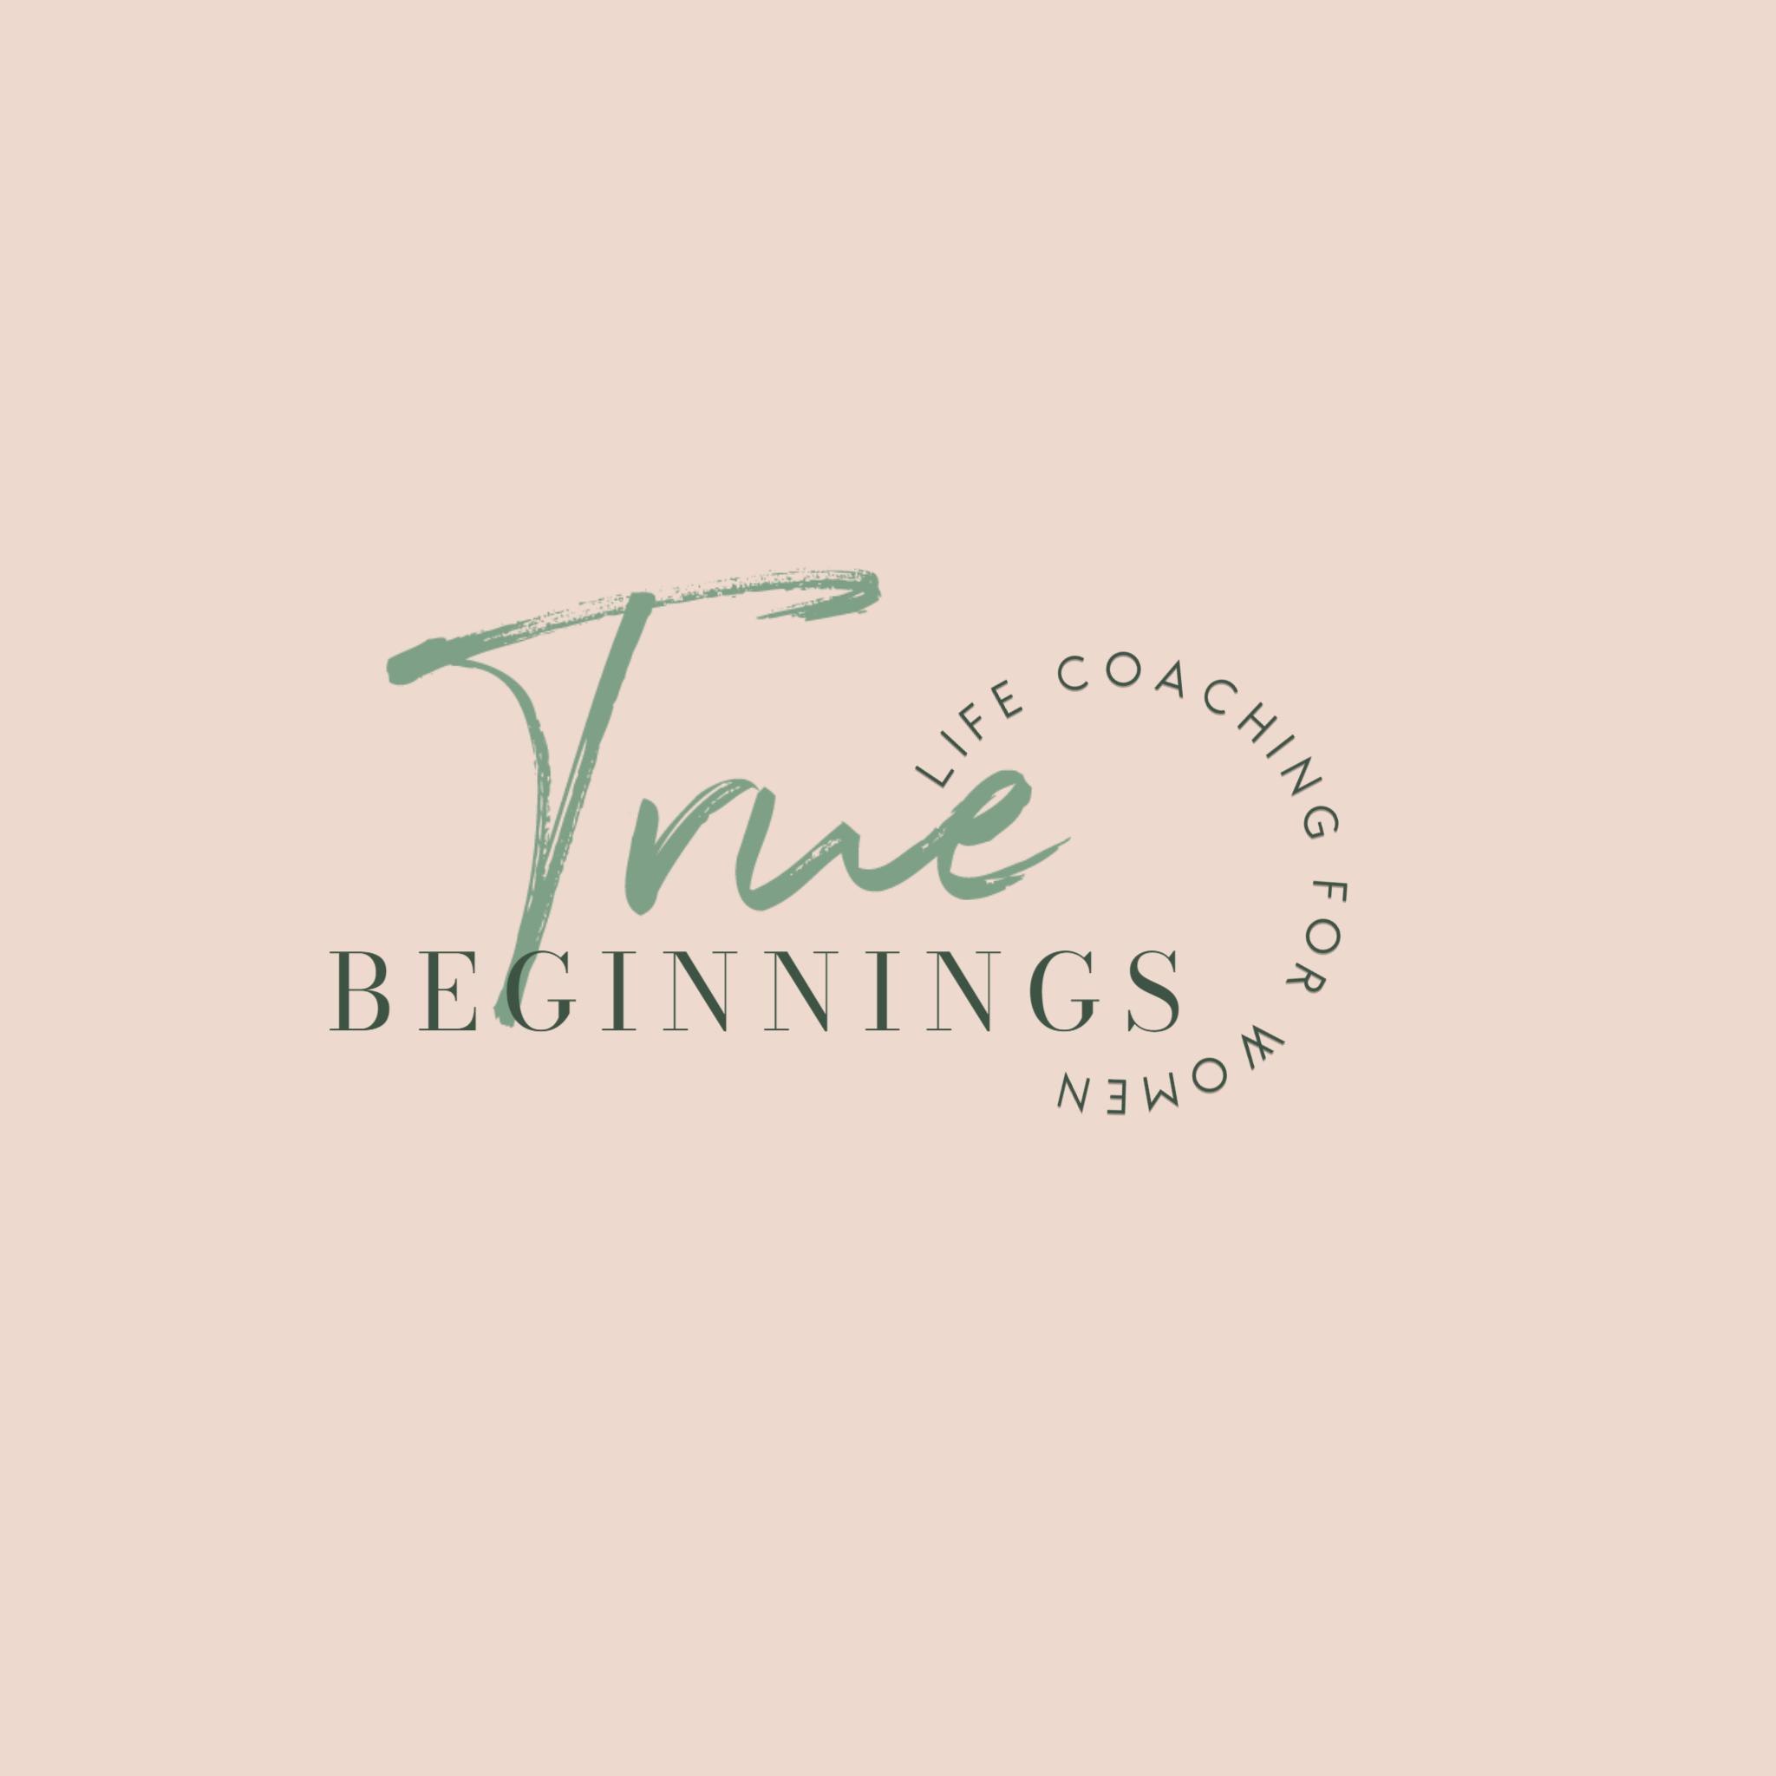

This Coaching Agreement between Alison Ruhter and will begin on ______ and will continue for _______. The fee is $________, payable in advance to Alison Ruhter.

The calls/meetings shall be ____________ (length of call or meeting for example 30, 45, 60, 90, 120 minutes). If rates change before this agreement has been signed and dated, the prevailing rates will apply

The client mentioned above will receive a one-time-only money-back guarantee for the initial month’s coaching. If dissatisfied with his or her coaching experience, the client must notify Alison Ruhter / True Beginnings Coaching in writing within 5 working days of his or her last coaching session of the initial month. The client can choose to receive a full refund or to be matched with a new coach. There is no additional money-back guarantee if the client decides to be matched with a new coach.

The service to be provided is coaching, which is not advice, therapy, nor counseling and may address specific personal projects, business successes or general conditions in the client’s life or profession. Coaching is a designed alliance that helps bring out the best in the client and helps the client create and live the life they want to live. Upon completion of the three months, coaching will convert to a month-to-month basis. In the event it is desired to cancel further services, the client and coach agree to provide one another with thirty days notice.

The coach promises the client that all information provided to the coach will be kept strictly confidential as allowed by law. Throughout the working relationship the coach will engage in direct and personal conversations. The client can count on the coach to be honest and straightforward in asking questions and making requests. The client understands that the power of the coaching relationship can only be granted by the client and the client agrees to do just that—have the coaching relationship to be powerful. If the client believes that coaching is not working as desired, the client will immediately communicate that to the coach and both will take action to remedy the situation.

Coaching Agreement

I, ___________________, hereby certify that I do not suffer from any physical or mental disability that might affect my participation in the coaching process, and, if I have any substance abuse problem or mental illness, I have consulted with my physical and other health care professional and been advised that I may participate in the coaching process without risk. I agree that if there is any change in this representation, I will promptly advise the coach.

I agree that, in the event if any claim or grievance against Alison Ruhter/True Beginnings Coaching by sole remedy will be the return of the fees paid to Alison Ruhter. Alison Ruhter / True Beginnings Coaching is not responsible for any direct, indirect, incidental or consequential damages beyond the total amount of fees paid by the client.

I understand that this document contains all of the information given to me by Alison Ruhter and all other representations or statements (prior or subsequent, whether oral or written) are superseded by this document.

Our signatures on this agreement indicate a full understanding of and agreement with the information outlined above.

Client (Print name) ________________________

Client Signature __________________________ Date ________________

Guardian (if under 18 years of age). _______________________________

Coach (Print name) ___Alison Ruhter__

Coach (Signature) _________________ Date ________________

