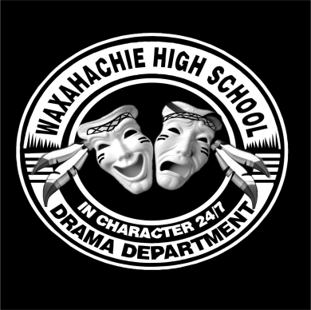

**Welcome to WHS Theatre!**

We would like to welcome you to the Theatre Program and its Booster Club, Pow-Wow Players. As parents of students in theatre, we know you will want to be informed of all of the ways that you can help our young actors and actresses, directors, tech students, and crew at WHS to be successful. We are building on an AMAZING, state-recognized, award-winning program, and we are excited to invite you to be a part of it! Please put our Booster Club meeting dates on your calendar. We meet the second Tuesday of each month, at 7:00 PM in the BlackBox Theatre at WHS. Meetings last no more than one hour. **Pow-Wow Players Booster Meetings:**

September 12

October 10

November 14

January 9

You will also want to sign up for our Remind communication, to receive theatre updates and opportunities throughout the year. **You can sign up by doing this: Text @e2b3f6 to 81010.**

**Other important events for your 2017-18 calendar include:**

WHS Homecoming Parade: October 13*. Come out and see our Theatre Float!!*

Fall Advanced Theatre Show: October 19-22.

BlackBox Show: November 6-11.

Texas Thespian Festival: November 15-18.

Winter Musical: January 25-28, 2018.

One Act Play Clinic: February 22-25, 2018.

UIL One Act Play: March, April, May (TBD) 2018.

New York City Trip: March 9-13, 2018.

Spring Musical: May 3-6, 2018.

Advanced BlackBox Show: May (TBD).

Theatre Banquet: May 2018.

We would be thrilled for you to join us in supporting our directors, staff, and students. When we all help, it’s easy, fun, *and* *you will be part of a top-notch program*! We are looking forward to partnering with you in supporting our Theatre Arts at Waxahachie High School!

Pow-Wow Players Booster Executive Board.