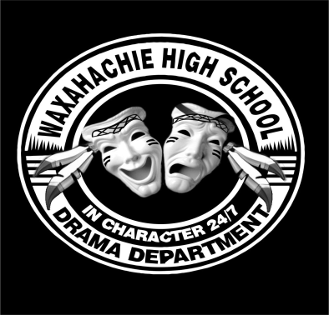
Pow Wow Players Booster Club
Waxahachie High School

All the world’s a stage and the men and women merely players

WHS Theatre Parents…. This is for YOU!!
“As a parent of a Theatre Student, what is expected of me? What can I expect from the Theatre Department and Booster Club?”
When our kids are involved in awesome things, we as parents always want to know how we can best help support them in their greatness! Here are a few things that you can count on, and a few ways that you’ll be expected to participate…
Every parent is expected to help! We can’t do it without you! Whether that means selling tickets or concessions, providing food or snacks, or serving on the Board… no job is too small, and there is much that goes on behind the scenes! We need your help!!
1. This year, we are asking each family to contribute at least one “show slot” (arriving 30 minutes early to the show, selling tickets, concessions, or helping with the Raffle) per semester. Please see our Interest and Information Form (attached).
2. We are asking each family to contribute prepackaged snacks, homemade baked goods, drinks, or other items to the concession stand each semester. More on that to come!
3. Your PRESENCE for your theatre student speaks loudly! Come and watch the shows, bring your families and friends, and be the first to stand up for the ovation at the end! You will be guaranteed an amazing and memorable production every time!
4. Support your student through the Booster Club… attend the meetings and sign up for the Remind messages so you can know what’s happening, and what’s coming up next! You can text @e2b3f6 to 81010 to get all of the updates for Pow-Wow Players.

