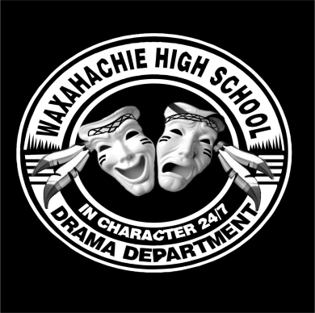

Theatre Students!!
We are getting ready to kick-off our amazing 2018-19 WHS Theatre Season, and we need your help recruiting Shining Star Patrons!
There is a BIG PRIZE for the student who sells the highest total dollar amount of Shining Star sponsorships!
THE BIG PRIZE is….
An entire season worth of FREE show shirts and TWO FREE tickets to every single WHS production!
(relative value near $200)
Rules of the contest:
- All Shining Star money must be turned in to Ginger Robinson by October 1 to qualify for the BIG PRIZE.
- The winner will be determined by the total amount of money contributed, linked to that student’s name.
- Winner will be announced at the Theatre Booster Meeting on October 2.
- For more details, see any Pow-Wow Players Booster Club Board member.

