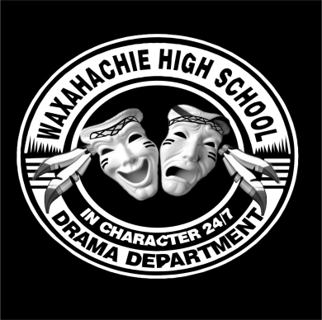

WHS Pow-Wow Players Theatre Extras Menu!
CIRCLE YOUR PREFERENCES!
Musical Theatre
Winter Musical Long-sleeve T-Shirt $20
Spring Musical T-Shirt $15
All Musical Theatre T-Shirts $35

Advanced Theatre
Fall Show T-Shirt $15

Black Box
Fall Show T-Shirt $15

Actor’s Studio
Spring Show T-Shirt $15
***************************************
General Drama T-Shirt 2018-19 $15
Size:
Drama Mama T-Shirt $15
Size:
Drama Papa T-Shirt $15
Size:
Car Decal $5 or $8
TOTAL: ____________

STUDENT NAME:_________________________

T-SHIRT SIZE:____________________________

PHONE #:_______________________________

GRAND TOTAL PAID: _____________________

Make checks payable to:
Pow Wow Players Booster
Turn forms and money into the locked metal box in the Black Box theater.

For more T-Shirt Information, contact:
Alicia Svrcek at asvrcek@hotmail.com
or
817-689-1271.

