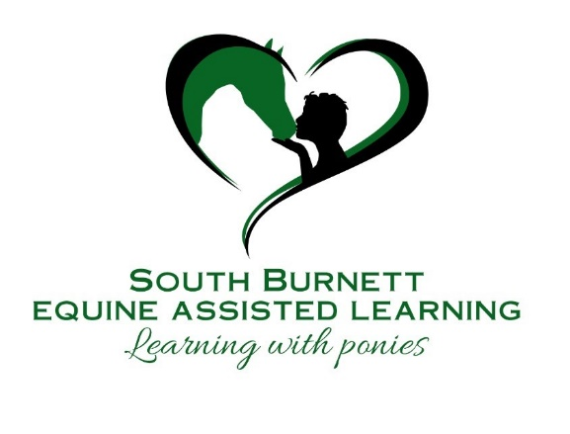



**EQUINE ASSISTED LEARNING**

**AGREEMENT**

|  |  |
| --- | --- |
| Client Name |  |
| Mailing Address |  |
| Email |  |
| Mobile/Home No. |  |
| EAL Package/No. of Sessions |  |
| Agreed Fee |  |
| Agreed Duration |  |
| Communication Medium |  |

**Timing:** All EAL sessions must be confirmed 1 working day prior to session. Client is responsible for contacting their practitioner for the session on the agreed communication medium (phone, email, etc)

**Payment Options:**

|  |  |
| --- | --- |
| Account Name | Rachael Cooper |
| Bank Name | **Commonwealth Bank** |
| BSB # | 064-418 |
| Account # | 10310936 |
| Reference (your name or invoice) | **Please enter your name or invoice #** |

**Changes:** Rescheduling or cancelling of appointments must be done at least 24 hours before the planned date, to avoid a full fee charge.

**Confidentiality:** All Equine Assisted Learning Sessions are confidential. You are free to discuss anything with your practitioner and know that your personal information will not be shared.

**Please note there are three exceptions to the above confidentiality agreement:**

1. When disclosure is required to prevent clear and imminent danger to yourself and others.
2. When legal requirements demand that confidentiality material be revealed.
3. You agree to inform your practitioner if you come under the care of any health care professional such as a Psychotherapist, Psychologist, Counsellor, Mental Health Social Worker, Psychiatrist or related professional during the course of our EAL relationship. If you are under this type of medical or psychological treatment, you must provide written permission from your practitioner stating their permission for you to attend EAL sessions.

**Equine Assisted Learning (EAL):** The Client (you) is aware that EAL is in no way to be construed as psychological counselling or any type of therapy. EAL is a specific social-emotional skills building, experiential learning modality. EAL results are not guaranteed. The Client **must** enter into the EAL sessions with the full understanding that they are responsible for creating their own personal learning and results. The Client is aware that their EAL outcomes are dependent on their level of commitment and participation throughout the process.

**We both:**

* Agree to abide by the mutually agreed time frames to complete all commitments
* Agree to ensure we keep EAL appointments
* Agree to honour our commitments to each other
* Agree to develop our EAL relationship as an open, honest and trusting relationship

**Other:**

**PROCEDURE:**

1. Return the signed and dated Equine Assisted Learning Agreement Form. You can either scan and email it to your practitioner or take a photo of the document and email the image.
2. Book in your session via email or phone with your practitioner – all sessions must be booked 48 hours in advance to allow preparation time.
3. Prior to the FIRST session the Client will complete the Client Profile Form at least 48 hours prior to the meeting.
4. At the completion of each session you may be invited to complete a Session Review Form and email it to your practitioner.
5. Your practitioner will email/SMS text you 24 hours prior to your session to confirm.

|  |  |
| --- | --- |
| EAL Practitioner  Name |  |
| Signature |  |
| Date |  |

|  |  |
| --- | --- |
| Client Name |  |
| Signature |  |
| Date |  |

**Please note: If you are experiencing a personal crisis, please call crisis helpline ‘Lifeline’ phone 13 11 14.**