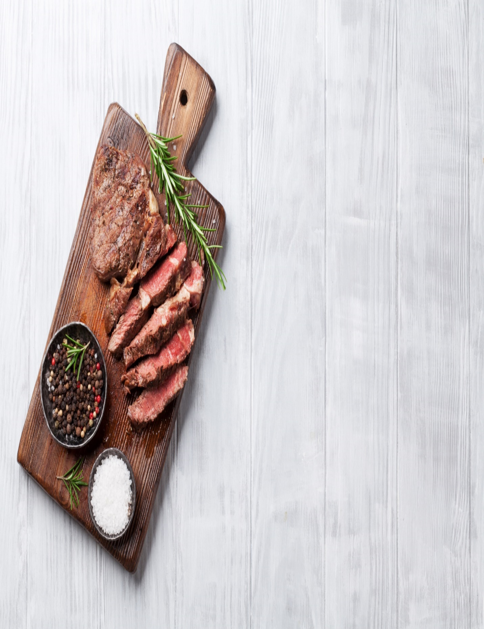**Dinner on the Lake**

**“Martini” of Low Country Pickled Shrimp Red Onion, Capers, Garlic, Parsley, Lemon**

**Watermelon, Star Anise and Basil Gazpacho Jicama, Cucumber, Serrano Chili, Mint**

**Southwestern Caesar Salad, Manchego, Applewood Smoked Bacon, Smoked Chili Caesar Dressing, Polenta Crouton**

**Smoked Jalapeno Crab Cake, Avocado -Lime Crème Fraiche, Fried Tortilla Salad**

**Smoked Oak Pepper Prime Tenderloin of Beef Serrano Chili- Blackened Tomato Butter, Roasted Garlic Mashed Potato, Seared Asparagus**

**Bitter Sweet Smoked Chili and Mezcal Chocolate Truffle Tart Pecan – Pasilla Chili Ice Cream, Bittersweet Chocolate – Ancho Chili Paint**

**Wine and Beer to Match/Liquor TBD**