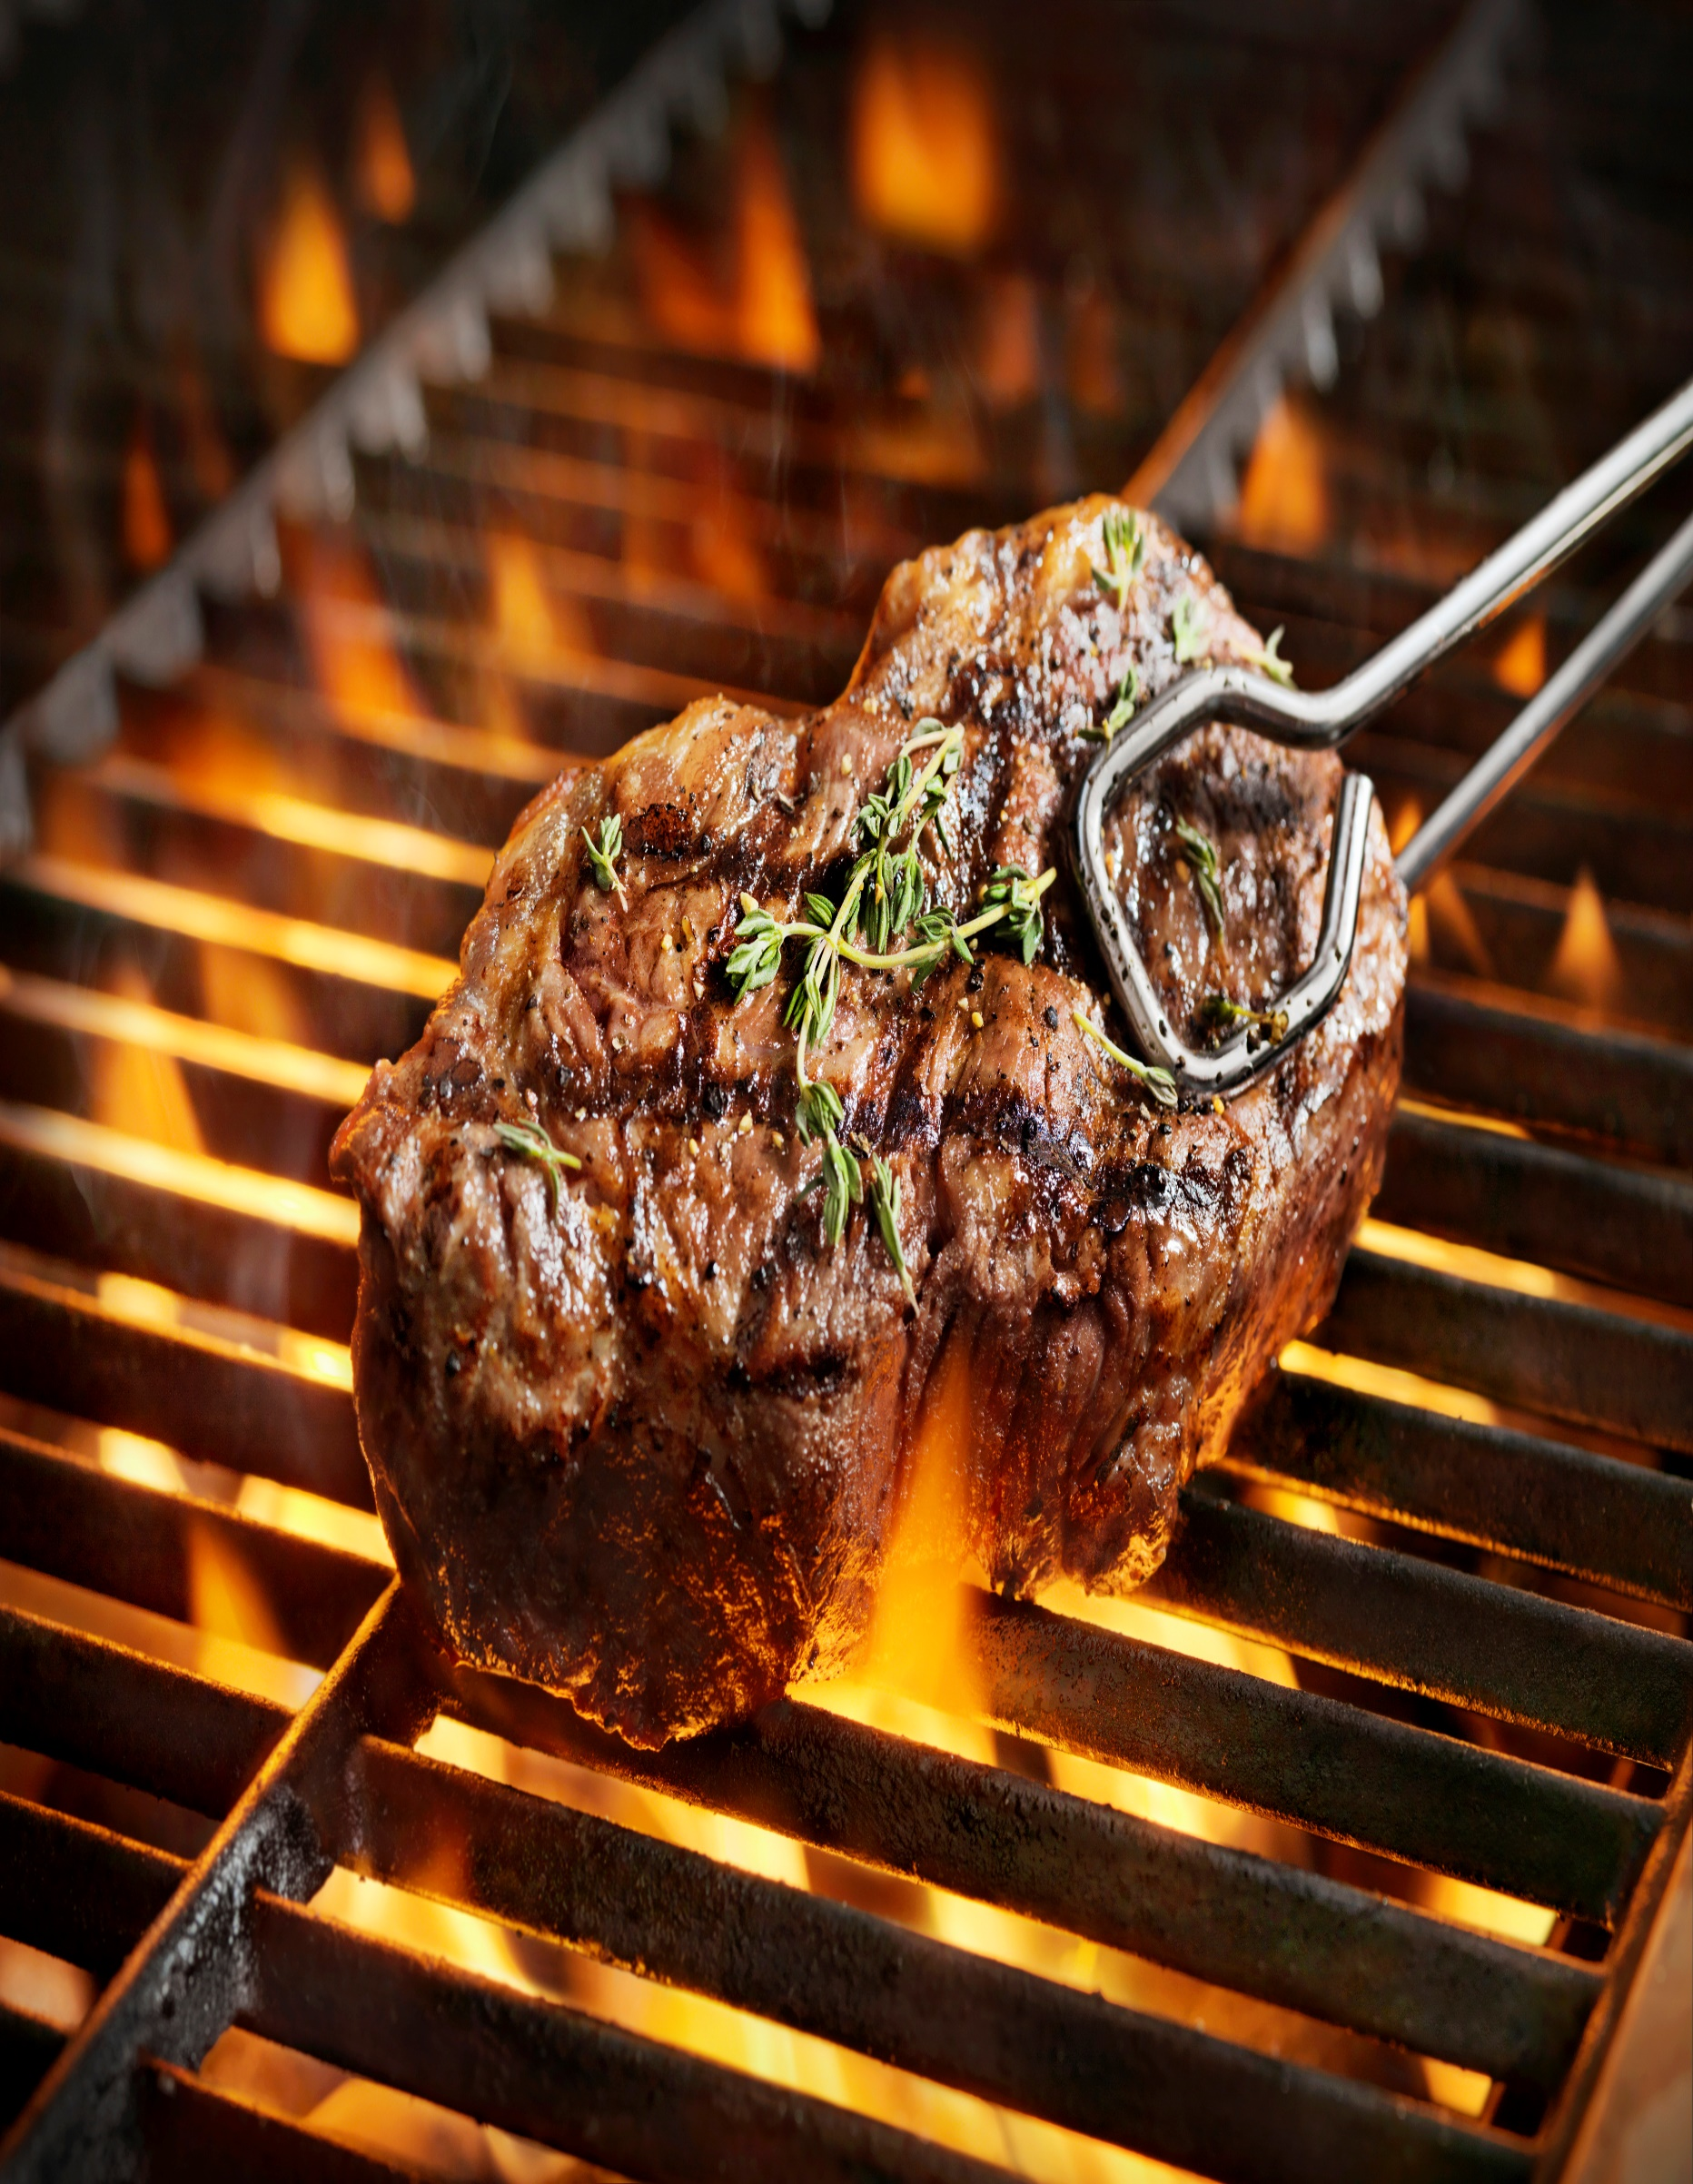**Dinner at Acme Ranch**

**Yucatan Style Guacamole “Martini” Tequila, Gulf Crab Salad, Mango, Pumpkinseed, Poblano Chili, Cilantro, Mint Blue Corn Cracker**

**Roasted Poblano Chili and Manchego Cheese Soup Ancho Chili Tortilla Salad**

**Southwestern Caesar Salad, Manchego, Applewood Smoked Bacon, Smoked Chili Caesar Dressing, Polenta Crouton**

**Seared Jumbo Prawn Wild Boar- Jalapeno Sausage, Stone Ground Benton Bacon, White Cheddar & Swiss Chard Polenta Gulf Coast “Gumbo” Broth**

**Prime Short Rib of Beef Coffee and Pasilla Chili Crusted, Roasted Garlic, Caramelized Onion and Arugula Mashed Potato Ancho Chili, Wild Mushroom Demi – Glace**

**Bitter Sweet Smoked Chili and Mezcal Chocolate Truffle Tart Pecan – Pasilla Chili Ice Cream, Bittersweet Chocolate – Ancho Chili Paint**

**Specialty Dinner Drinks Jalapeno and Cucumber Margarita, Smokey Margarita De Mezcal**