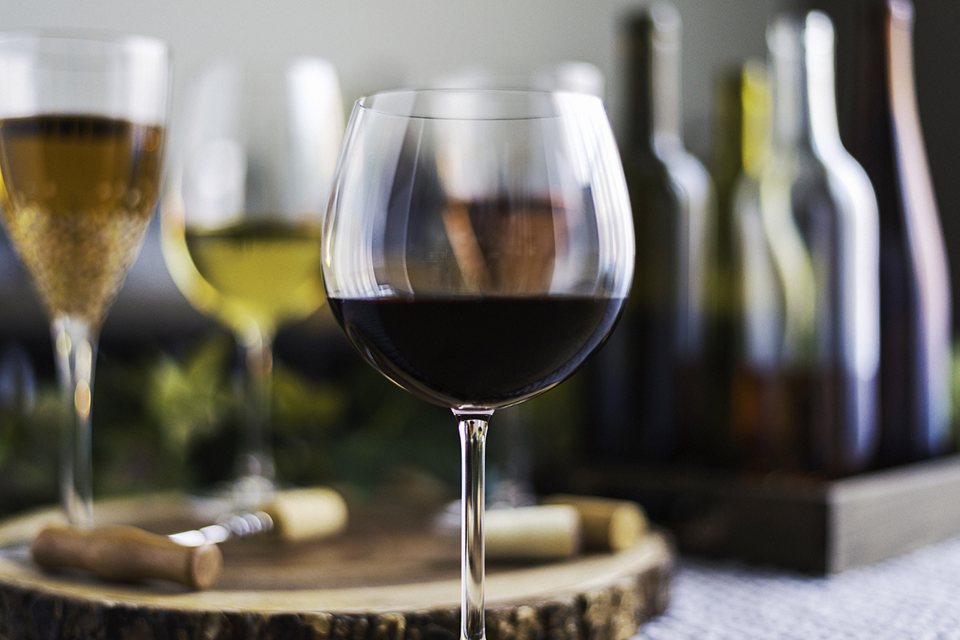**The “Getaway Girls” Welcome Dinner**

Pre Dinner Mingle

**Artisanal Spanish Goat Cheese and Charcuterie Platter, Arugula, Pistachio Butter, Crostini**

**Dinner**

**Chefs Choice Amuse**

**Martini of Watermelon, Star Anise and Thai Basil Gazpacho Thai Chili, Mint Jicama, Green Apple, Cucumber**

**Spanish Style Caesar Salad, Applewood Smoked Bacon, Shaved Manchego, Smoked Pimenton Caesar Dressing, Serrano Chili –Polenta Crouton**

**Seared Jumbo Prawn Stone Ground Benton Bacon, White Cheddar & Swiss Chard Polenta Gulf Coast “Gumbo” Broth**

**Coffee and Pasilla Chili Crusted Smoked Pork Tenderloin Roasted Garlic, Caramelized Onion and Arugula Mashed Potato Smoked Jalapeno –Maker Mark Bourbon Demi Glace**

**Key Lime “Natilla” Pie Chili De Arbol, Cilantro Syrup, Mango**

**Bitter Sweet Smoked Chili and Mezcal Chocolate Truffle Tart Pecan – Pasilla Chili Ice Cream, Bittersweet Chocolate – Ancho Chili Paint**

**Wine to Match**