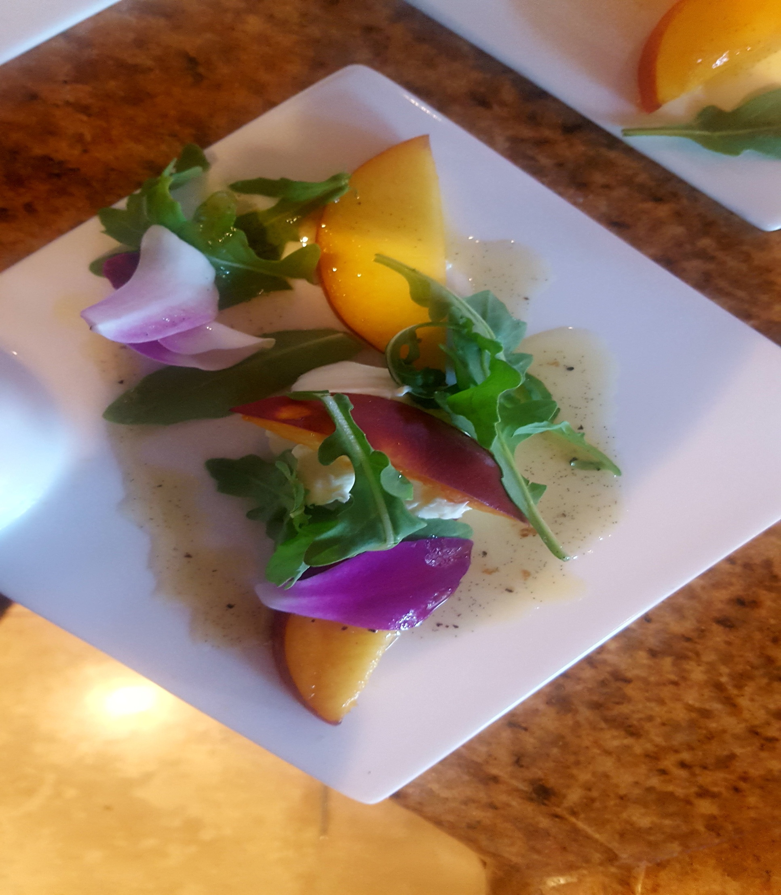**Bryce and Kathleen Private TaskUs Celebratory Dinner**

**Appetizers**

**Martini of Malaysian Style Spiced Shrimp Sriracha-Peach Cocktail Sauce**

**Tapas “Deviled” Egg Lollipop Caramelized Onion - Bacon and Bourbon Jam**

**Brochette of Roasted Potato, Oloroso Sherry Seared Mushroom Spanish Chorizo –Parsley Oil**

**Thai style pickled Cucumber, Red Onion and Roasted Shashito Pepper Salad Toasted Peanut, Cilantro, Mint**

**Dinner**

**Sashimi of Tuna, White Soy, Marcona Almond, Dried cranberry, Green Onion, Micro Coriander, Togarashi Oil**

**Caramelized Mission Fig Orange Scented Mascarpone, Prosciutto, Arugula, Ruby Port - Balsamic Syrup, 100 dollar Olive Oil**

**Beef and Mesquite Smoked Pulled Pork Albondigas Roasted Tomato – Smoked Jalapeño Broth, Cotija Cheese Cilantro**

**Seared King Prawns and Wild Boar –Sausage Stoned Ground White Cheddar and Wild Green Grits, New Orleans Style “Gumbo Broth**

**26 Guests 85.00 PP**