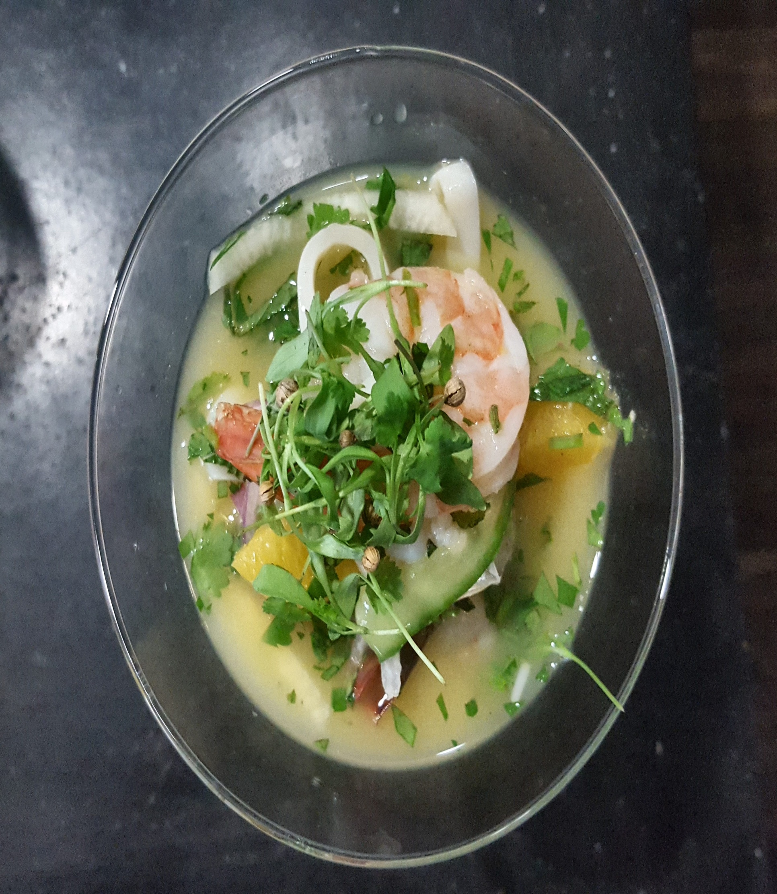

**Shrimp Cocktails, Ceviches and Tastings**

**Martini of Malaysian Style Shrimp Sriracha-Peach Cocktail Sauce**

**Island Style Bay Scallop “Cocktail” Ginger, Lime Coconut Milk, Thai Chili, Cilantro, Mango**

**“Martini” of Low Country Pickled Shrimp Red Onion, Capers, Garlic Parsley, Lemon**

**Grilled Guajillo Pepper Spiced Shrimp Tequila, Avocado, Mango, Serrano, Toasted Pumpkin Seed Blue Corn Tuile**

**Seared Tiger Prawn with Papaya – Mustard Glaze - Micro Cilantro**

**Ginger, Soy, Finger Chili Cured King Salmon Asian Pear, Micro Greens, Scallion – Lime Crème Fraiche**

**Shrimp Ceviche Orange, Lime, Habanero, Jicama, Cilantro, Red Onion, Mint**

**Mexican “Poke” of Black Pepper, Coriander and Ancho Chili Crusted Tuna Pomegranate- Red Onion Emulsion**

**Sashimi of Tuna, White Soy, Marcona Almond, Dried cranberry, Green Onion, Micro Coriander, Togarashi Oil**

**Tuna, Goat Cheese Fuji Apple, Pumpkinseed Oil, Micro Shiso**

**Seared Cube of Ivory King Salmon, Baby Spinach Pickled Red Onion, Mustard Crème Fraiche, Mint Sherry- Orange Vinaigrette**

**Yellow fin Tuna, Chimichurri Crème Fraiche, Micro Cilantro, Plantain Chip**

**Ginger, Soy, Finger Chili Cured King Salmon, Asian Pear, Micro Greens, Scallion – Lime Crème Fraiche**

**Tapas “Deviled” Egg Lollipop Caramelized Onion - Bacon and Bourbon Jam**

**Croustade of Spanish Style Smoked Pimenton Egg Salad Applewood Smoked Bacon, Watercress**

**Ginger, Kaffir Lime and Coconut Milk Carrot “Panna Cotta,” Pea Tendril, Mint Garnish**

**Assorted Melon Lollipops Agave, Mint, Black Lava Salt**

**Pistachio Crusted Irish Blue Cheese Mousse “Lollipop”**

**Mint, Parsley and Pistachio Crusted Honey Goat Cheese “Truffle” Pistachio Butter, Arugula**

**Stuffed Campari Tomato Feta cheese, Red Onion, Toasted Walnut, Parsley. Lemon Olive Oil Vinaigrette**

**Garlic infused Goat Cheese flan, Herbs, Flowers, Garlic Chive**

**“Julep” of Bourbon Marinated Fresh Pineapple Mint, Thai Basil**

**Red Curry Seared Shrimp Satay Spicy Thai Peanut Sauce**

**Paquillo Pepper Black Pepper and Parsley Goat Cheese Mousse, Micro Watercress, Lemon Olive Oil, Violets**

**Martini Of Smoked Jalapeno Fingerling Potato Salad Blackened Crawfish, Green Onion and Zap Potato Chip**

**Martini of Yucatan Style Guacamole Smoked Jalapeno Crab Salad, Mango, Pumpkinseed Mint**