

**Knoxville, TN 37923**

**Phone:(865) 399-2055**

**Email:** [**Sky@akamassage.com**](mailto:Sky@akamassage.com)

**AKAM Client Intake Form**

Personal Information:

Name: Phone (day): 

Address:  City/State/Zip: 

Email: Date of Birth:

Occupation: Emergency Contact:

Phone:

**The following information will be used to help plan safe and effective massage sessions.**

**Please answer the questions to the best of your knowledge.**

Date of Initial Visit:

1. How did you hear about AKAM? ______________________________
2. Have you had a professional massage before? Yes or No

If yes, how often do you receive massage therapy

1. Do you have any difficulty lying on your front, back, or side? Yes or No

If yes, please explain 

1. Do you have any allergies to oils, lotions, or ointments? Yes or No

If yes, please explain

1. Do you have sensitive skin? Yes or No
2. Are you wearing contact lenses ( ) dentures( ) a hearing aid( )
3. Do you sit for long hours at a workstation, computer, or driving? Yes or No

If yes, please explain 

1. Do you perform any repetitive movement in your work, sports, or hobby? Yes or No

If yes, please explain 

9.) Are you or could you be pregnant? ______________

10.) Do you experience any stress in your work, family, or other aspect of your life? Yes or No

If yes, please describe  

11.) Is there any particular area of the body where you are experiencing tension, stiffness, pain, or other discomfort? Yes or No

If yes, please identify

12.) Do you have any particular goals in mind for this massage session? Yes or No

If yes, please explain

X any specific areas you would like the massage therapist to concentrate on during the session.

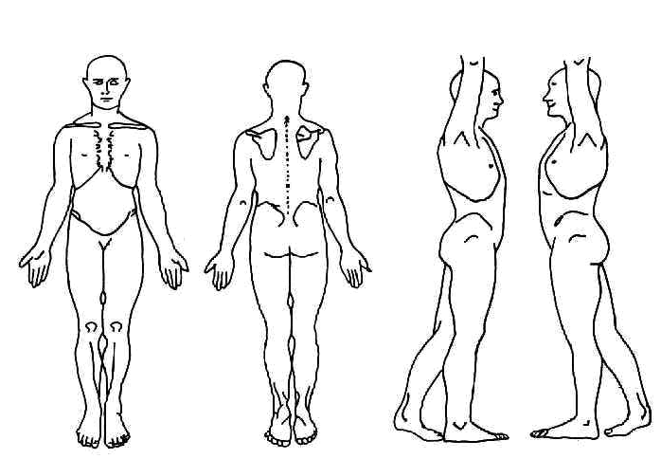

**Medical History**

11.) Please check any condition listed below that applies to you:

( ) contagious skin condition ( ) phlebitis

( ) open sored or wounds ( ) deep vein thrombosis/blood clots

( ) easy bruising ( ) joint disorder/rheumatoid arthritis/osteoarthritis/tendonitis

( ) recent accident or injury ( ) osteoporosis

( ) recent fracture ( ) epilepsy

( ) artificial joint ( ) headaches/migraine

( ) sprains/strains ( ) cancer

( ) current fever ( ) diabetes

( )swollen glands ( ) decreased sensation

( )allergies/sensitives ( ) back/neck problems

( )heart condition ( ) fibromyalgia

( )high or low blood pressure ( ) TMJ

( ) circulatory disorder ( ) carpal tunnel syndrome

( ) varicose veins ( ) tennis elbow

( ) atherosclerosis ( ) pregnancy If yes, how many months?

( ) HIV/AIDS

Please explain any condition you have marked above:



Is there anything else about your health history that you think would be useful for your therapist to know to plan a safe and effective massage session for you?





Draping will be used during the session- only the area being worked on will be uncovered.

Clients under the age of 17 must be accompanied by a parent/ legal guardian during the entire session. Informed written consent must be provided by parent/legal guardian for any client under the age of 17.

I, (print name) understand that the massage I receive is provided for the relaxation and relief of muscular tension for therapeutic purposes. If I experience any pain or discomfort during this session, I will immediately inform the person working on me so that the pressure may be adjusted to my level of comfort. I further understand that massage should not be construed as a substitute for medical examination, diagnosis, or treatment and that I should see a physician, chiropractor or other qualified medical specialist for any mental or physical ailment that I am aware of. I understand that AKAM is not qualified to perform spinal or skeletal adjustments, diagnose, prescribe, or treat any physical or mental illness, and that nothing said during the session given should be construed as such. Because massage should not be performed under certain medical conditions, I affirm that I have stated all my known medical conditions, and answered all questions honestly. I agree to assume the risk of injury or damage and I am signing this of my own free will. I agree to keep the person working with me updated as to any changes in my medical profile and understand that there shall be no liability on Ahhh Knead A Massage’s part should I fail to do so.

Signature of client Date 

Signature of AKAM independent contractor  Date