**Virtual and Augmented Reality in the**

**Disaster Management Technology**

**AR** and smart **technologies** offer significant potential to improve crisis **preparedness**, response, and recovery. As these **technologies** continue to develop, they will undoubtedly play an even more important role in saving lives and minimizing damage during critical events.

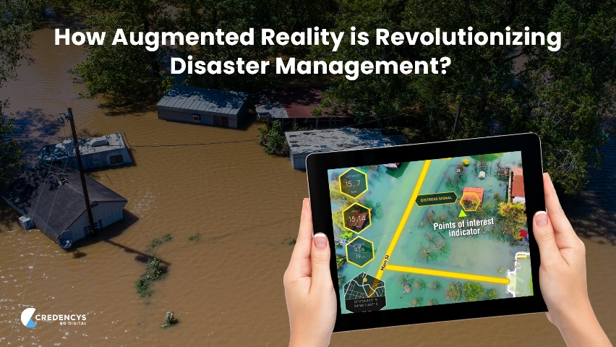Whether they are human-caused, natural, or hybrid ([Shaluf, 2007](https://www.frontiersin.org/journals/virtual-reality/articles/10.3389/frvir.2022.843195/full" \l "B75)), disasters are significantly responsible for the massive destruction of both life and property. Appropriate preparedness for disaster can make significant difference on society. Disaster management is “the body of policy and administrative decisions, the operational activities, the actors and technologies that pertain to various stages of disasters at all levels” ([Lettieri et al., 2009](https://www.frontiersin.org/journals/virtual-reality/articles/10.3389/frvir.2022.843195/full#B57)). Although technology is a single aspect of disaster management, it becomes apparent in the discussion that its role is intricately coupled with the rest of the aspects of disaster management. Within the disaster management field, VR and AR technology has discovered some unique opportunities in the areas of information communication, rapid damage assessment, reliable Building Information Modeling (BIM), and so on.

Augmented Reality (AR), Virtual Reality (VR) and Mixed Reality (MR), collectively called Xtended Reality (XR), are the application areas of computer graphics that allow the user to interact with the computer-generated imagery in both real and virtual environment scenarios. VR scenes consist of a fully virtual environment with virtual elements that obscure the physical environment, and simulate the physical objects whereas an AR scene consists of a real environment with integrated but non - dominating virtual objects that can react to the user and/or the scene ([Anderson et al., 2021](https://www.frontiersin.org/journals/virtual-reality/articles/10.3389/frvir.2022.843195/full#B4)). In addition, we consider an umbrella term MR to be synonymous to Augmented Virtuality where the virtual elements fuse with real elements to provide a perception of a single element to the user ([Girau et al., 2019](https://www.frontiersin.org/journals/virtual-reality/articles/10.3389/frvir.2022.843195/full#B38)). VR allows rapid prototyping at a low cost and early human-in-the-loop design ([Anderson et al., 2021](https://www.frontiersin.org/journals/virtual-reality/articles/10.3389/frvir.2022.843195/full#B4)). This allows the integration of physical systems in the simulation cutting down costs in the modeling and testing of the models. These features make these tools extremely useful for Disaster Management Applications. Various governmental agencies like New York Office of Emergency Management, Los Angeles Police Department (LAPD), DHS Federal Emergency Management Agency, etc. and academic institutions such as The University of Illinois at Chicago School of Public Health, the University of Minnesota Public Health Preparedness Center, the Johns Hopkins Office of Critical Event Preparedness and Response etc. are utilizing and exploring the applicability of the XR technology in Training activities ([Hsu et al., 2013](https://www.frontiersin.org/journals/virtual-reality/articles/10.3389/frvir.2022.843195/full#B43)).

Nevertheless, as developing technology, disaster management AR/VR systems, have some barriers to overcome such as efficient processing in low-cost XR, smart rendering, and minimizing motion sickness ([Kawai et al., 2016](https://www.frontiersin.org/journals/virtual-reality/articles/10.3389/frvir.2022.843195/full#B51); [Lovreglio et al., 2018](https://www.frontiersin.org/journals/virtual-reality/articles/10.3389/frvir.2022.843195/full" \l "B64)). Similarly, every disaster simulation designer needs to balance ecological validity and the potential psychological effect of a scenario.

This systematic review ([Borrego et al., 2014](https://www.frontiersin.org/journals/virtual-reality/articles/10.3389/frvir.2022.843195/full#B12)) seeks to add to the theoretical framework in the major trends of XR usage in disaster management by exploring the research questions below:

Q1. What are the trends of XR in Disaster Management Technology?

Q2. Why is XR preferred as a Disaster Management technology and what is its boundary?

Q3. What are the common research areas on the application of XR in disaster management technology?

Q4. What are the challenges and gaps in the literature in the application of XR in disaster management technology?

The paper starts with the reviewed papers’ demographics (Q1), search tactics, selection criteria, and classification based on their source. After that, it discusses the analysis of the reviewed papers based on their application focus (Q3) with an embedded report of the peculiarity and boundary of the XR (Q2). Then, it discusses the limitations of the research and suggests possible future research opportunities (Q4). This paper maps the recent and current application areas of XR technology in disaster response on the civil infrastructure. The paper performs a critical analysis of the conference and journal papers published from 2009 to 2019 and describes their focus, results, and problems. Finally, this paper provides directions for what the current literature does not address. The paper will be specifically useful to scientists and engineers with a research interest in advanced visualization and modeling applications in the area of emergency and disaster risk management.

The main objective of the Literature Review is to investigate the major research directions for the application of XR technology in disaster management. A significant amount of research papers were tracked in the review but no Literature Review papers in this interdisciplinary field were found.