**January 12, 2024**

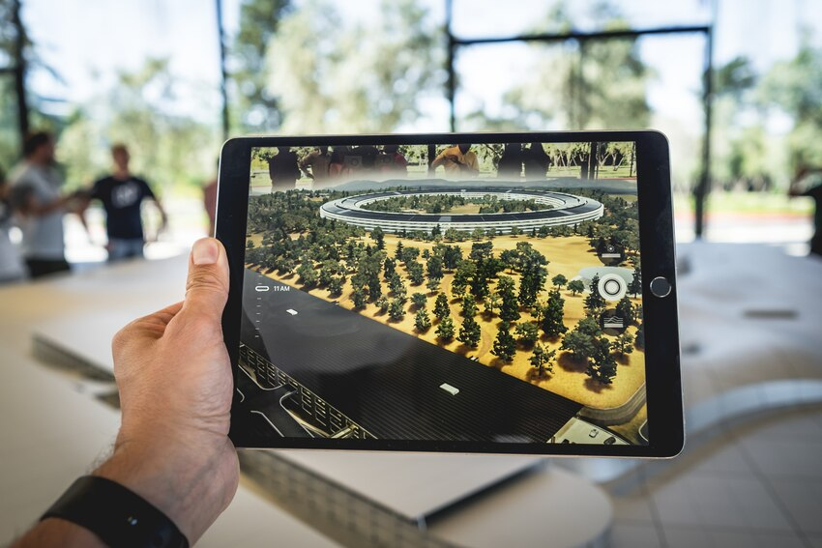

**Augmented Reality in Disaster Mitigation and Resilience: A Transformative Approach**

The advent of Augmented Reality (AR) technology has not only revolutionized the entertainment and gaming industries but has also found its way into critical areas such as disaster mitigation and resilience. FirstLine TaskForce approaches the narrative of “Readiness,” from two prospectives. First, is to develop a preparedness messaging network through AR edutainment experiences, secondly, by utilizing AR, with its ability to overlay digital information onto the physical world. The technology has become a powerful tool for enhancing situational awareness, improving decision-making processes, and ultimately contributing to more effective disaster response strategies.

**Enhanced Situational Awareness**

One of the primary ways in which AR contributes to disaster mitigation is by providing enhanced situational awareness to first responders and emergency management teams. AR-enabled devices, such as smart glasses or AR-equipped helmets, allow professionals to overlay real-time data onto their field of vision. This can include vital information like maps, building layouts, and live data feeds from sensors, enhancing their understanding of the disaster scene. This heightened awareness enables quicker and more informed decision-making, ultimately saving precious time in emergency situations.

**Simulation and Training**

AR is also instrumental in disaster preparedness through simulation and training. Emergency responders can use AR simulations to recreate various disaster scenarios, allowing them to practice and refine their response strategies in a controlled environment. This virtual training enhances their ability to handle complex situations and adapt to unforeseen challenges. Moreover, AR simulations can be utilized for community-wide disaster preparedness, educating the public on evacuation procedures and emergency protocols, fostering a more resilient society.

**Remote Assistance and Collaboration**

In the aftermath of a disaster, the ability to access real-time expertise remotely can be a game-changer. AR facilitates remote assistance by allowing experts to virtually “see” the disaster site through the eyes of on-site personnel wearing AR devices. This real-time collaboration can streamline decision-making processes and provide valuable insights, even when physical access to the affected area is limited. Such capabilities are particularly crucial in situations where immediate physical presence might be challenging due to safety concerns or logistical constraints.

**Damage Assessment and Resource Allocation**

AR technology aids accurate and efficient damage assessment following a disaster. Through the use of AR-enabled devices, responders can overlay digital markers on damaged structures, infrastructure, or hazardous areas, facilitating a comprehensive and detailed assessment. This information is invaluable for prioritizing response efforts and allocating resources effectively. By streamlining the damage assessment process, AR contributes to a more organized and targeted disaster recovery phase.

**Public Awareness and Communication**

AR applications also play a role in enhancing public awareness and communication during disasters. Mobile AR apps can provide real-time information, safety instructions, and evacuation routes to the general public. By leveraging AR for public communication, authorities can disseminate critical information in a visually engaging manner, ensuring that the message is not only received but also understood. This proactive approach helps in reducing panic, improving public compliance with safety measures, and ultimately contributes to building a more resilient community.

**Challenges and Future Outlook**

While AR holds immense promise in disaster mitigation and resilience, there are challenges to address. Issues such as the cost of AR devices, interoperability between different AR platforms, and concerns about data privacy and security need careful consideration. Additionally, continued research and development are essential to further refine AR applications for disaster management.

Looking ahead, the integration of AR with other emerging technologies like Artificial Intelligence (AI) and the Internet of Things (IoT) holds the potential to create more sophisticated and interconnected disaster response systems. As these technologies continue to evolve, the AR industry’s role in disaster mitigation is likely to expand, ushering in an era where the combination of digital and physical realities becomes an indispensable asset in safeguarding communities from the impacts of disasters.