Slippery Rock Park Civic
Association
Spring 2026
Hello Spring! Our community is going through changes with many new people to the community. This issue is dedicated to the historical work of the Association Members in the care of our community. This issue will hopefully explain who and what the Association is and does. New knowledge for some and a review for others. Hopefully we can inspire more newer people to become involved in the Association and our community. Together we are stronger. Together we are the Association. And remembering can be fun. Volunteer today!!
Janet Powell, SRPCA President
Janet794@gmail.com
724-406-0100
Our Mission Statement. The purpose Slippery Rock Park Civic Association is a Non-profit Corporation and is organized to promote social welfare within the meaning of section 501(c)(4) of the Internal Revenue Code including but not limited to promoting the health, safety, and welfare of the members of Slippery Rock Park and other property owners/renters adjacent to the territory tributary who own/rent at least one (1) qualifying property adjacent to said territory tributary, , and to promote the civic, social, educational, recreational, and economic interests of the people of Slippery Rock Park and those along the territory tributary. This corporation is not organized for profit, and no part of the net earnings of this corporation shall inure to the benefit of any member of the Board of Directors or any other individual, except that this corporation may make payments of reasonable compensation for services rendered. The corporation shall not intervene in any political campaign on behalf of, or in the opposition to, any candidate for public office to an extent that would disqualify it for tax exemption under section 501(c)(4) of the Internal Revenue Code. The corporation shall never be operated for the primary purpose of carrying on a trade or business for profit. This corporation does not anticipate and/or contemplate any pecuniary gain, or profit, incidental or otherwise. Notwithstanding any provision of these Article of Incorporation, this corporation shall not carry on any activities not permitted to be carried on by an organization exempt from federal tax income under section 501(c)(4) of the Internal Revenue Code of 1986 (or the corresponding provision of any future United States internal revenue law). 3.02 Public Benefit This corporation is a non-profit public benefit corporation and is not organized for the private gain of any person.

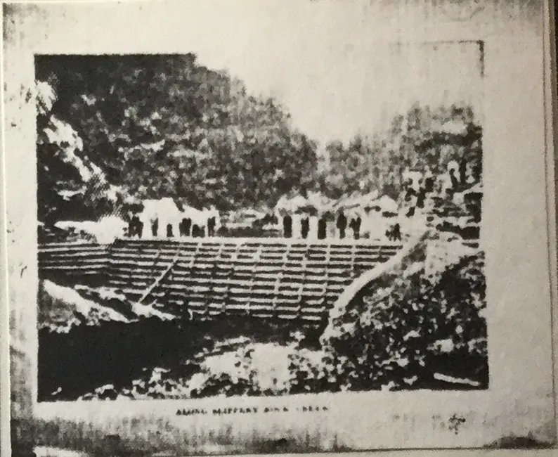

the Slippery Rock Park Civic Association — it’s a real, local community organization based in Slippery Rock, PA with a focus on neighborhood and recreational life:

🌟 What it is
The Slippery Rock Park Civic Association is a non-profit community group (organized as a 501(c)(4) corporation) that’s been around since the mid-1950s (incorporated August 23, 1955). It exists to promote social, recreational, and community welfare for people in the Slippery Rock Park area. They built a dam at Ralston road and route 173 after the old dam failed. The creek was just puddles and rivets of water and rocks.

🏘️ What we do
While full details are on the web site, Slipperyrockpark.com, some of the kinds of activities and highlights include:
Annual community events — a family picnic and seasonal social gatherings such as Happy Hour wednesdays.
Boating and creek activities — information on paddling or boating on Slippery Rock Creek within the association’s neighborhood and the broader boating community.
Local newsletters and email updates — keeping members informed about community happenings.
Social engagement and neighborhood support — part of their mission as a civic association.

🤝 What it’s for
Creates opportunities for neighbors to connect socially.
Helps organize community events and activities.
Advocates for local concerns or improvements.
Encourages a sense of shared identity and care for the area.
It’s a volunteer-driven community group focused on making the neighborhood around Slippery Rock Park a better place to live and gather — not a government body, but more of a neighborhood civic organization.
If you’re curious about membership, events, or how to get involved, the website (slipperyrockpark.com) has details and contact info.

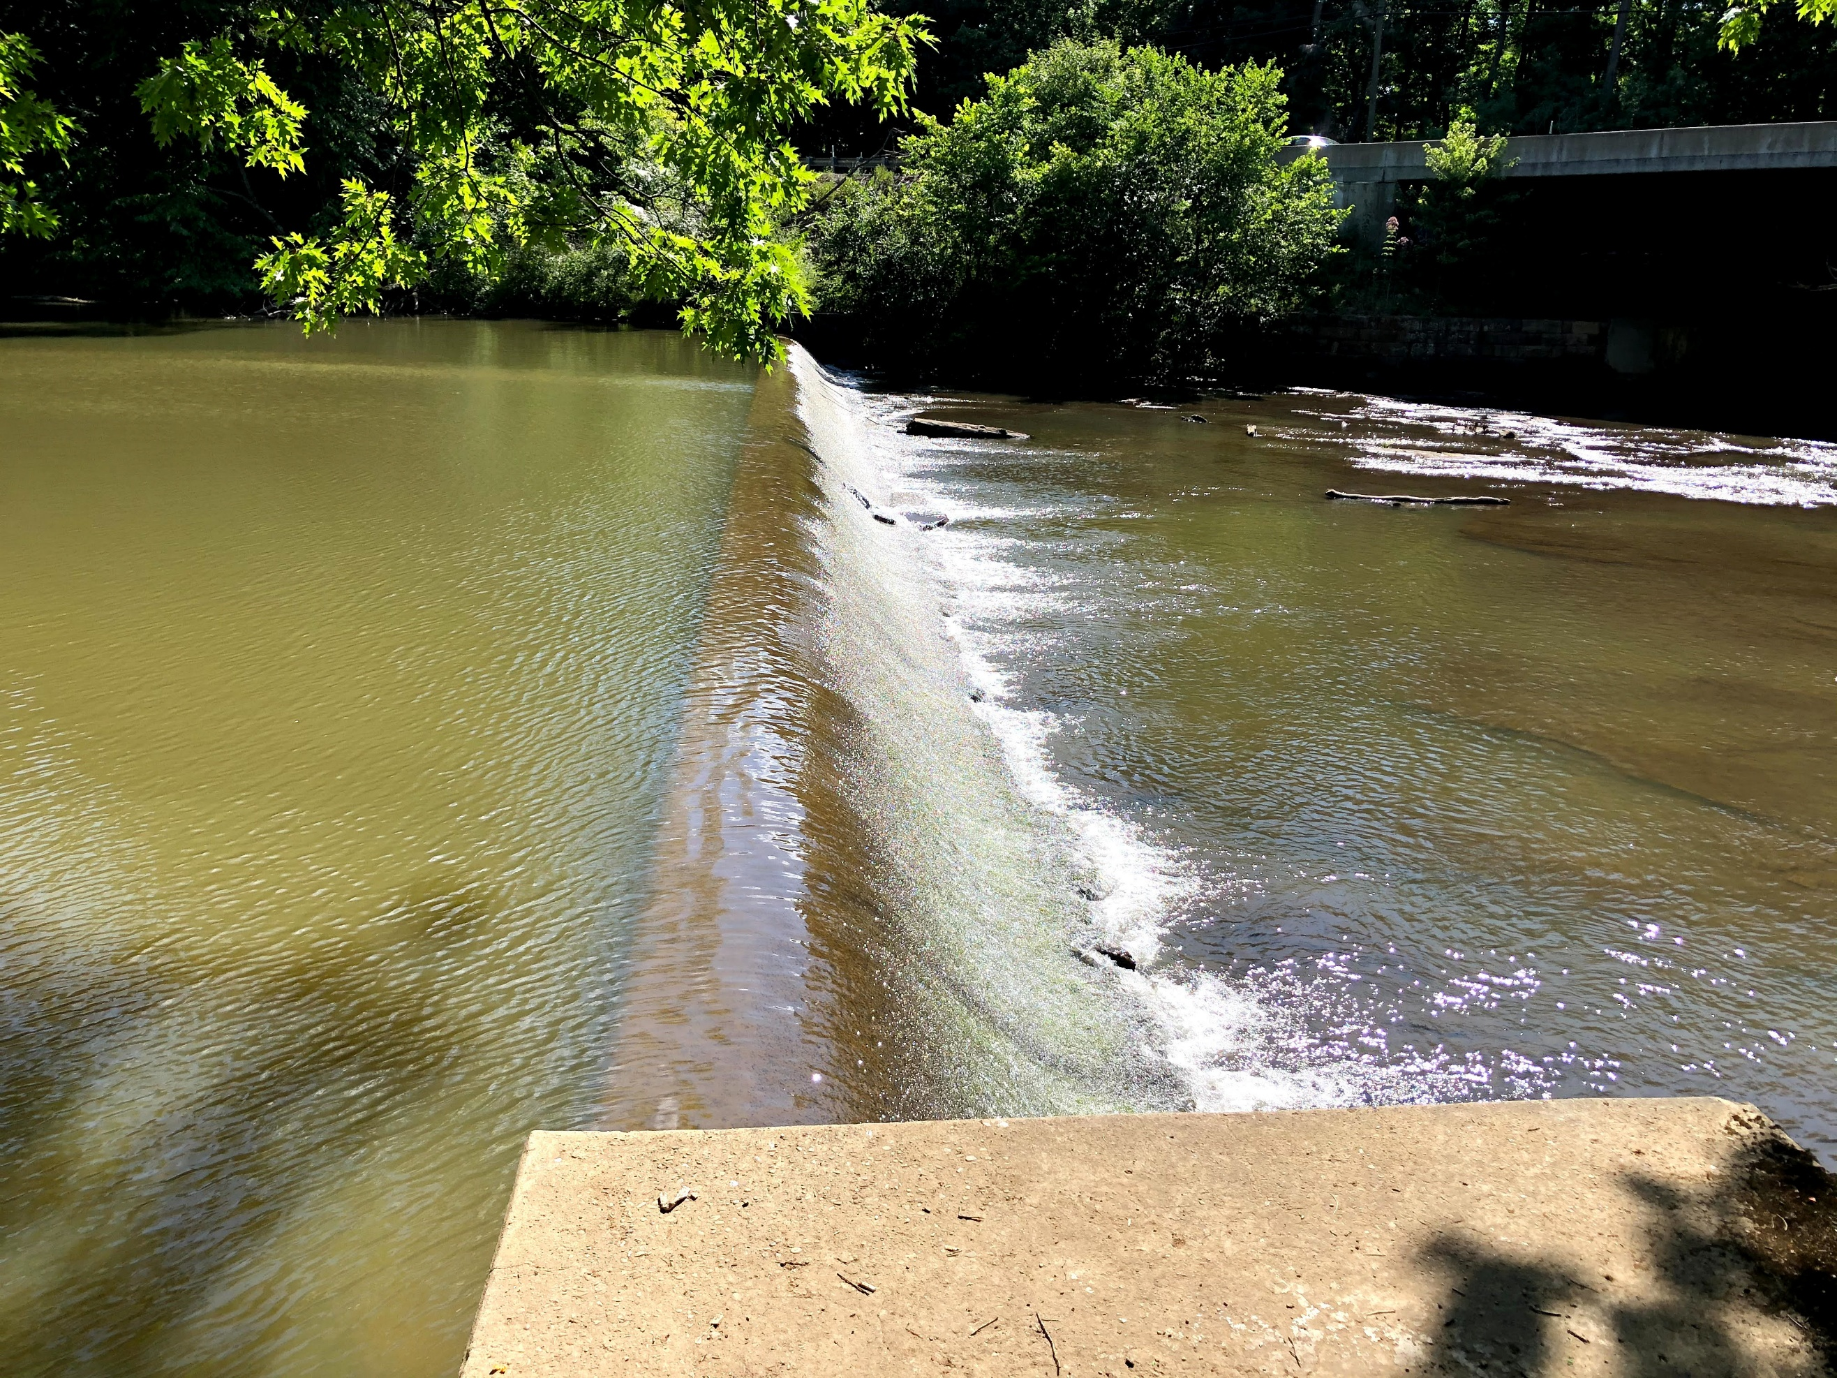
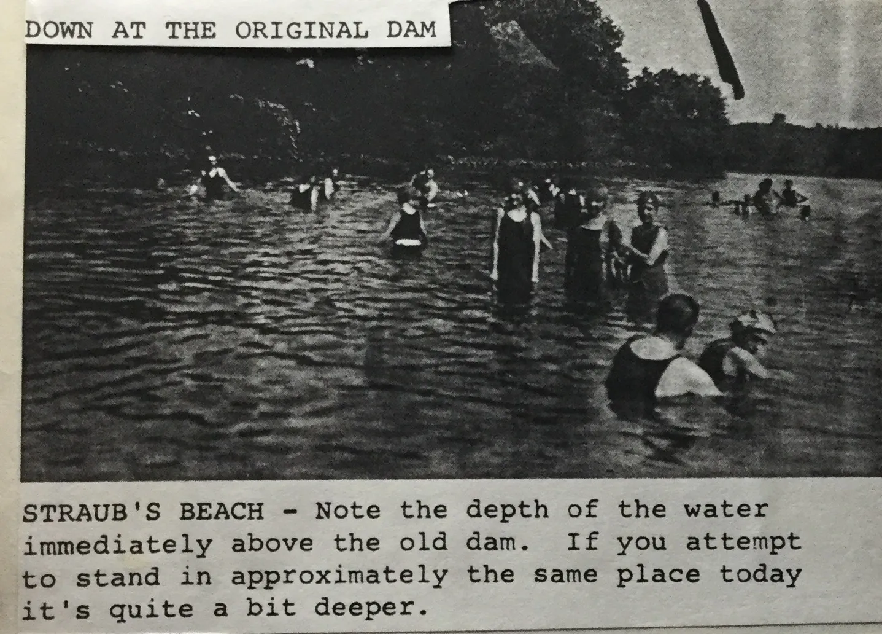
What is a 501(c)(4)
A 501(c)(4) is a type of nonprofit organization recognized by the IRS. It’s officially called a “social welfare organization.”
Here’s the plain-English version:
What is a 501(c)(4)?
It exists to benefit the community as a whole, not to make money for individuals
Common examples: civic associations, neighborhood groups, advocacy organizations, community improvement groups.
The group’s primary purpose must be social welfare (quality of life, safety, community interests, etc.)
What it can do
Advocate for issues (like zoning, parks, community concerns)
Engage in some political activity (as long as it’s not their main purpose)
Lobby for or against legislation related to their mission
Run community events, meetings, and programs
What it cannot do
It cannot exist primarily to influence elections
It cannot distribute profits to members or leaders
Tax details (important difference)
The organization does not pay federal income tax on income related to its mission
Donations are usually not tax-deductible for donors (this is a big difference from a 501(c)(3))

How it differs from a 501(c)(3)
501(c)(3) | 501(c)(4)
Charitable | Social welfare
Donations are tax-deductible | Donations usually are not
Very limited political activity | More flexibility to advocate
Examples: charities, churches | Civic associations, advocacy groups
Why civic associations use 501(c)(4)
Neighborhood or civic groups (like the Slippery Rock Park Civic Association) often choose 501(c)(4) status because it lets them:
Speak up on local issues
Represent residents’ interests
Organize socially and advocate when needed

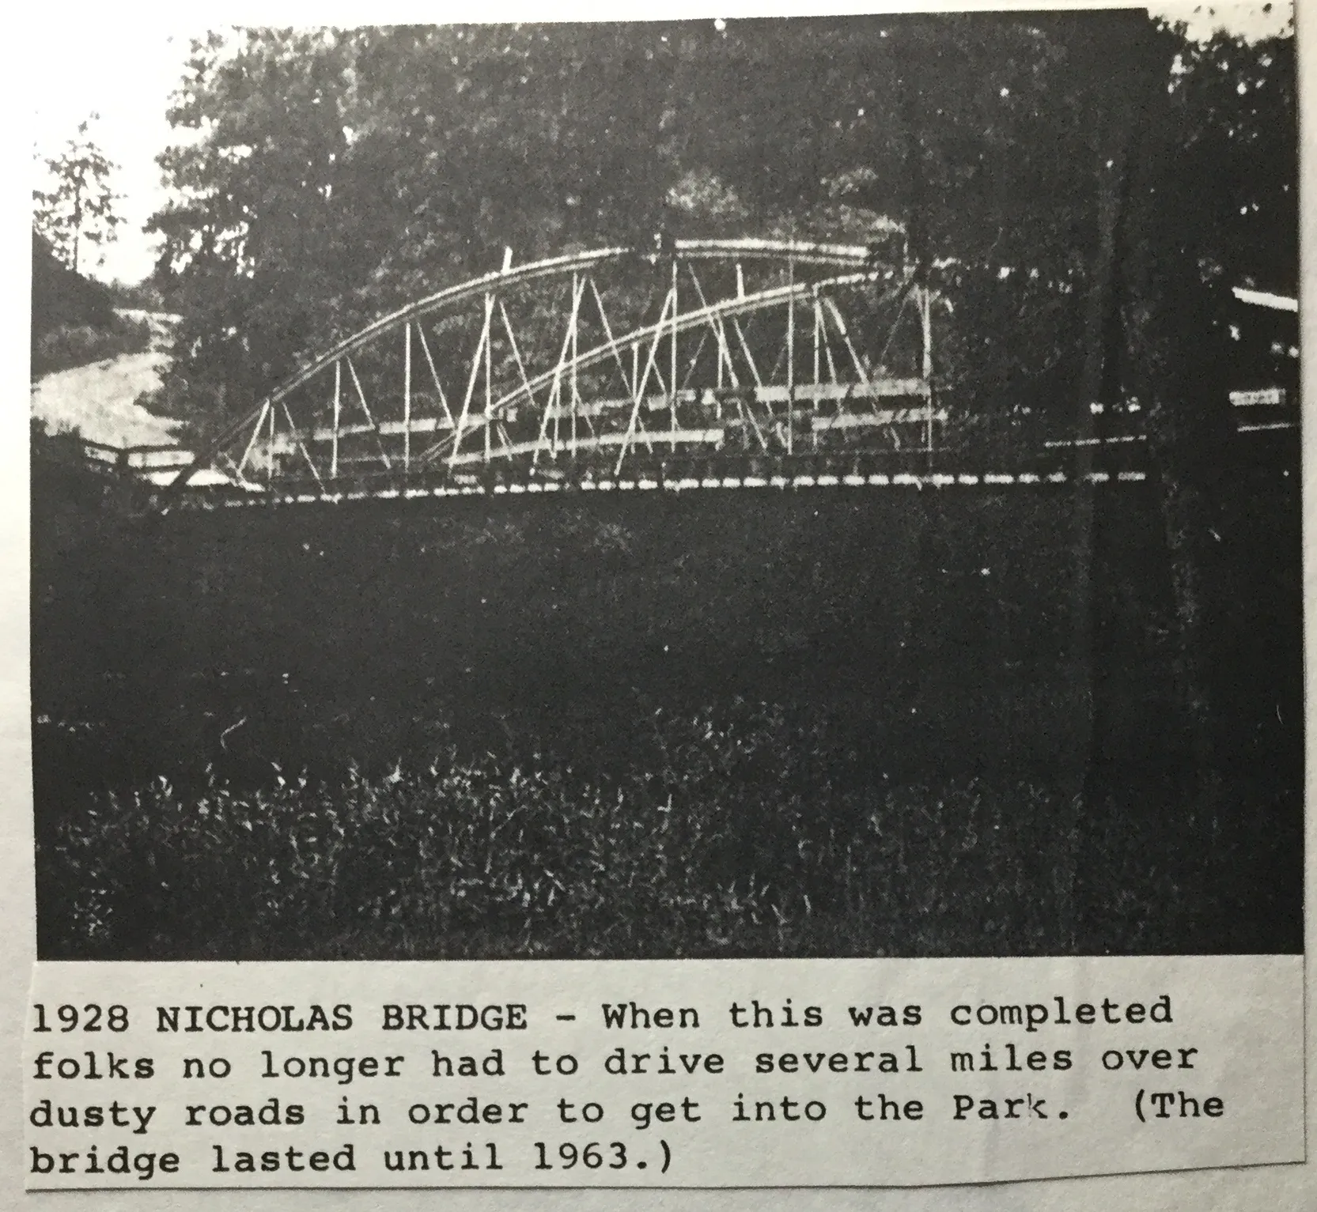
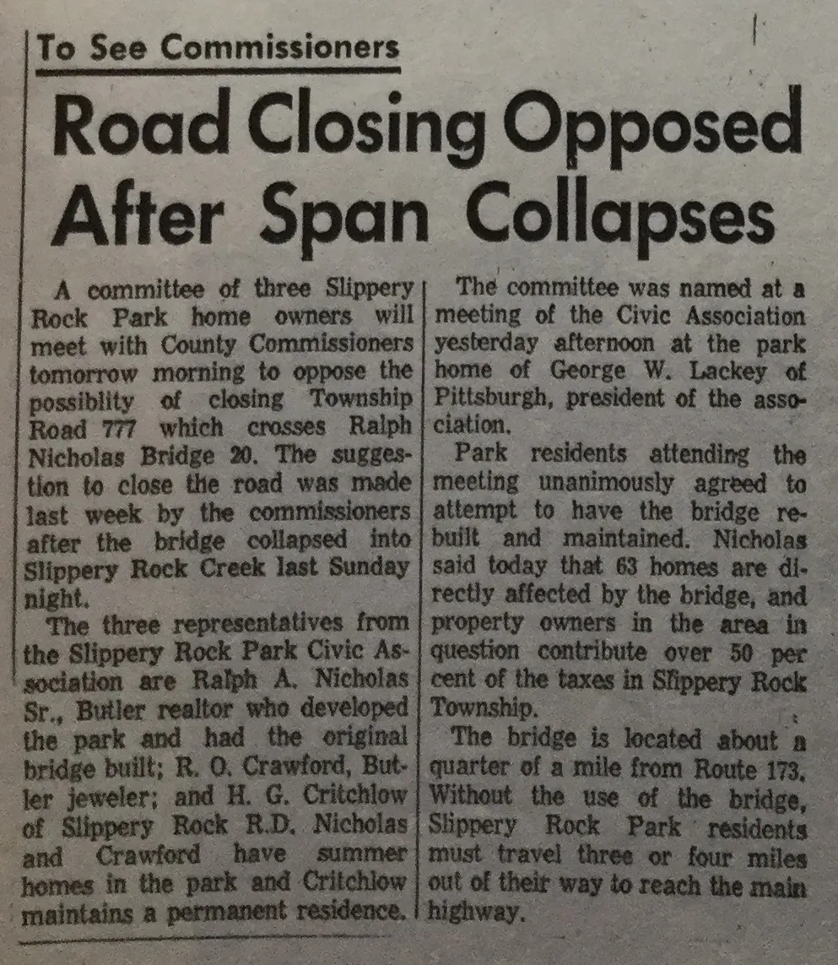
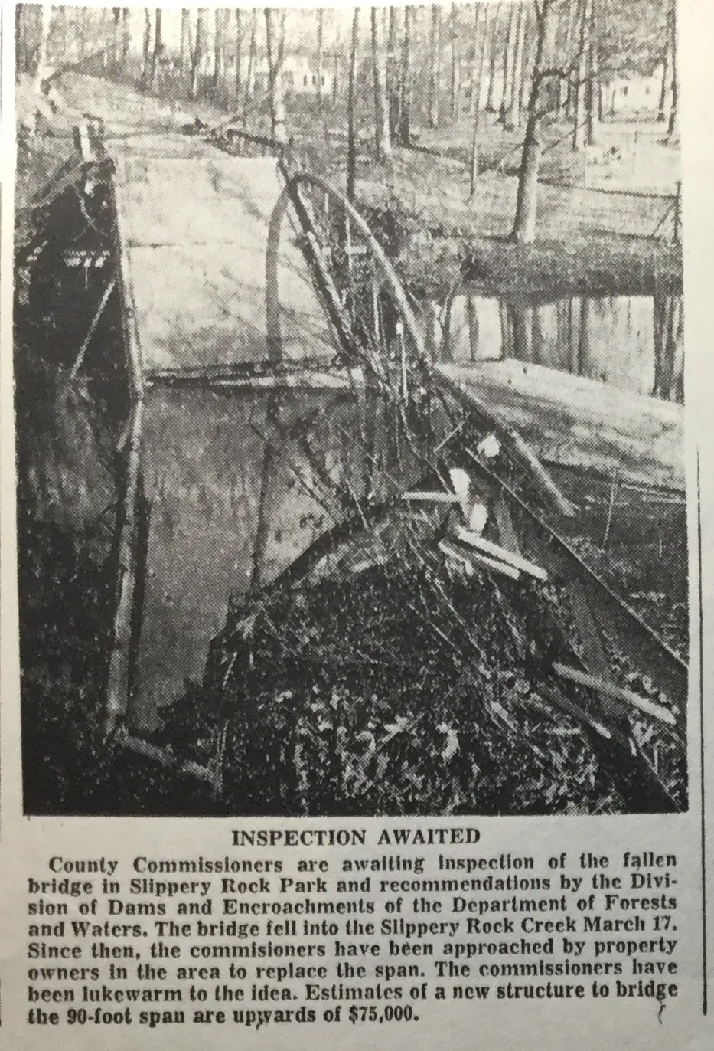
What is the Reserve Tract?

The reserve tract along Slippery Rock Creek means land next to (or near) the creek that is intentionally set aside and restricted from normal development.
What it’s usually reserved for
Along a creek like Slippery Rock Creek, a reserve tract is commonly designated to:
🌿 Protect the creek and floodplain (erosion control, water quality, wildlife habitat)
Allow access for tree removal

🌊 Allow for flooding without damaging homes or infrastructure. Not building on the Reserve Tract prevents excess refuse from entering during a flood and piling up behind the dam causing stress to the dam.
🚶 Preserve access to the creek for residents with inner lots.
🛑 Prevent unsafe or inappropriate development in flood-prone or environmentally sensitive areas

What it is not
Not a privately buildable lot. Ask permission to build anything. Most often permission is granted when asked. Just put in a gate.
Not usually taxable or usable like standard property
Not a park unless officially dedicated as one
Not meant for permanent structures

How it shows up legally
On subdivision plats or zoning maps, a reserve tract is often labeled as nothing, shows blank ownership. The community, the Association owns the ever changing creek banks. The Reserve Tract is governed by deed restrictions. One might need to do a Title search to find the language on the original Deeds. This type of verbiage often gets dropped off current Deeds, but still legally applies.

Bottom line
The Reserve Tract along Slippery Rock Creek is land deliberately kept undeveloped to protect the creek, allow access to remove fallen trees, manage flooding, and preserve natural space.
The core purpose is conservation and protection, not development.

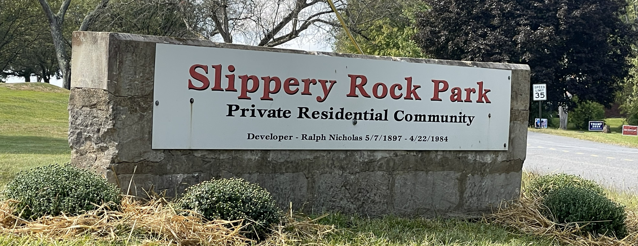
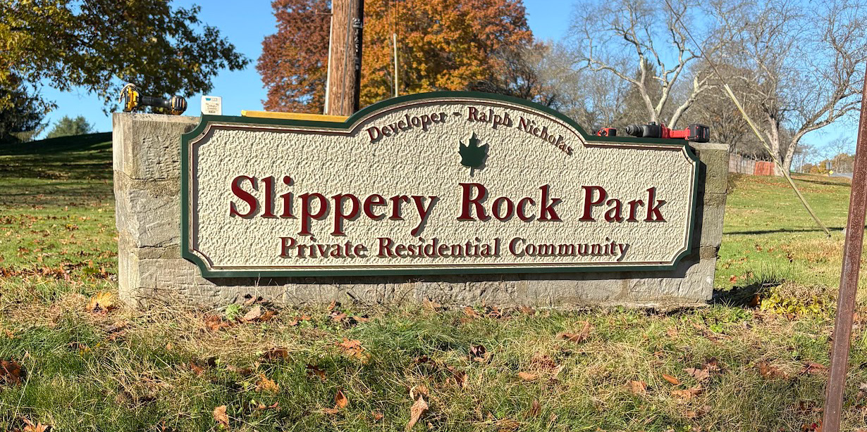
Please consider volunteering for our Committees
Litter Gitter Day
Yard Sale
Creek Clean Up
Annual Picnic
We are in need of your assistance in maintaining an active Association for the community. Please contact Janet Powell to volunteer for any Committee. We need a Chairperson for the Yard Sale Committee this year.

Regular maintenance of your septic system is a necessary part of home maintenance. Regular maintenance will not only extend the life of your system, but will also help ensure our creek remains a valuable asset to our community!
Check the list of resources for the name of a local “Honey Dipper” to pump your system as needed.

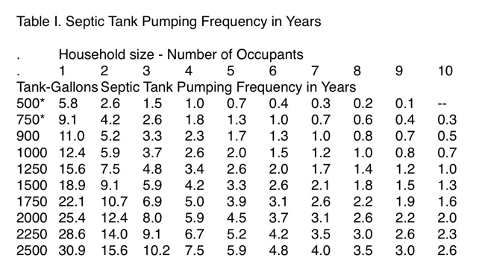

Slippery Rock Township Office: 724-794-2369
Slippery Rock Township Sewage Enforcement Officer: Doug Duncan 724-679-4860
If one is having septic issues there are options for our area depending upon existing soil conditions. A permit is required for all new, repaired, or replaced systems. Soil testing determines the type of system that may be installed with proper permits.
*Traditional Individual lot systems with septic tank and field drains
*Elevated Sand Mound for shallow soils and/or high water tables
*Small Flow Treatment Facility is a miniature private sewage treatment plant for homes that cannot support a Traditional or Sand Mound systems.
Maintaining your system is the best way to ensure decades of getting rid of your waste!!

How to be a good neighbor
Being a good neighbor is mostly about small, steady kindnesses—not grand gestures. Here’s what really makes a difference:
1. Be friendly, not intrusive
A smile, a wave, or a quick “good morning” goes a long way. You don’t have to be best friends—just warm and respectful.
2. Respect shared spaces. Keep noises reasonable, clean up after pets, be mindful of barking dogs, park considerately, turn out outside lights. Quiet consideration builds trust fast.
3. Communicate early and kindly. If there’s ever an issue (noise, parking, fences, pets), a calm, friendly conversation beats resentment every time.
4. Lend a hand when you can.Collect a package, bring in trash cans, check in during extreme weather, or help during an emergency. These moments stick.
5. Be reliable.If you offer help, follow through. Reliability makes people feel safe around you.
6. Mind boundaries.Everyone has different comfort levels. Being a good neighbor includes knowing when to give space.
7. Practice everyday decency.Hold doors, return misdelivered mail, say thank you, apologize if you mess up. Simple, human stuff.
8. Look out for one another. You don’t have to pry—just notice. A quick “You okay?” or “Need anything?” can mean more than you realize.
At its core, being a good neighbor is about making the people around you feel respected, seen, and at ease. You don’t need to be perfect—just consistently kind.
The Pavilion at the Beach can be reserved for private parties. There is no charge for Members, and $25.00 for non-members.
Contact Janet Powell for further information.
724-421-7425
janet794@gmail.com
When using the beach and facilities, please remember to pick up after yourself, and take your trash with you. Please respect the neighbors located near the beach.

Please be sure to check our web site, which has a tremendous amount of resources and information www.slipperyrockpark.com
Also:
facebook.com/SlipperyRockParkCivicAssociation

A short list of local community resources:
Agway Water Treatment Services 800-458-5587
Book and Proch Well Drilling 724-652-9861
Book and Book Well Drilling 724-654-3861
K and M Septic Tank Service 724-735-2978
B and L Air Conditioning, Heating, and Plumbing Services , Shawn Ireland 724-794-5484
Armstrong Comfort Solutions 866-290-8938
Laskowski Plumbing 724-282-2521
Nemcheck 724-426-3210
Stone Brothers Construction 724-290-2845
Workman Remodeling 724-496-9262
HandyMan Justin Skarbek 724-822-5708
A-1 Piano Service, Bill Glesner, 412-367-3155

2026 Dates to remember:
Association Board of Directors’ Meeting: Sunday, May 3rd, 2pm at the Powell’s.
Annual Dumpster: The week before and after the Yard Sale.
Annual Yard Sale: Saturday, May 16th.
Annual Corporation meeting and Family picnic: Saturday, August 1st. This year the picnic will be held at the Beach area as we did last year. We will be doing a traditional Pot Luck style meal with all the usual fun games.
Creek Cleanup: The second Saturday in June, July and August. Meet at the beach at 9am

