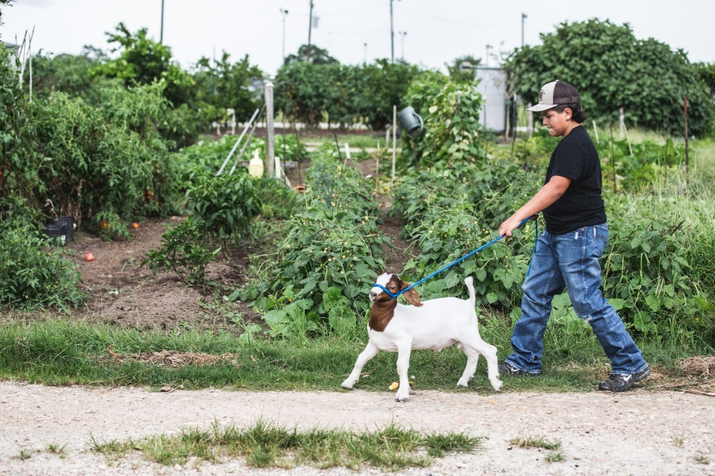

Hello there!

My name is Joe Smith and I this is my seventh year in Lane County 4-H. In 4-H, I show swine and goats, along with photography, welding, baking, and horticulture. Additionally, I am a Lane County 4-H Ambassador. I love 4-H! Outside of 4-H, I enjoy hiking, reading, practicing piano, and playing soccer and tennis. I am a sophomore at Springfield High School, and am a part of their National Honor’s Society.

My favorite 4-H memory is participating in the Coastal Farm and Ranch Father’s Day BBQ. At this event, 4-H runs a BBQ, 4-H outreach booth, small petting zoo, and a book drive to donate books to local libraries. This event showed me the importance of community and giving back. It was so fun to meet new people from my community, as well as share the great opportunities 4-H has to offer with the community.

This year in 4-H, I am raising a market goat named Bear. Bear and I have had so much fun together this year. We go for walks twice a day, occasionally he likes to turn it into a run! I feed Bear Purina Honor Show feed for goats. He also gets hay and minerals. Bear has taught me responsibility and compassion. I have greatly enjoyed raising a 4-H market goat and look forward to doing it again next year.

I would like to invite you to join Bear and I at the Columbia County Fair for the 4-H and FFA youth auction. This will be on Saturday, July 22nd at 2:00 PM. You can come early to walk around the barns and visit Bear and I at his pen. We’d love to chat with you!

I appreciate your support for me and Columbia County 4-H! Have a great day!

Joe Smith

Joe Smith

Springfield 4-H Community Club

541-555-5555