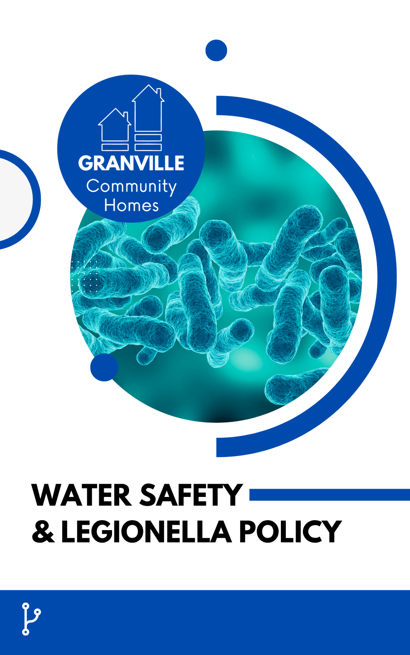

Version: 0.2
Approved: 01/08/2026
Review Date: 01/08/2027
Policy Reference: HS09

Contents
Section 1
Granville’s Policy Statement……....………………………………...……………………………………...……....2
Section 2
Policy Context
Purpose…………….…………………………………………………………………………………….………………2
Scope…………………………….………………………………………………………………………………………..2
Definitions………....…………………….………………………………………………………………………………3
Legal & Regulatory Framework.….………………………………………………………………………………3
Section 3
Roles & Responsibilities
Board of Directors....………………………………………………………………………………………………….3
CEO………………………………………………………………………………………………………………………...3
COO………………………………………………………………………………………………………………………..3
Housing Manager……………………………………………………………………………………………………...3
Data & Audit Officer………………………………………………………………………………………………….3
Managing Partners..…………………………………………………………………………………………………..3
Section 4
Management Plan
Assessment & Control Measures.………………………………………………………………………………...4
Voids & Low-Use Properties...……………………………………………………………………………………..4
Monitoring, Reporting & Assurance……………………………………………………………………………..4
Section 5
Equal Opportunities………………………………………………………….……………………………………….4
Section 6
Related Documents……………………………………………………………………………………………….......5
Section 7
Revision History & Document Control………………………………….………………………………………5

Section 1 – Policy Statement
Granville is committed to managing the risks associated with Legionella and other waterborne hazards across its homes and schemes, taking a proportionate, risk-based approach to protect residents, staff, contractors, and visitors.
A suitable and sufficient Legionella risk assessment will be completed for properties and schemes where the design, operation, or use of the water system presents a material risk. Particular consideration will be given to shared and supported housing containing communal water systems, storage tanks, showers, complex pipework, or outlets that may be used infrequently. Risk assessments will be undertaken by a competent person and reviewed at the frequency identified within the assessment, or sooner where there are significant changes to the water system, occupancy, building use, or other circumstances that may affect the level of risk.
Control measures identified through the risk assessment will be implemented and recorded in accordance with the required frequency. These may include monitoring water temperatures, flushing little-used outlets, cleaning and descaling showerheads and associated fittings, inspecting water storage systems, and taking appropriate corrective action where required standards are not achieved.
Responsibility for water safety controls will be clearly established for each property, taking account of the respective obligations of Granville, the property landlord, and any managing partner. Where another party undertakes monitoring or control activities, Granville will seek appropriate assurance that required measures are being completed and that identified concerns are escalated and addressed.
Particular attention will be given to void properties, vacant rooms, and outlets that are used infrequently, as periods of low water use can increase the risk of stagnation and bacterial growth. Appropriate flushing, monitoring, and recommissioning arrangements will be implemented before affected accommodation is brought back into regular use. Records of risk assessments, monitoring, control measures, remedial actions, and relevant responsibilities will be maintained to provide assurance that water safety risks are being effectively managed.

Section 2 – Policy Context
Purpose
This policy sets out how Granville manages the risk of legionella and other waterborne hazards in its properties, particularly in shared supported schemes with communal water systems, in line with the HSE's L8 Approved Code of Practice.
Scope
Granville Community Homes ("Granville") is a registered provider whose stock is predominantly held on head-leases and let as supported/exempt accommodation. Day-to-day repairs and safety compliance activity for leased properties is typically split between the landlord (structural/major repairs, per the lease) and the managing partner or Granville (responsive repairs, certificate scheduling and reporting), so clear allocation of responsibility in the lease and management agreement is essential to safety compliance. This policy applies to every scheme with a water system presenting a legionella risk, with particular focus on shared/communal supported accommodation where risk is typically higher than in a single-household dwelling.
Definitions
Legionella risk assessment: the assessment identifying legionella risk in a property's water system and the control measures required to manage it.
Legal & Regulatory Framework
This policy is drafted to give effect to, and should be read alongside, the following:
- Health and Safety at Work etc. Act 1974
- HSE Approved Code of Practice and guidance L8 (Legionnaires' disease: the control of legionella bacteria in water systems)
- RSH Safety and Quality Standard

Section 3 – Roles & Responsibilities
Board of Directors: Receives the annual water safety compliance summary; holds the CEO to account for legionella risk management across the portfolio.
CEO: Accountable for water safety compliance; escalates to the relevant authority if a legionella-related incident poses a risk to residents.
COO: Ensures a current legionella risk assessment is in place for every scheme where required; oversees the water management plan programme; allocates duty-holder responsibilities in management agreements.
Housing Manager: Maintains the legionella risk assessment register; coordinates access for risk assessments; ensures water management plans (including temperature monitoring and flushing regimes for infrequently used outlets) are being implemented by managing partners.
Data & Audit Officer: Tracks legionella risk assessment currency and monitoring log dates; alerts the Housing Manager to assessments due for renewal; records monitoring outcomes.
Managing partners: Implement the water management plan for their scheme; carry out and record routine temperature monitoring and flushing; report any suspected legionella concern or incident to the Granville COO immediately.

Role | Responsibility under this policy
Asset / Compliance Lead | Maintains the legionella risk assessment register and tracks control measure completion across the portfolio.
Managing Partners | Carry out routine control measures (flushing, temperature checks) to schedule and report any suspected case of illness linked to water systems immediately.

Section 4 – Management Plan
Assessment & Control Measures
- Legionella risk assessments are commissioned from a competent assessor for relevant schemes and logged on the central compliance register.
- Routine control measures (temperature monitoring, flushing of low-use outlets, tank inspection) are scheduled and evidenced.
Voids & Low-Use Properties
- Any void or infrequently occupied property is flushed on a defined schedule to reduce stagnation risk, coordinated with the voids management policy.
Monitoring, Reporting & Assurance
- Legionella risk assessment coverage and control measure completion are reported to the Board at least annually.
- Any suspected case linked to a Granville property is investigated immediately and considered for regulatory self-referral.

Section 5 – Equal Opportunities
Granville Community Homes is committed to promoting equality, diversity and inclusion in all aspects of its work. We will provide equal opportunities in employment and service delivery and will not unlawfully discriminate against employees, residents, applicants, contractors or any other individual on the grounds of any protected characteristic under the Equality Act 2010.
Granville is committed to treating everyone fairly, with dignity and respect, and to making reasonable adjustments where required to support disabled employees, residents and others with additional needs.
This policy has been developed in accordance with the Equality Act 2010 and is intended to be applied consistently and fairly. An Equality Impact Assessment will be completed before the policy is submitted to the Board for approval.

Section 6 – Related Documents
The following laws, legislation, and standards have been considered in accordance with the composition of this policy:
- Regulatory Reform (Fire Safety) Order 2005
- Decent Homes Standard / Government Decent Homes Guidance.
- Control of Asbestos Regulations 2012
- Control of Substances Hazardous to Health Regulations 2002 (COSHH)
- Building Safety Act 2022
- Health & Safety Rating System (HHSRS)
- Housing Act 2004
- Equality Act 2010
Other documents relevant to this policy from Granville’s Policy Suite include:
- Corporate Health & Safety Policy (HS02)
- Repairs & Maintenance Policy (HM02)
- Voids & Empty Homes Management Policy (HM06)
- Stock Condition & Asset Management Strategy (PC03)

Section 7 – Revision History & Document Control
Version | Date | Author | Summary of Changes | Approved By
0.1 | 06/07/2026 | Policy suite build project | Initial draft – not yet approved | Pending Board approval
0.2 | 01/08/2026 | Policy suite build project | Company branding and improved policy structure – not yet approved | Pending Board approval
This policy will be reviewed Annually, or earlier if there is a relevant change in legislation, regulatory requirements, or Granville's operating model (including material change to the partner/lease-based portfolio).

