**Volume 13 Issue IX Johnston Square Journal April, 2023**

**Johnston Square Journal**

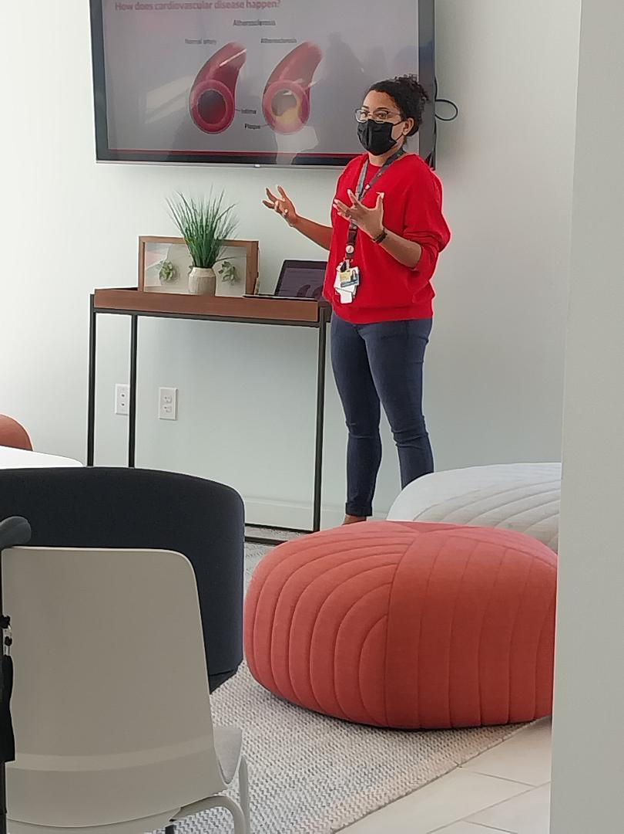

**February was Healthy Heart Month**

On Tuesday, February 14th, 2023; Valentine’s Day the Rebuild Johnston Square Neighborhood Org. hosted an healthy heart event at 700 E. Chase Street Apartment office.

Our presenters were our partners EBMC, The Brancati Center, Holistic Wellness, and the 6th Branch!! With presentation on Heart Health and a cooking demonstration and tasting, and fresh vedetables on hand for all who were in attendance.

We would like to thank all that attended 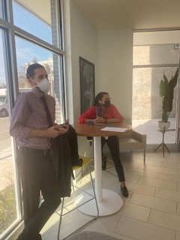

**Watch us grow!**

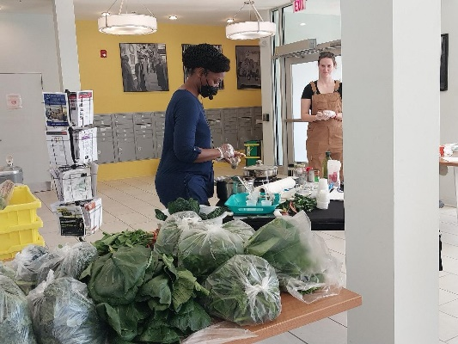

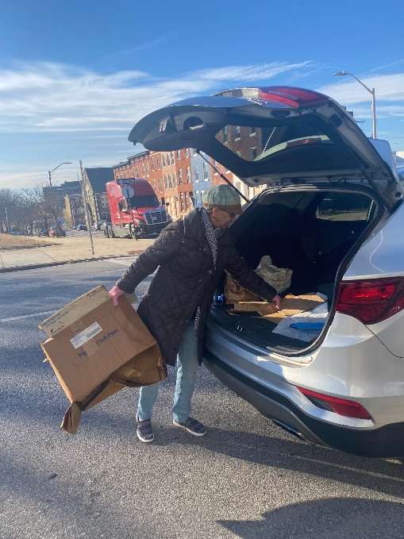

**Residents come together to clean up our community**

On Saturday, January 28th, community members come together fill our first dumpster of 2023. Neighbors helping neighbors loading the dumpster and bringing stuff to the dumpster.

On Saturday, April 8th, 2023 again neighbors packed another dumpster, I don’t know if it was because of tax time (lol) on Spring cleaning, but we got the job done filling up another dumpster.

I would like to Thank the volunteers who stayed and help load the dumpster, the neighbors who helped fill the dumpster and the Green Team for devoting their time and help in making this a successful event.

Stay tuned for this next date.

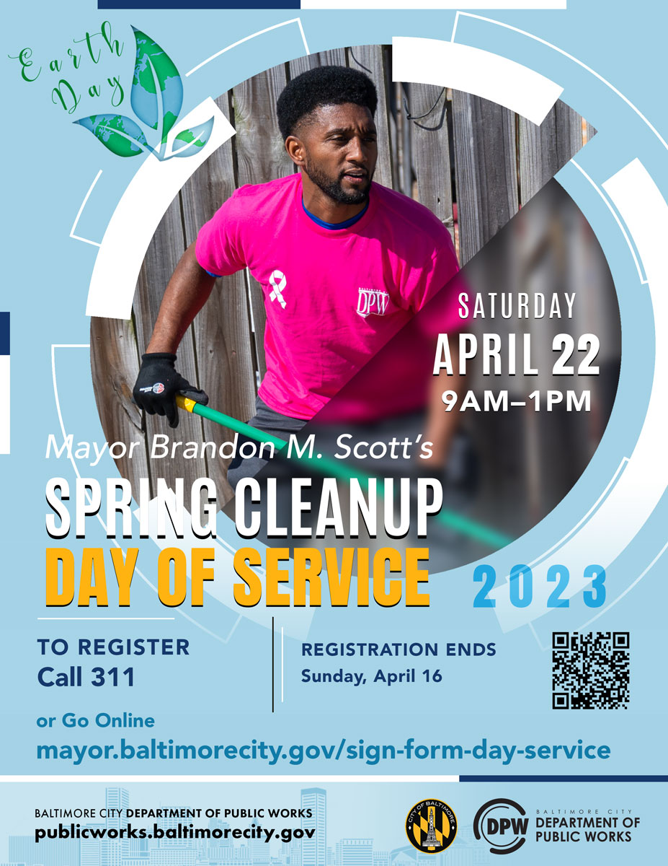

Rebuild Johnston Square Neighborhood Org.

Community meetings are

The Second Monday of each month at 6:30 PM – 7:30 PM

At Open Works Building

1400 Greenmount Avenue

Baltimore, MD 21202

Rebuild Johnston Square Neighborhood Org.

700 East Chase Street

Baltimore, MD 21202

Open: Mondays…10:00 AM until 3:00 PM

Or by appointments

[www.rebuildjohnstonsquare.com](http://www.rebuildjohnstonsquare.com)

Facebook: Re-Build Johnston Square

410.870.4834

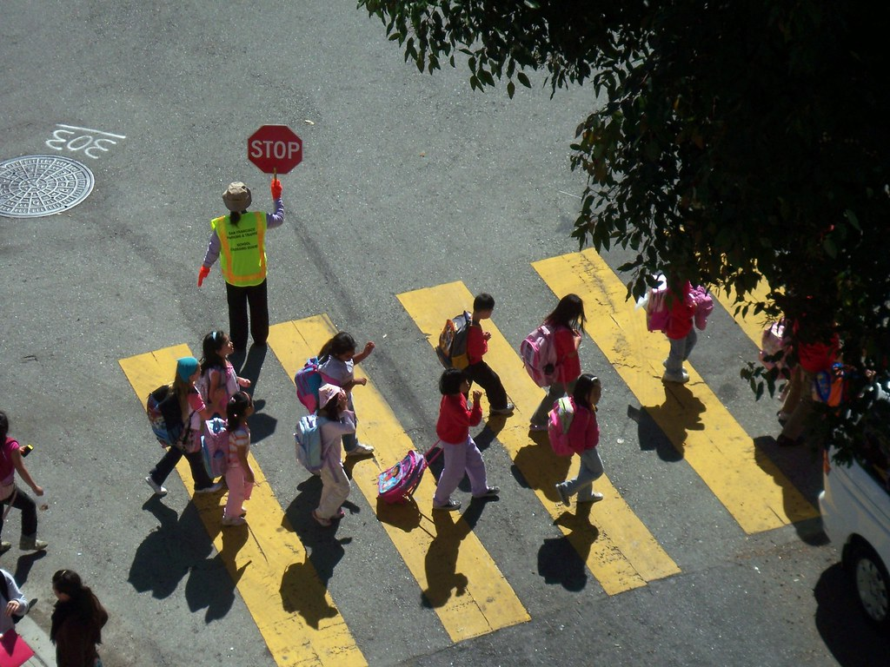 

**Have A Business**

**You can place an ad in**

**Our bi-monthly newsletter**

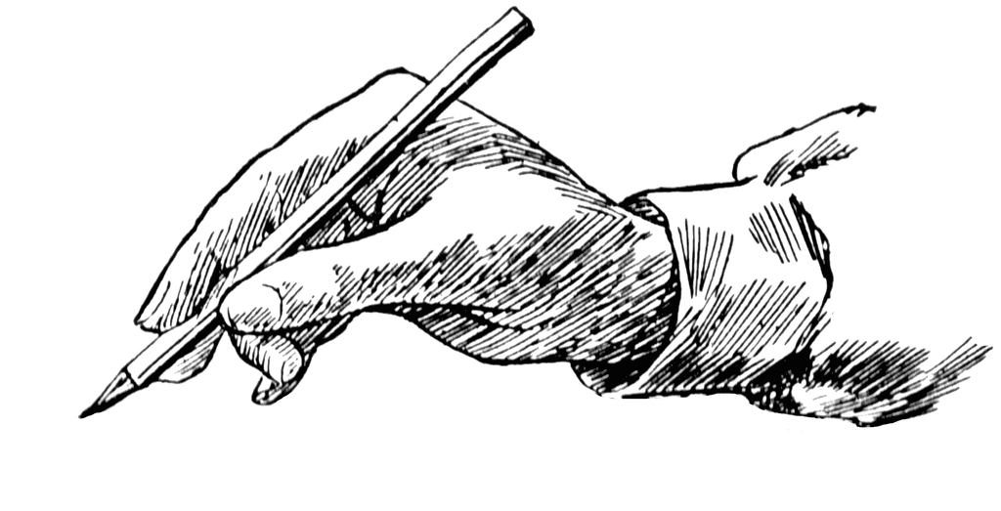

1/4 Page

You supply the content and any

artwork

$5.00 per issue

Must be submitted 2 weeks before publication.