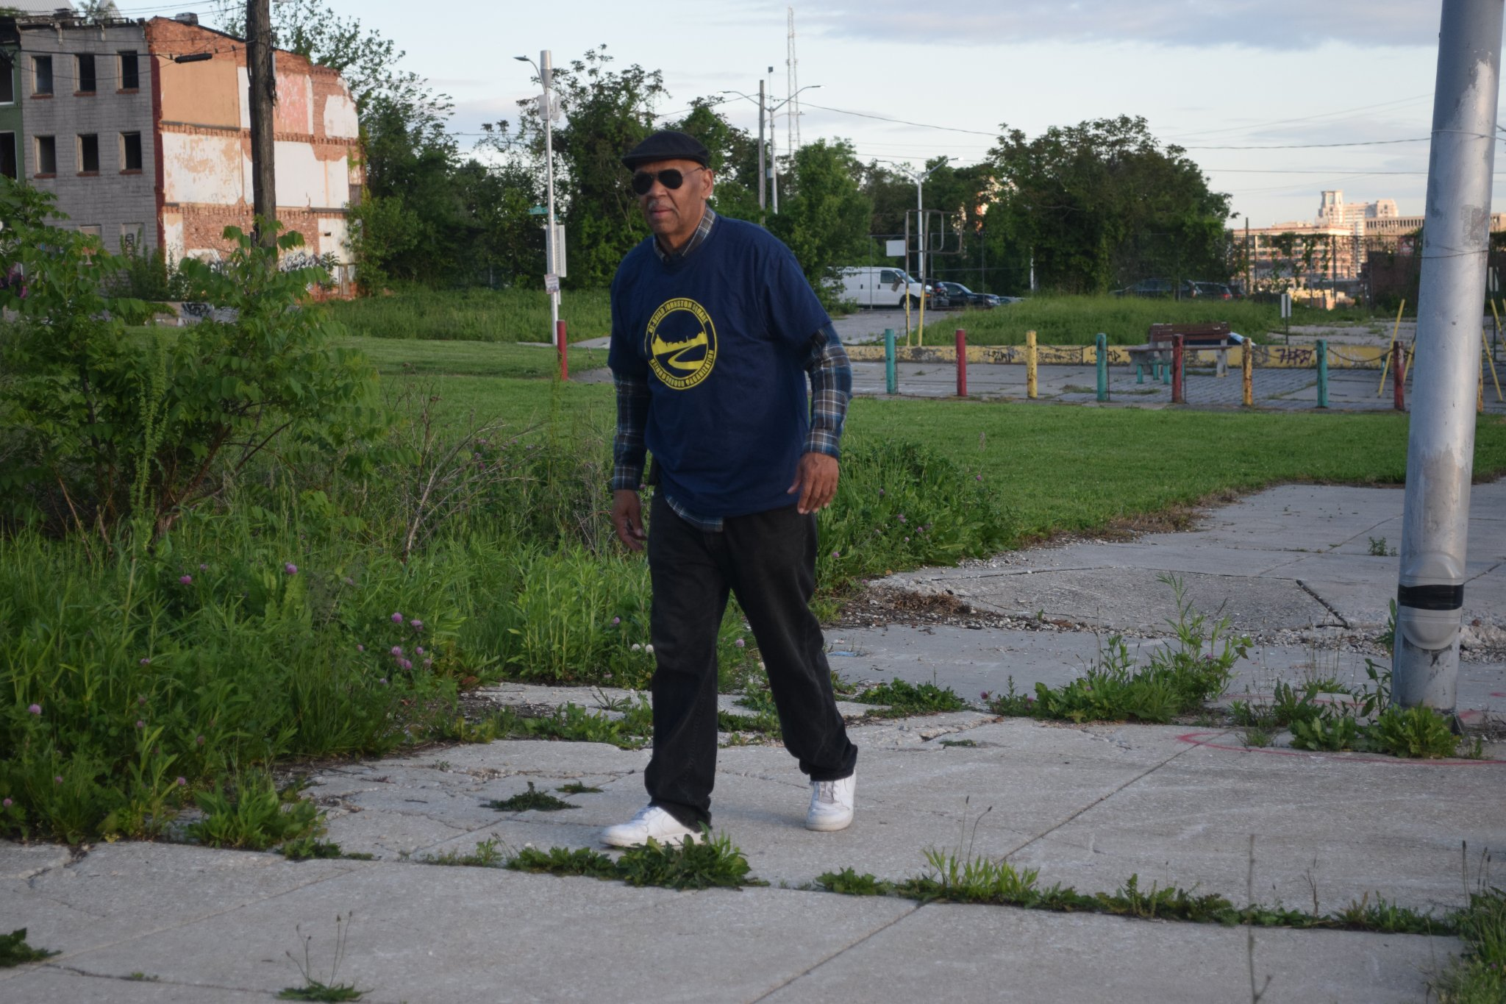

This month I would like to honor Mr. Keith Hammond (Mr. Johnston Square). Mr. Hammond can be seen all over the community cutting grass, cleaning alleys, weeding tree pits, doing all the things that DPW should be doing. Sometimes alone or with his Green Team. Mr. Hammond coordinates with volunteer groups that comes in the community to perform numerous activities. Keith is normally the first to arrive at all events to setup and the last to leave with the cleanup.

So, if you happen to see Keith in the community or at a meeting stop wish him a Happy Belated Birthday and Thank him for keeping our community clean.

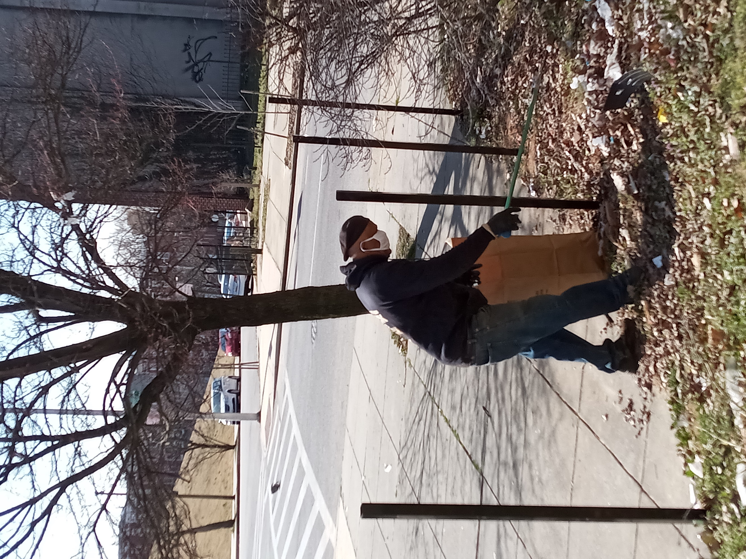 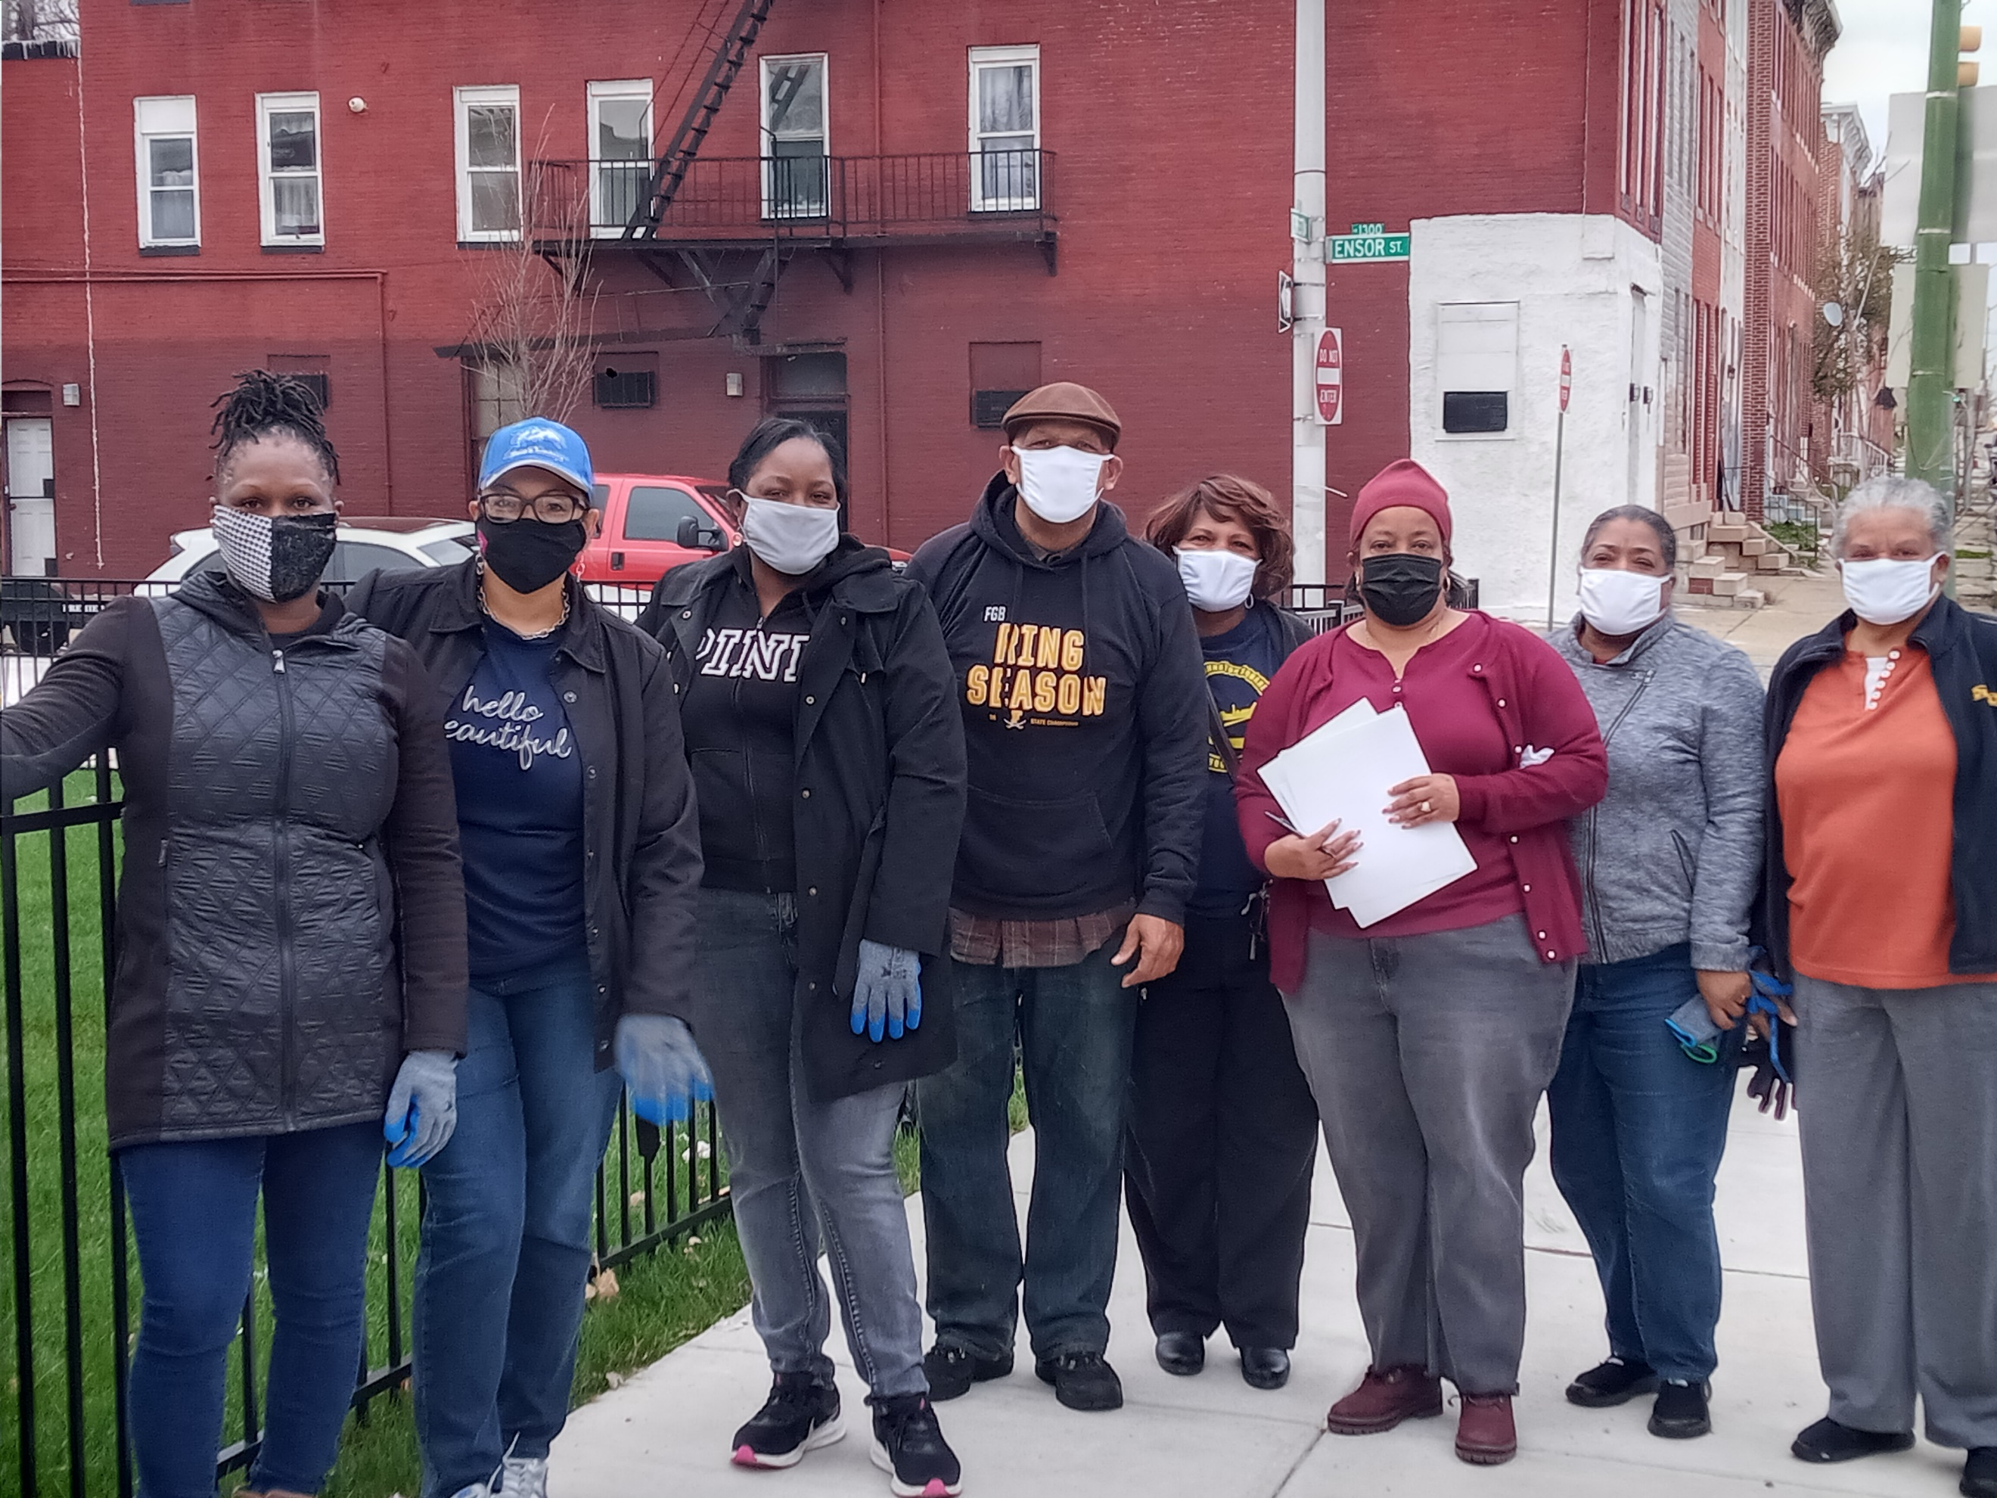 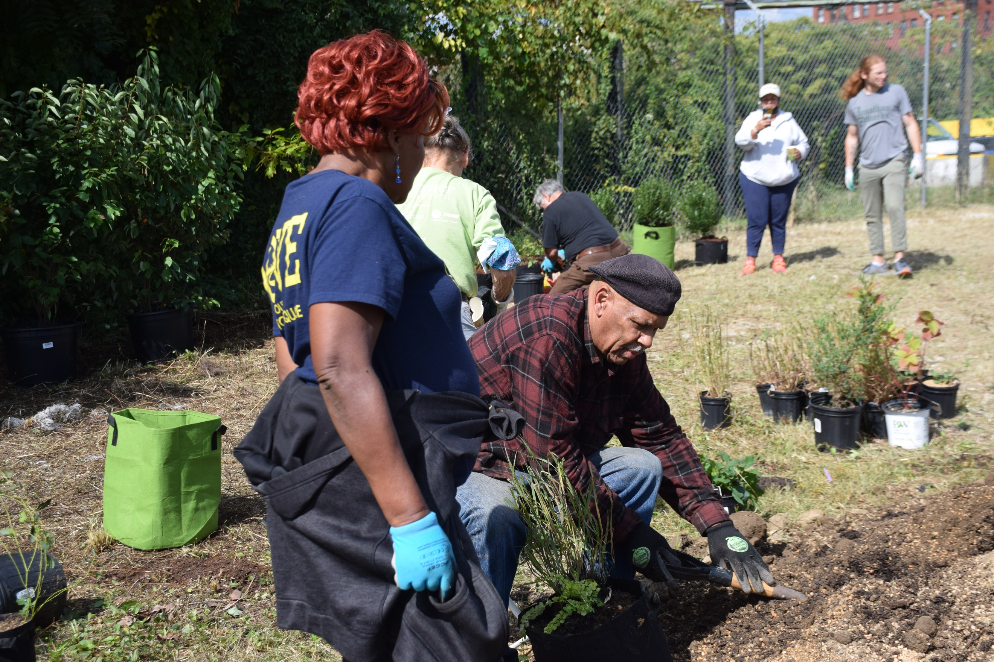

**Volume IV Issue IV Johnston Square Gazette June 2022**

**Johnston Square Gazette**