Re-Build Johnston Square Community Walk

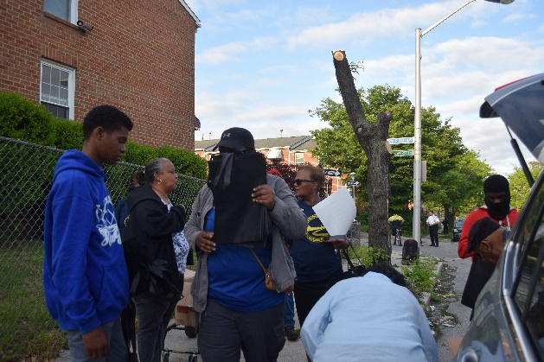
On Wednesday, May 11, 2022, members of Re-Build Johnston Square Community Organization along with Major Thacker and members of the Baltimore Police Department Eastern District. Walked a route thru the Johnston Square community distributing information about community events and the Maryland Volunteer Lawyer Service.
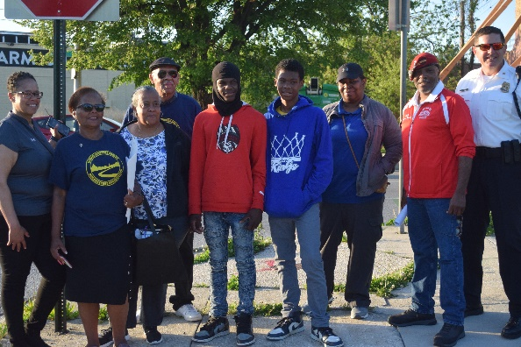
They started the walk on the Biddle Street Bridge walking East along Biddle Street talking to residents and hanging bags with information. They continued east to Eden Street down to east Chase Street, turning onto Chase back up to Barclay Street feeling that they have accomplished their task at hand giving out over 200 bags of information and talking to numerous people along the route. After one last photo opportunity they discussed having another walk in the future to cover another area of Johnston Square.

‘
Fun Day Sundays
Re-Build Johnston Square Community Organization will be hosting 6 weeks of sport activities in our community parks. Activities will begin on Sunday, May 22nd, 2022, at Johnston Square Park. We will be offering Basketball, Flag Football, Net games (volleyball, badminton), Kick Ball and Self Defense. We are currently registering youth between the ages of 10 and 12, Consent forms can be picked up and return to the Re-Build Johnston Square Office located at 700 E. Chase Street on Tuesdays between the hours of 11:00 a.m. and 3:00 p.m. This is on a first come, first served basis. We will welcome parent volunteers to assist during these events. Refreshments will be served to all participants. Also talk to your Block Leader for more information or to pick up a consent form.
Greenmount Park Phrase I
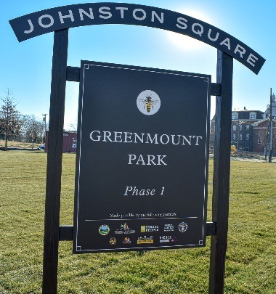
Greenmount Park, Phase I has officially opened for use, events can be scheduled by permit thru the Re-build Johnston Square office, located at 700 E. Chase Street on Tuesdays, between the hours of 11:00 a.m. and 3:00 p.m. or by appointment. Please Keep in Mind, this is an activity field not a Doggie Park, please if you must use it…Please pick up after your pet. It isn’t fair to our youth and adults to risk walking, falling in animal poop or poop flying in the face of the person cutting grass.
We have scheduled some upcoming events at the park, beginning with the Fun Sundays in May and June, we plan to use all the Parks in Johnston Square so that residents and visitors can see that the Parks are being utilized.

