Keeping Updated on the Events in Johnston Square

The 2nd Monday of each Month is the community meeting of Re-Build Johnston Square Community Organization. Meetings are in person if Covid-19 numbers are not rising. Virtual meetings are on Zoom when necessary.
We also have a Web site at http://www.rebuildjohnstonsquare.com visit our website and view photos of past events, upcoming events, and meetings.
There is also a Facebook page, for people who regularly visit Facebook. Like our page and join to keep informed. Log in on Facebook and visit Re-Build Johnston Square page for updates.
Re-Build Johnston Square is always looking for volunteers with different projects in the community.
Our next Community Dumpster is Saturday, June 4th, 2022, the dumpster should arrive around 8:00 a.m. and leave around 12:00 noon or when filled. No appliances, tires, hazardous waste (paint, household cleaners). The dumpster will be located on the corner of E. Biddle Street and Homewood Avenue, either on Biddle Street or Homewood Avenue as dictated by parking. So please don’t wait for the last moment once it is filled, we call DPW for pick up
The next meeting for the Re-Build Johnston Square Community is on Monday, June 13th, 2022, at 6:30 p.m., at Open Works, 1400 Greenmount Avenue, Baltimore, Maryland
Update: 90% of trash pick up in Johnston Square is on the front, Trash cans and Recycle cans should be pulled to the curb no earlier than 7:00 p.m. the night before normal pick up. If you have pick up in the alleyway, please use cans with tight fitting lids. Please stop throwing plastic trash bags in the alleys overnight. Doing this will only feed the rat population. Let’s stop throwing bulk trash in the alleys giving the rodent population a home. You can call 3-1-1 to schedule a bulk trash pick-up, you are allowed up to 3 items of bulk trash. Bulk trash is picked up once a month.
If you see a U-Haul pick-up driving around on dumpster days, it isn’t for personal residential pick-ups…it is for the illegally dumped in our community. We pick up along the streets where there are no houses or abandon houses, around the parks and on the bridges.
It takes the whole community to keep our community clean. If you only sweep in front and back of your property you have helped, remember the days of the Afro-American Clean Block Contest, where every Saturday we were out there scrubbing steps and sweeping the streets and gutters.
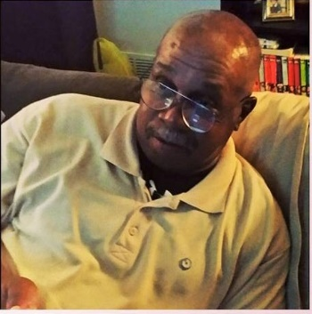
New Office Assistant

Jon “Coach” Randall has been brought on as the Administrated Assistant for the Re-Build Johnston Square Neighborhood Organization, Coach is in the office every Tuesday from the hours of 11:00 a.m. until 3:00 p.m.
While in the office Coach will be available to handle permits for community-controlled parks and lots, handing out Covid Test kits and light bulbs (when available).Plus answer any questions that you may have or will find the answer and get back to you.

