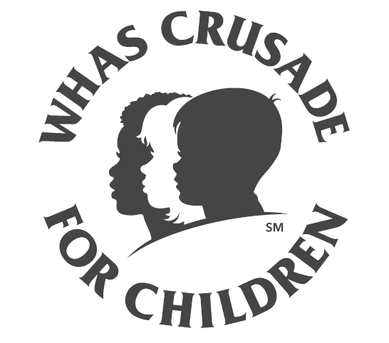
Shelby County Suburban Fire District and

Taylorsville-Spencer County Fire District
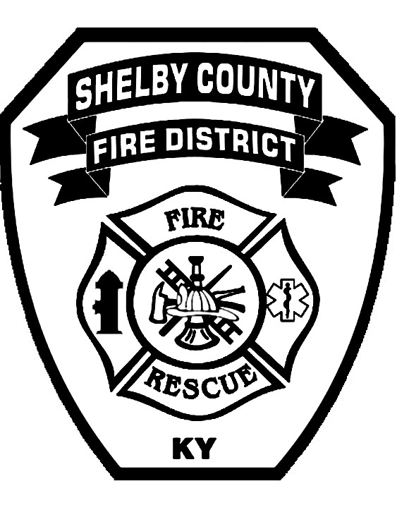
Bass Tournament
to benefit the
WHAS Crusade for Children
Guist Creek Lake
Saturday, April 18, 2026
REGISTER NOW-REGISTRATION CLOSES 04/13/2026 5:00PM
$100 per boat
Boater #1 Please fully complete information below.

Name:
 | Address:
 | City: State: Zip:
 | Phone: Email:
Boater #2 Please fully complete information below.

Name:
Address:
City: State: Zip:
Phone: Email:
Registration time:  6:00am to 6:45am  Return this form to  Shelby County Fire Department  PO Box 1027, 200 Alpine Drive  Shelbyville, KY 40066-1027 |  | Tournament time:  7:00am to 2:00pm  Phone: 502-633-6648  Fax: 502-633-7033    Email: info@shelbycofire.com www.shelbycofire.com  @shelbycofire
All proceeds benefit the WHAS Crusade for Children a 501C3 charity and boat fees are tax deductible.

