Shelby County Suburban Fire District
30th Annual Golf Scramble
to benefit the
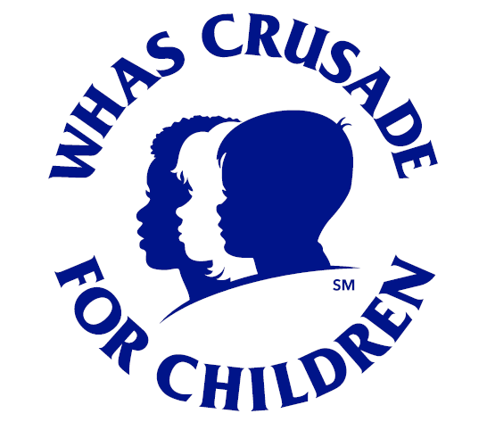

WHAS Crusade for Children
Weissinger Hills Golf Course
Shelbyville, Kentucky
Monday, May 11, 2026
REGISTER NOW
$100 per player
Player #1 (Team Captain) Please fully complete information below.

Name:
 | Phone: Email:
Player 2 Name: |  | Email:
Player 3 Name: |  | Email:
Player 4 Name: |  | Email:
Registration time:  7:30am to 8:30am |  | Shotgun Start at  8:30am

Additional $20 Packet includes: 5-Raffle Tickets, 5-Split the Pot Tickets, 2-Mulligans, 1-Skirt
We will have additional games and raffles available for cash purchase as well!
Return this form to:
Shelby County Fire Department Phone: 502-633-6648
PO Box 1027, 200 Alpine Drive Fax: 502-633-7033
Shelbyville, KY 40066-1027 Email: Jennifer@shelbycofire.com
www.shelbycofire.com

All proceeds benefit the WHAS Crusade for Children, a 501C3 charity and player fees are tax deductible.
Please Note: A credit card convenience fee of 3% will be applied to all card transactions

