The year 2017 for TWIG Kidz was very exciting and eventful with our talented young ladies all eager to take on the challenge of learning golf, staying focused with academics and competing in golf tournaments. Where to start in sharing all the wonderful accomplishments each and every young lady from ages 8 to 17 completed with tenacity and enthusiasm……
Our golf season was kicked off with thirteen young ladies ready to swing into action during our meeting at Hillandale Golf course with Fran James, LPGA and Golf Instruction Director in March, 2017. Coach Fran shared the importance of practice, practice, practice by giving each TWIG Kid a key, which symbolized their 2017 entrance to success as junior golfers having access to the golf driving range and golf course:
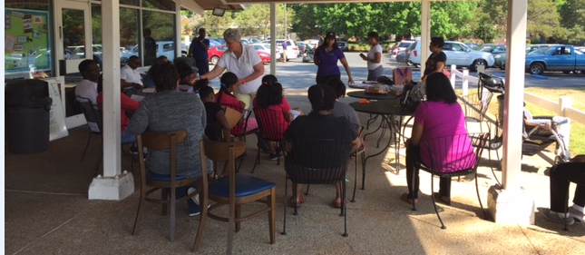
TWIG Kidz for 2017 consist of Aniyah, Chanell, Gabrielle, Genesis, Hanna, Jessica, Kaia, Lydia, Tyla, Tyler, Samantha, Layke and Zariel. TWIG Kidz committee members consisted of the following TWIG ladies; Esther, Joselyn, Perrianne, Barbara, Nyliah (Honorary TWIG) and Valerie Willis (Chairperson).

This year the TWIG Kidz were invited to return to Dona Lerner’s Golf Academy, (DLGA), at Brier Creek Country Golf Course, in Raleigh, NC. Dona Lerner introduced us to their new coach, Nick Zurowski, who welcomed and taught each TWIG Kid with encouragement and strong leadership.
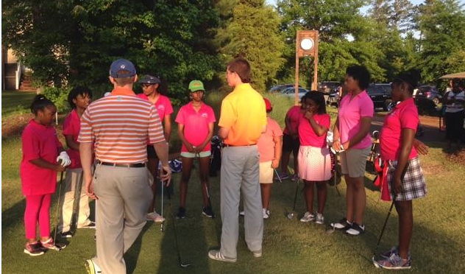
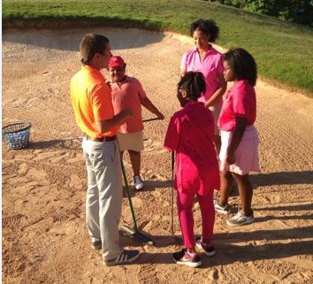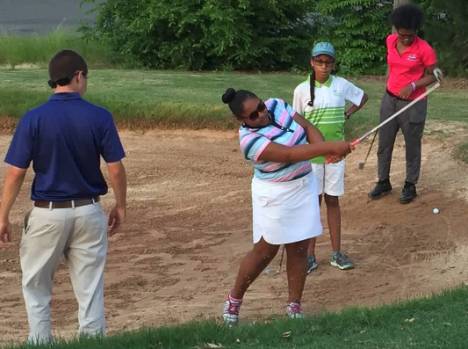
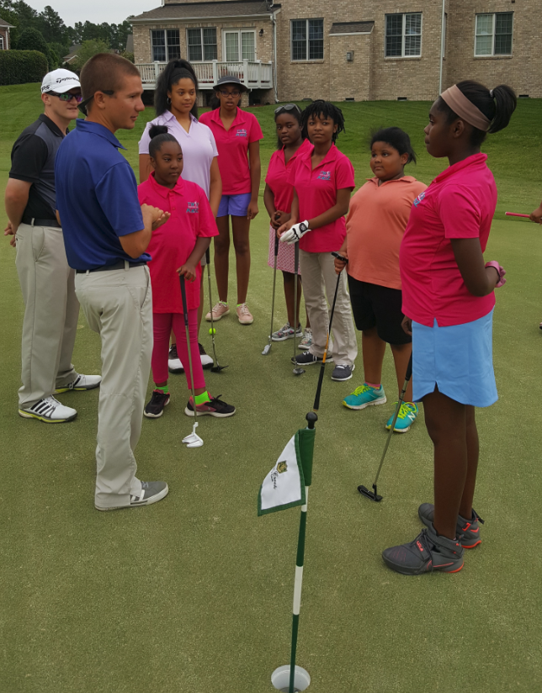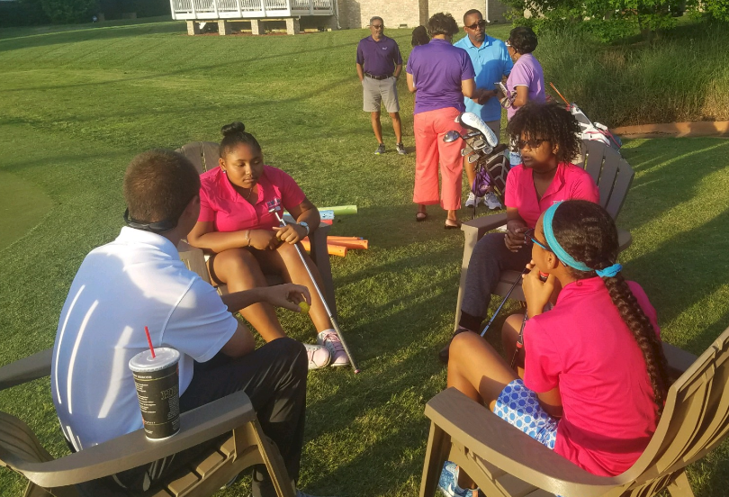
6PM Golf Sessions; counter clock 7PM Golf Sessions; clock wise
- Coach Nick *Coach Nick
- Assistant Coach *Tyla
- Aniyah *Layke
- Kaia *Tyler
- Gabrielle
- Samantha
- Lydia
- Hanna
- Jessica

2017 was truly exciting for the TWIG Kidz, because outside of the three DGLA golf sessions from March to August, the young ladies were competing in golf tournaments, meeting personal trainers and receiving various recognitions in the golf community.

Doug Boyd Foundation Annual Golf Event
Four TWIG Kidz playing a full round of 18 holes of golf. TWIG Kidz also walked away with winnings at this tournament.

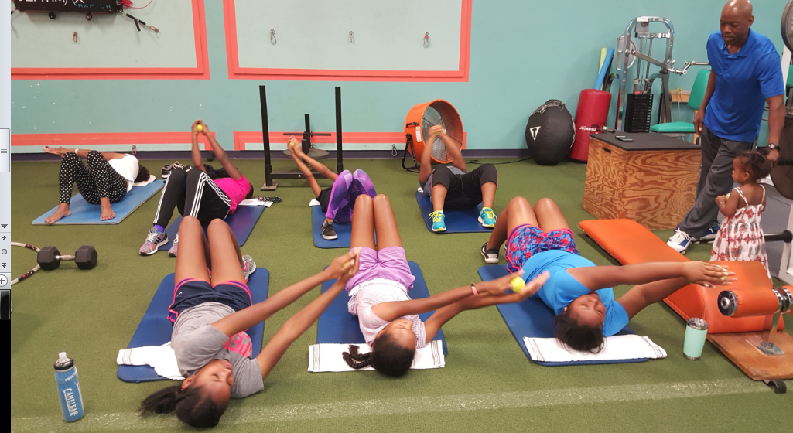
Raleigh Personal Training Center
Training with owner and operator Mr. Wade Harris

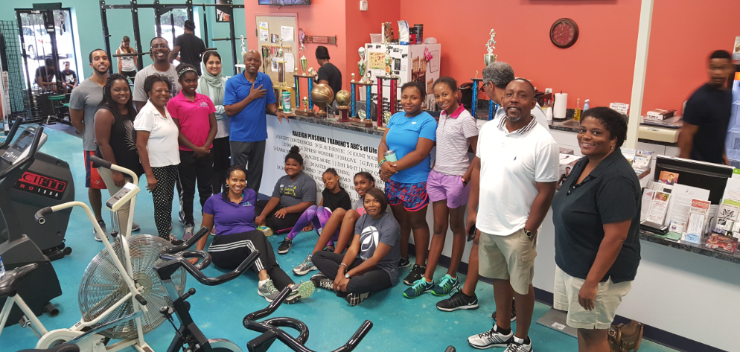
TWIG Kidz and parents still smiling after their health awareness and work out session at Raleigh Personal Training fitness facility.

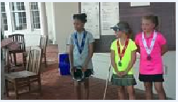
Genesis receiving first place
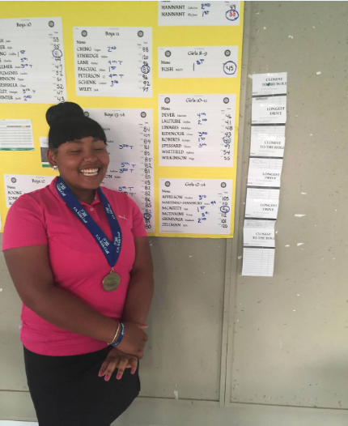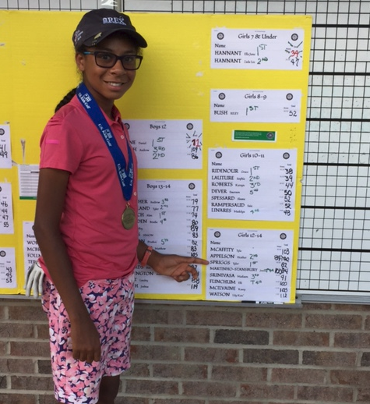
Tyla winning 1st in USKidz Tyler winning US Girls 12-14
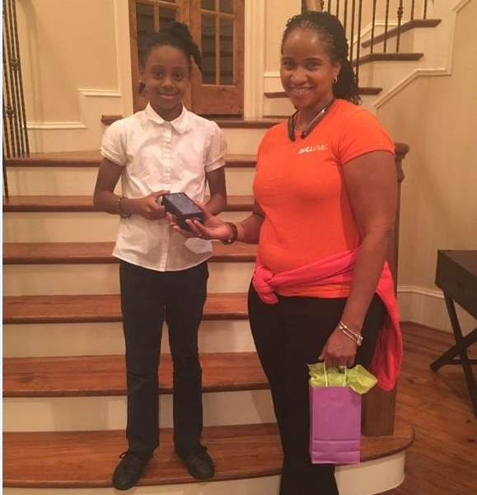
TWIG Kidz closing ceremony, Genesis receiving her awards for being recognized as “Independent”. Although she did not participate with the DLGA program, Genesis was a full participant in the game of golf by traveling from North Carolina to Australia playing and placing in numerous golf tournaments.
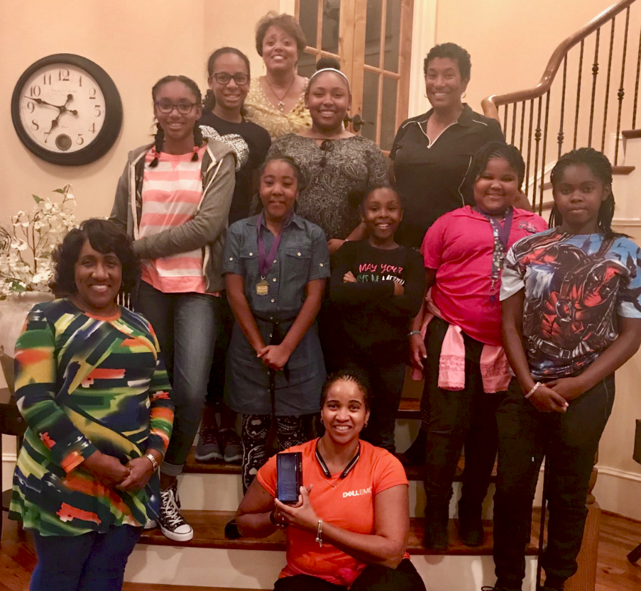
TWIG Kidz closing ceremony, hosted at TWIG ladies Vice President Renee Allain-Stockton in Raleigh, NC. Each TWIG Kid received a personalized award describing their individual attributes; Anyilah (Genuine), Channell (Courageous), Gabrielle (Dedicated), Genesis (Independent), Hanna (Committed), Jessica (Focused), Kaia (Selfless), Lydia (Proficient), Tyla (Tenacious), Tyler (Driven) and Zariel (Confident)!
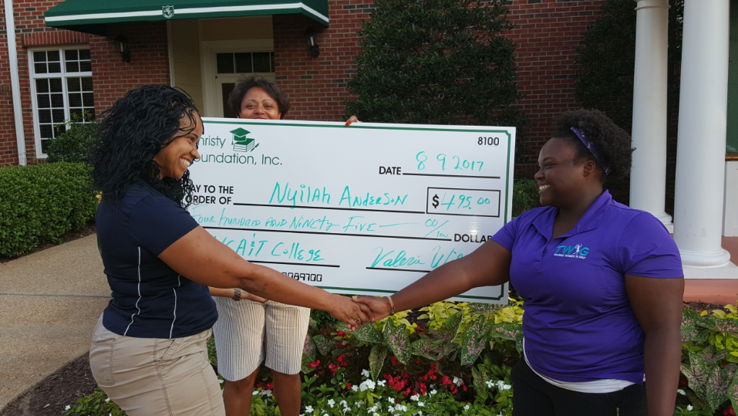
A special recognition goes to former TWIG Kidz committed member from age 8 to 17, Nyilah Anderson of Durham, NC. Nyilah was very devoted as a TWIG Kid and as a TWIG mentor to the 2017 TWIG Kidz. Nyilah will truly be missed from TWIG Kidz and by the TWIG ladies for her selfless devotion to the game of golf and mentoring. Nyilah graduated from high school this year and will attend North Carolina Agricultural and Technical State University carrying a gift from TWIG ladies and an academic scholarship from the Christy Foundation, Inc. 501(c)(3) owned by Valerie Willis, TWIG Kidz Chairperson.

