Monday, September 21, 2026
Lochmere Golf Club, 2511 Kildaire Farm Road, Cary, NC
Shotgun start at 9:00 am (on-cart time 8:45 am)

Please join us as we celebrate 25 years of sponsoring the TWIG Kidz Program.

TWIG Foundation Invitational Golf Tournament funds our TWIG Kidz Program which introduces girls aged 6 – 18 to the game of golf. Golf is a lifelong sport that also teaches valuable life lessons such as honesty, discipline, perseverance, and critical thinking skills. The TWIG Foundation is a tax-exempt organization under IRC Section 501(c)(3).

Tournament Information:
Registration Deadline: Friday, August 21 (midnight)

Format: Captains Choice: Scramble
Three divisions: Men, Women & Mixed


Registration Information:
Register as a twosome ($250) or a foursome ($500)
Fees include two mulligans per person

Sponsorship Opportunities:

TWIG Kidz – one seasons $600

two seasons $1200

three seasons $1800

Trophy - $1,250

Awards Dinner - $1,000

Goodie Bags - $500

Closest to the Pin - $300

Beverage Cart - $250

Driving Range - $250

TWIG Kidz Tournament Registration - $150 per TWIG Kid

Hole Sponsor - $100

Donation Opportunity:
We welcome donations through the TWIG Foundation Eventzilla. All proceeds benefit the TWIG Foundation, a 501(c)(3) organization.

Awards:
Longest Drive
Closest to the Pin
Hole-In-One (all players included)
1st place gross and 1st place net for each division

Thank you!
We look forward to playing with you!
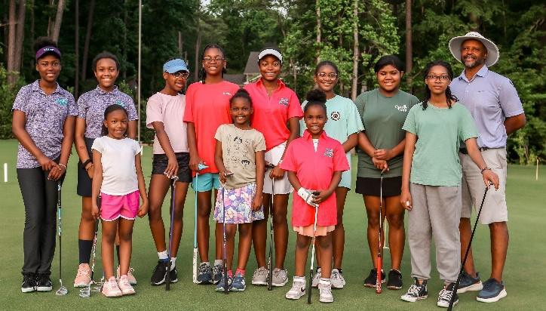
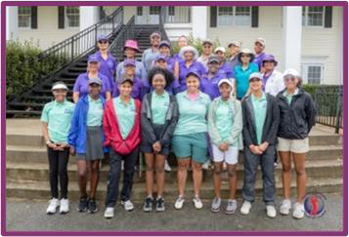

Contact us: Invitational@TriangleWomenInGolf.com

Visit our website: www.TriangleWomenInGolf.com

Find us on Facebook: www.facebook.com/trianglewomeningolf

Find us on Instagram: www.instagram.com/twig_kidznc/

Triangle Women in Golf, PO Box 99630, Raleigh, NC 27624-9630

