OUR PROMISE AT CREATIVE BEGINNINGS PRESCHOOL

We promise you everyday your child will learn something.
Some days they will bring it home in their hands.
Some days they will bring it home in their heads.
And some days they will bring it home in their hearts.
It’s going to be a great year!

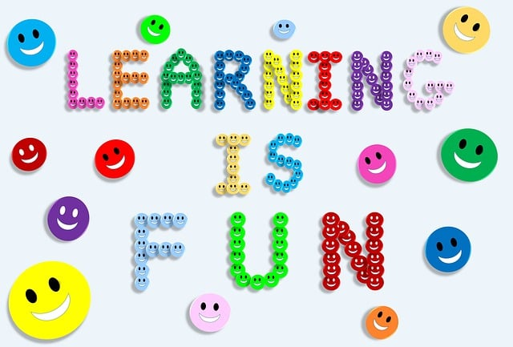

The CBP Family

