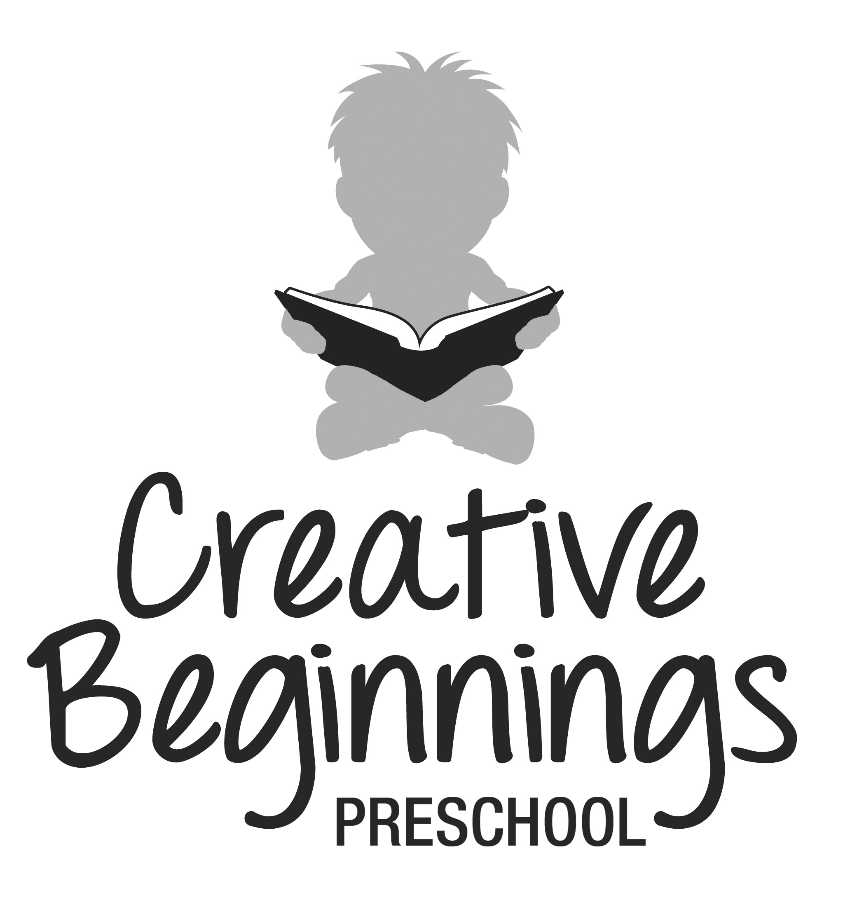
Creative Beginnings Preschool Mailing address:
36 Gould Street 108 Passaic Avenue Apt A1
Verona, NJ 07044 Nutley, NJ 07110
973-239-2242 cbpnj@yahoo.com

Information Regarding Registration for 2021-2022 School Year

CBP has always prided itself on providing a quality, nurturing preschool experience for all our students. Our qualified, dedicated staff works hand in hand with each of your children on a personal level. The best way to accomplish this is for CBP to maintain small class sizes and focus in on offering your children a challenging, yet age appropriate curriculum.

CBP is excited to announce our 2021-2022 schedule:
For the 2021 - 2022 school year, you can select from the following options:
Before Care: 7:30 am – 8:30 am
Morning session: 8:30am – 11:45 am
Lunch: 11:45 am – 1:15 pm
Full Day Session: 7:30 am – 4:00 pm

The morning session offers a three hour learning session which includes the following:
Thematic lessons, language, story time, puzzles, dexterity games, snack & bathroom,
science & math, arts & crafts, rhythmics & music and indoor/outdoor play.

A lunch program is offered to the AM students on a daily basis. Lunch schedules are sent home at request and preregistration is required each month.

The full day session offers the topics covered above, including lunch and rest time. After rest time,
the multi-aged group focuses on arts & crafts, music and free play.

If you enroll your child in the AM class, you can opt for some or all of the days to be full days.

When completing the attached registration form, please provide us with 3 options that work for you. We will do our best to give you your first choice, however, as days and times fill, we will need to have other options in order to reserve a spot for your child.

Registration forms for returning students and their siblings will be accepted beginning
January 15, 2021 at 8:30 am. No registrations will be accepted prior to this day and time.

Registration forms for new students will be accepted beginning January 22, 2021 at 8:30 am.

As always, if you have any questions, please do not hesitate to ask! Thanks in advance for your understanding and cooperation with this matter.

