Product Details:

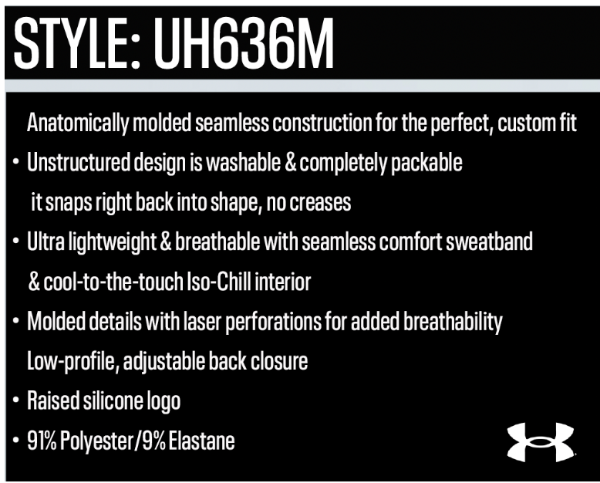

- Start Ship: 7/1/25
- Key highlights: Uncrushable, Breathable, Seamless, Sweat Wicking, and Washable – WOW!
- Colors: Midnight Navy, Castlerock Heather, Black
- Wholesale/Retail: $25/$50
  - This cap is amazing and worth every penny. The cost per wear is a real thing and it will be the consumers new fave hat = low cost per wear! As soon as your customer touches, feels, and sees the innovation and the need for the cap, the price WILL NOT MATTER!
- Mins: 48 per patch/graphic
- Process method: CVT – Cap Versa Twill
- Domestic production: All plain caps are stocked in our warehouse and decorated domestically
- Lead times: 4 weeks for patch lead time

