SS 26 Order Submission Guidelines

Email
- Add your subject. It must include: Account Name, Account Number, SS26
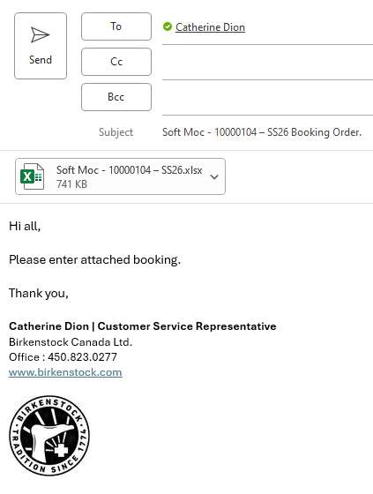

- Attach your order form. The Excel file must be saved with the Account Name, Account Number and SS26 (Example: Soft Moc – 10000104 – SS26)

Order Form
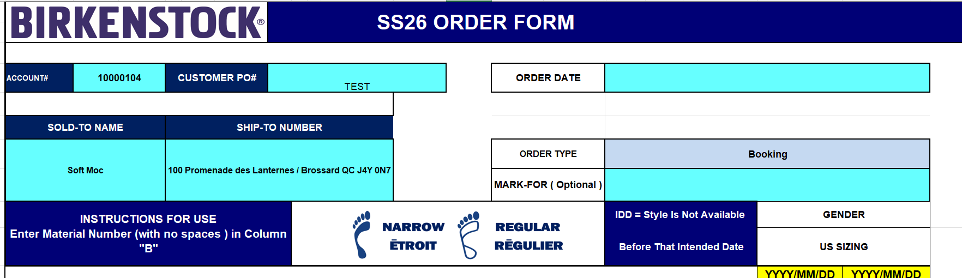
- Enter your Account Number, PO number, and the date you are placing the order
- Enter your Account Name and your Ship-To Details (Including your Ship-To Number and specific identifiers for the location). If you have multiple locations, please use separate forms. No tabs are allowed to be added to the form.
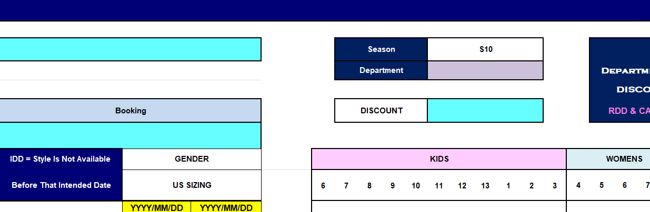
- Discount (add qualifying discount negotiated with rep)

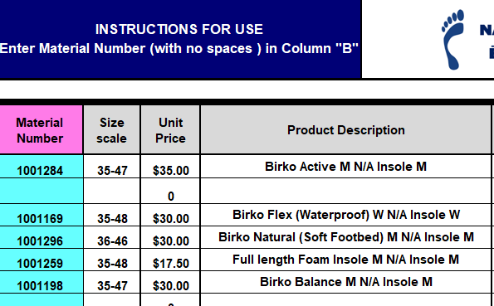
- Enter the material numbers you wish to order.

- Enter the Delivery Date and Cancellation Date (It must be after the Initial Delivery Date in the “Not Available Before” Column)
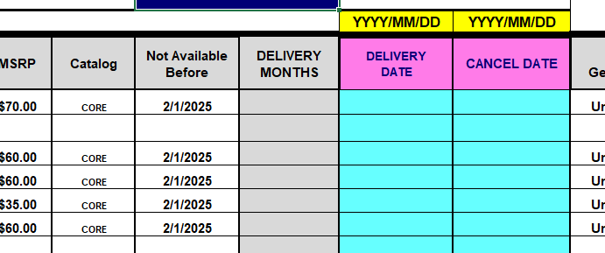

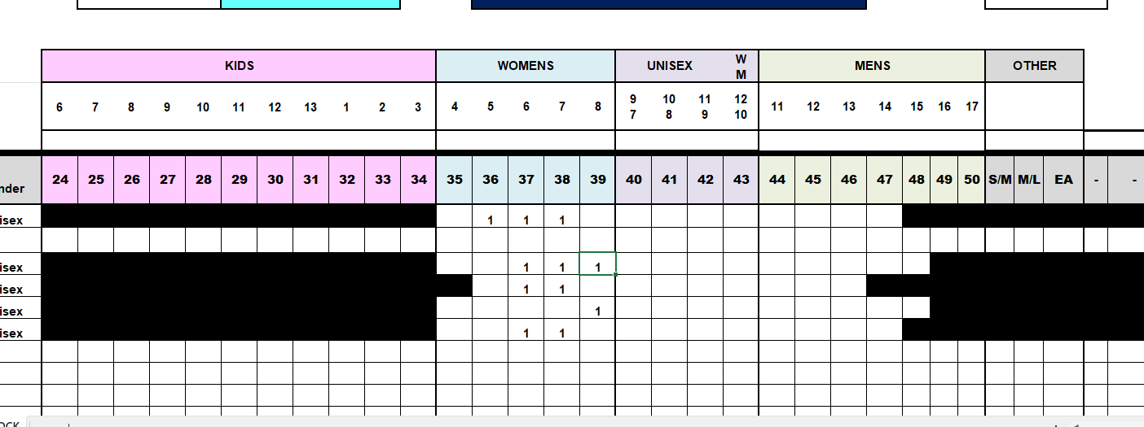
- Enter the quantities under the sizes you are ordering.

- The Excel file must be saved with the Account Name, Account Number and SS26
  - Example: Soft Moc – 10000104 – SS26

