**TERMS AND CONDITIONS**

**Below are the terms and conditions, which will apply to your use of the Under Armour VIP Ordering System. If you do not agree to these terms and conditions, please do not use your VIP Login to place your order.**

It is Under Armour’s expectation that VIPs adhere to the VIP Manual and all VIP Discount Program terms and conditions. This includes the following rules:

* VIPs may not share their VIP log-in information with others, nor may VIPs allow others to access their account;
* VIPs must place online orders using a credit card linked to the VIP (i.e., the name on the credit card matches that of the VIP);
* VIPs may not place bulk orders for products (i.e., no more than 10 of an item); and
* VIP products must be purchased for personal use. VIPs may not purchase products with the intent to resell or receive payment for such products.

• All on-line orders must be submitted on www.underarmour.com by a designated Under Armour contracted athlete, team representative or customer subject to and in accordance with the agreement by which you received the discount and/or product credit or allowance (the "Agreement"). Abuse of the VIP Ordering System may result in termination of your ordering privileges, this includes allowing others to place orders using your account, placing orders using someone else's credit card, placing bulk orders or orders with the intent to resell, and any of the following terms and conditions listed below.

• You may purchase products through your VIP Login only for your personal use or as otherwise permitted in the Agreement. You may not order products with the intention to resell or to receive repayment of any kind.

• In the event the total of your cart exceeds your VIP points, your full order must be paid for with a credit card. We are unable to accept both allotment points and credit card payment on one order transaction. For example, if you only have 100 points left in your allotment account but your merchandise total amounts to $134.98 before discount, you must pay for the entire amount by credit card or remove items until your total, including shipping and taxes, is below 100 points. However, any discount to which you are entitled would be applied to the $134.98 merchandise total if you choose to exceed your point total. Credit card orders can only be processed with your personal U.S. based credit card with valid billing and shipping addresses.

• Please protect your personal login information and password as you are responsible for maintaining the confidentiality of your login/password and any activity under your account.

• All orders must ship to a valid U.S. address. We do not offer international shipping options at this time.

• Applicable shipping charges and sales tax will be deducted from your allotment points or sales order.

• High demand, new releases, and/or seasonal items may not be available for order using allotment points nor have your discount applied; they must be purchased at full price.

• Orders purchased through the VIP Website cannot be returned for refund/exchange to our retail and/or outlet stores. All returns must be mailed back to the warehouse and contain a copy of the returns form which was included in your order.

• Gift cards may not be purchased using VIP allotment points or discounts.

• Additional promotions (promo codes) or discounts are not valid on VIP orders.

• All orders placed through a VIP Login are monitored for compliance with these terms and conditions.

• All VIP accounts are only valid for a specific amount of time. Once an account has expired, any discount privileges are removed, and any remaining allotment points are zeroed out.

**INTRUCTIONS**

**Logging In**

1. Sign in to www.underarmour.com using the login information provided to you in the "VIP Account Created" email.

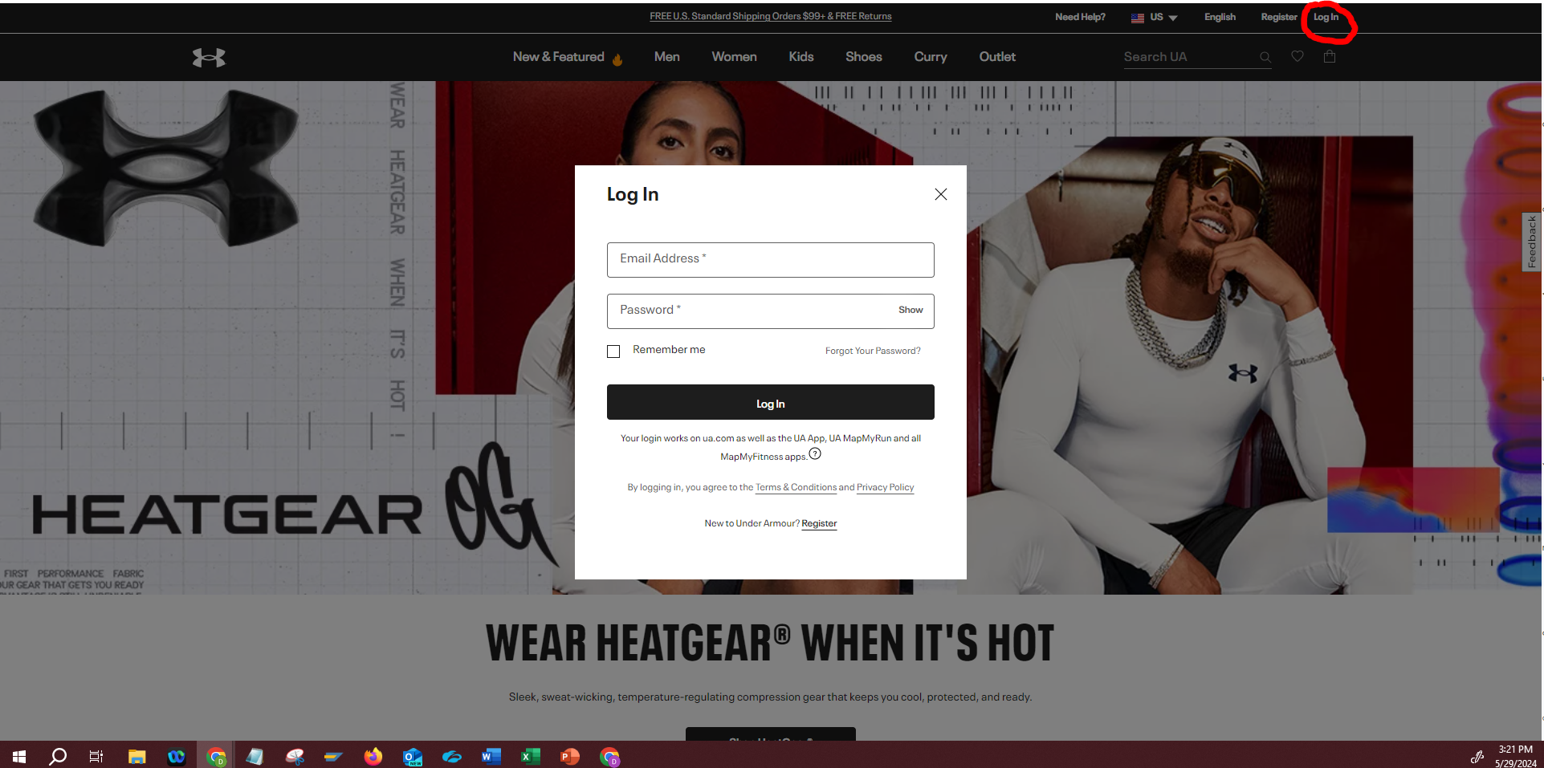

**VIP Points System**

1. Displaying Point Balance
   1. Go to “My Account” and select “Payment Methods”
   2. Here you will be able to see the active point balance along with the discount you can use if no points are active.

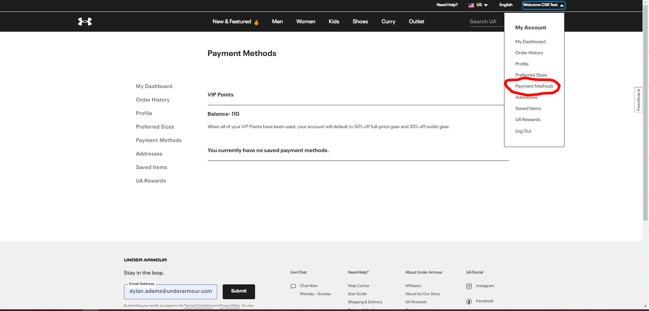

1. If all points have been used, the system will automatically default to using the VIP Discount
2. WHEN USING VIP POINTS PLEASE KEEP IN MIND
   1. **Points cannot exceed order total (including shipping and taxes)**
      1. **If the order total exceeds the point balance you must pay for the entire amount by credit card or remove items until your total, including shipping and taxes, is less than your point balance.**
   2. **Points cannot combined with VIP discount**
3. Using Points to Checkout
   1. Go to your cart and select “Checkout”
   2. Please fill out Shipping section and proceed to Payments
   3. Under the “Payment” section you should see “Allotment Point Applied”
   4. Fill out Contact Information Section
   5. Read VIP Terms & Conditions, then select the box agreeing to the terms.

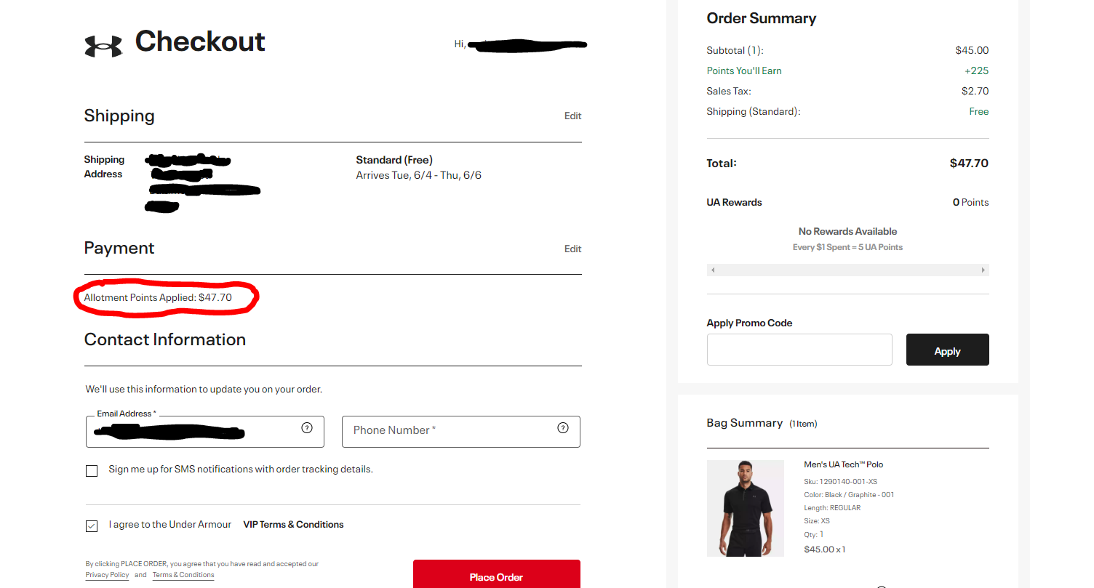

**Product Detail/Shopping Cart**

1. Find the product you like.
2. Select the color you want by clicking on the color.
3. Select the size.
4. Select the quantity.
5. 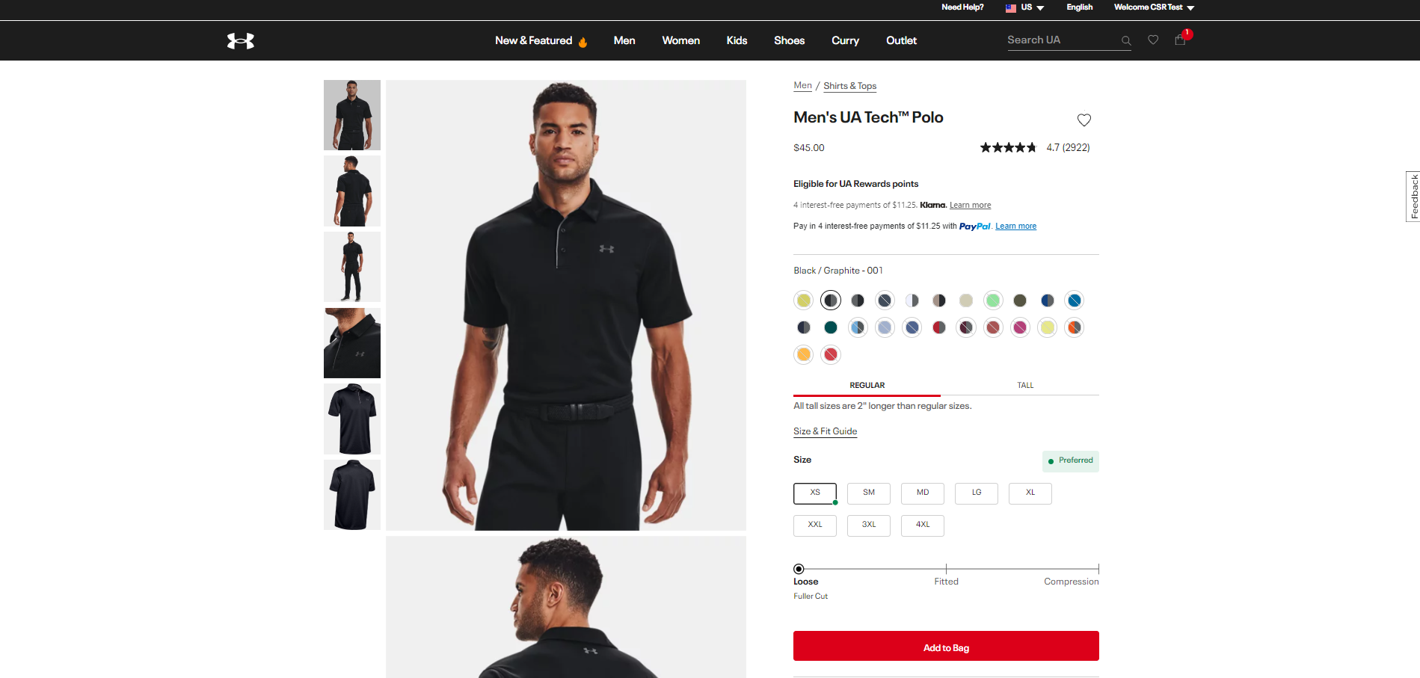Click the “ADD TO BAG” button.
6. You may want to view your shopping cart and contents at any time by clicking on the checkout bag icon.

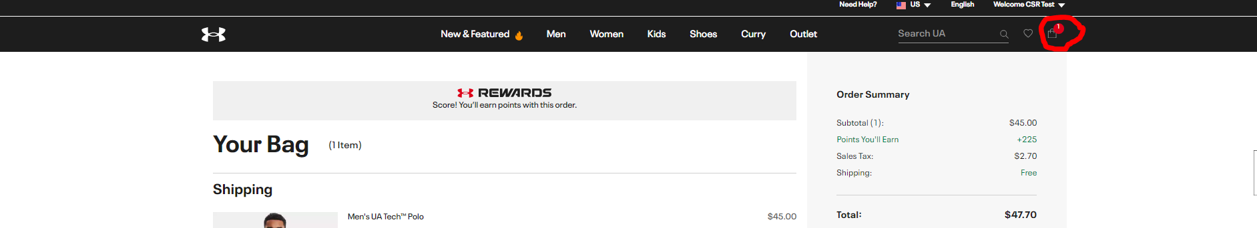

1. If you wish to remove items from your cart, click the checkout bag icon then select “Remove” on the item you wish to remove.

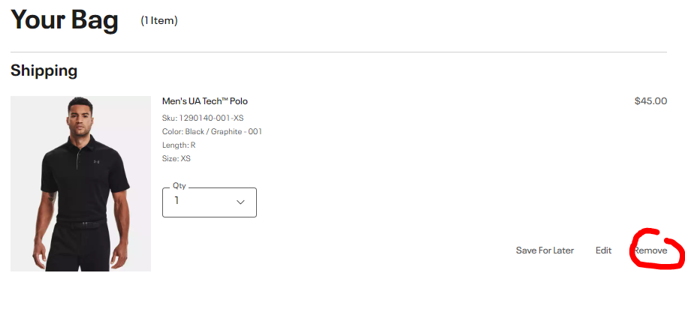

**FREQUENTLY ASKED QUESTIONS**

**How do I log in to place an order?**

Once set up, you will receive an email from Under Armour outlining the initial login process. Please make sure to remove us from spam or junk email blockers. Your email address will serve as your login on

www.underarmour.com. You will know you are logged in as your name will appear on the welcome screen at the top left of the site.

**Where can I view my discount or allotment points?**

Discount and allotment points can be viewed under the payments tab. Log in to your VIP account and click on your name in the top right side of the page. From the drop-down menu, select payment methods.

**How can I tell if an item is in stock?**

Once you've selected the style, you can determine what color/size is in stock by first selecting the color (1. Select color), and then the size (2. Select Size). If the size you want is not listed for the selected color, it is not available. Our website is designed to feature 'real-time' inventory levels so that only in-stock items are visible and available for purchase. If the item you would like to purchase is currently out of stock, we apologize for the inconvenience and encourage you to contact your customer service representative to help find an alternative.

**How is the sales tax calculated for my order?**

Some Under Armour gear may be tax exempt depending on the shipping destination and time of year. Our systems automatically account for tax exemptions when they occur.

**How do I make changes to my account?**

Using your email address and a password of your choice, you may access your account online at any time to add, delete or change information including saved ship to addresses, credit card information, etc.

**Can I use my discount before my points?**

Your VIP discount will not be applied to your order until you have used all of your points. The VIP site is intended for personal use, so you should be using your points first when ordering, and then your discount will be automatically applied. In the event the total of your cart exceeds your VIP points, your full order must be paid for with a credit card. We are unable to accept both allotment points and credit card payment on one order transaction.

**Why won't my password work?**

If you have an existing Under Armour online account, click on the "Sign In" link at the top of the page. You will be taken to the Sign In page, where you can select "Forgot Password." You will then be prompted to give your email address so we may email you a link - for your security - to change your password.

**How soon after my order is placed can I track it?**

You will receive a tracking number via email once your package has been shipped. If you are a registered member and do not have this information and would still like to track your package, log into your account and use the Order Number from your original order confirmation email to track your package. Please allow 2 - 4 business days between placing your order and using the tracking tool.

**I tracked my order and saw the message "in transit," what does this mean?**

If you tracked your order on our website and received the message that your order is "in transit," this simply means that your order is being processed for shipment, or that the tracking information has not been updated with the shipping carrier yet. It typically takes 2 - 4 business days for the carrier to receive our tracking information.

**Can I order gift cards with my allotment or at a discount?**

Gift cards are only able to be purchased at full retail value. Neither your allotment points nor any applicable discount may be applied toward the purchase of gift cards.

**Can I use gift cards or promo codes when I check out?**

Gift cards and promo codes may not be combined with discounts or allotment points.

**Do you ship internationally?**

At this time, we are only able to ship to a valid U.S. address on orders placed under a VIP login.