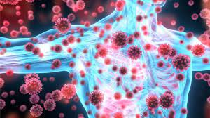  The Immune System against Covid-19  A Healthy Immune System during a Pandemic  The key to preventing infection and disease is to keep your immune system healthy year-round. This has become even more important during the Covid-19 pandemic. There are many natural ways to boost your immune system by making healthier lifestyle choices. Research has shown that certain vitamins, minerals, herbs, and supplements can help bolster the immune response and potentially protect against the virus. | Who We Are  About Us  Wellness-MBS was created to help others achieve optimal wellness while focusing on Moderation, Balance, and Sustainability  Contact Us  Pamela Kosinski  Email: Pamela@wellness-mbs.com  Web: www.wellness-mbs.com  Wellness - MBS  www.wellness-mbs.com | Wellness - MBS  - The Immune System
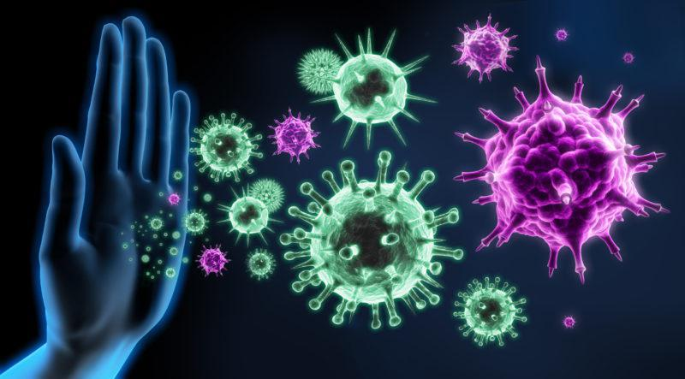  The Body’s Defense System  What is the Immune System?  The Immune System is made up of different cells, organs, and proteins. These systems work together as our body’s defense system by recognizing foreign antigens and fighting them off to protect us from infections caused by bacteria, viruses, fungi, and toxins.  There are three types of immunity- innate, adaptive, and passive. | Innate immunity:  A natural immunity that everyone is born with. Barriers such as our skin blocks out foreign antigens.  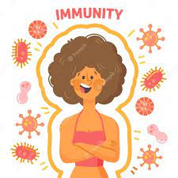  Adaptive Immunity:  Adaptive immunity, also known as active immunity, develops throughout life. This happens when we are exposed to diseases. Another form of adaptive immunity is the use of immunizations and vaccines. |   Passive Immunity:  “Borrowed” immunity from others. These antibodies and immunity are received from another source and only lasts for a short period of time. An example of passive Immunity would be antibodies being passed from mother to child through breastmilk.

