***NDM Performance Horses*** 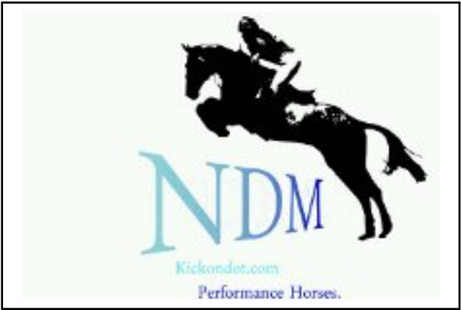

***Marton Gate Farm***

***School Lane***

***Marton***

***Macclesfield***

***Cheshire***

***SK11 9HA***

***Tel: 07810 483855***

***Email: Dixieniki@hotmail.co.uk www.kickondot.com***

|  |  |
| --- | --- |
| **EVENT(Pls fill in with current Clinic your wishing to attend)**  All groups will start small and slowly build up to the maximum height of group.  **DATE (of clinic you wish to attend)** | **VENUE (The venue your wishing to attend)**  **Please Tick Here If you would like us to hold this information to be used on a future Clinic** |
| Name:  Age:  Address:  Postcode:  Email:  Mobile: | **Preferred Height** or info on horse & rider ability/height currently jumping/experience/nervous/new combo to help us place you in the correct group, |
| **Brief Description** of what you would like to achieve/learn during the clinic |
| In Case of a Emergancy:  1 Contact:  2 Contact: | **Rider Medical Condition(s)** that we should be made aware of & will be kept confidential |
| Horses Name:  Height:  Age: | **Horse Medical Condition(s)** we should be made aware of |
| **Other Details:** such as preferred times/time constraints, travelling alone, who you may want to be grouped with | |



**Terms and Conditions:**

Please make cheques payable to **Niki De Macedo** with the full amount and send to the above address with completed form to confirm your place. Without full Payment and form a space sadly cannot be reserved.

Times will be given the week before the clinic. Please be mounted and ready to ride for your allocated time.

*Pls Tick*

* I understand that riding at any standard has inherent risk and that all horses may react unpredictably on occasions
* I may fall off and could be injured. I accept that risk.
* Neither the organiser nor venue hold any responsibility for loss, damage or injury to persons/Horses on the Clinic.
* I understand that instructions are given for my safety and agree to follow instructions given to me by staff and instructors.
* I understand that wearing an appropriate riding hat and body protector may reduce the severity of an injury should an accident happen. I understand that I should always wear a riding hat that meets the current British Standards when riding, grooming, lunging and leading a horse and if I choose not to I am doing so at my own risk. I understand it is my choice whether or not I wear a body protector.
* I understand that children are at a particular risk around horses and agree that I will keep children that I am responsible for, under close supervision.
* I understand that the proprietor of the livery yard or freelance instructor may refuse a request to ride or keep horses as per the loan agreement for safety or operational reasons
* I understand that competing carries enhanced risk over general riding and agree that if I chose to participate in any competition or event, it is up to me to ensure that I have the experience and ability to ride the course including any jumps which form part of it. If I am in any doubt, I will use my judgement and experience not to enter.
* I understand that my instructor will make decisions based on information I give them and agree to always be honest and volunteer information about:

1. my abilities and riding experience
2. any previous riding accidents
3. any medical condition(s) which may affect my ability to ride

Signed: ______________________________ Print Name: ______________________________ Date: ______________________________

**If under 18 suitable adult must sign**