**Clinical Connections**

**A Monthly Newsletter for Physicians & Case Managers. April 2025 - Recognizing When It's Time for Hospice**

# **Clinical Spotlight: Recognizing When It's Time for Hospice**

Timely hospice referral is one of the most impactful clinical decisions we can make for seriously ill patients.

Yet referrals are often delayed - not due to lack of care, but uncertainty about timing.

## **Key indicators hospice may be appropriate:**

- Progressive decline despite treatment

- Frequent hospitalizations or ER visits

- Unintentional weight loss or increasing frailty

- Increasing dependence in ADLs

- Patient or family expressing a desire for comfort over cure

Earlier referrals allow for better symptom control, psychosocial support, and more time for meaningful closure.

### **Case Collaboration Highlight**

Case: A 78-year-old male with end-stage CHF, hospitalized 3 times in 2 months for volume overload and fatigue.

Intervention: Case manager identified hospice eligibility. Patient referred and began receiving home visits from nursing,social work, and spiritual care.

Outcome: Avoided further hospitalization, achieved better symptom control, and his family reported feeling supported and less overwhelmed.

#### **Tools & Resources**

- Hospice Eligibility Quick Guide-

<https://hsc.unm.edu/medicine/departments/emergency-medicine/_docs/clinical_resources/general-policies-and-guidelines/hospice-eligibility-criteria.pdf>

- Palliative vs. Hospice Care Comparison Chart-

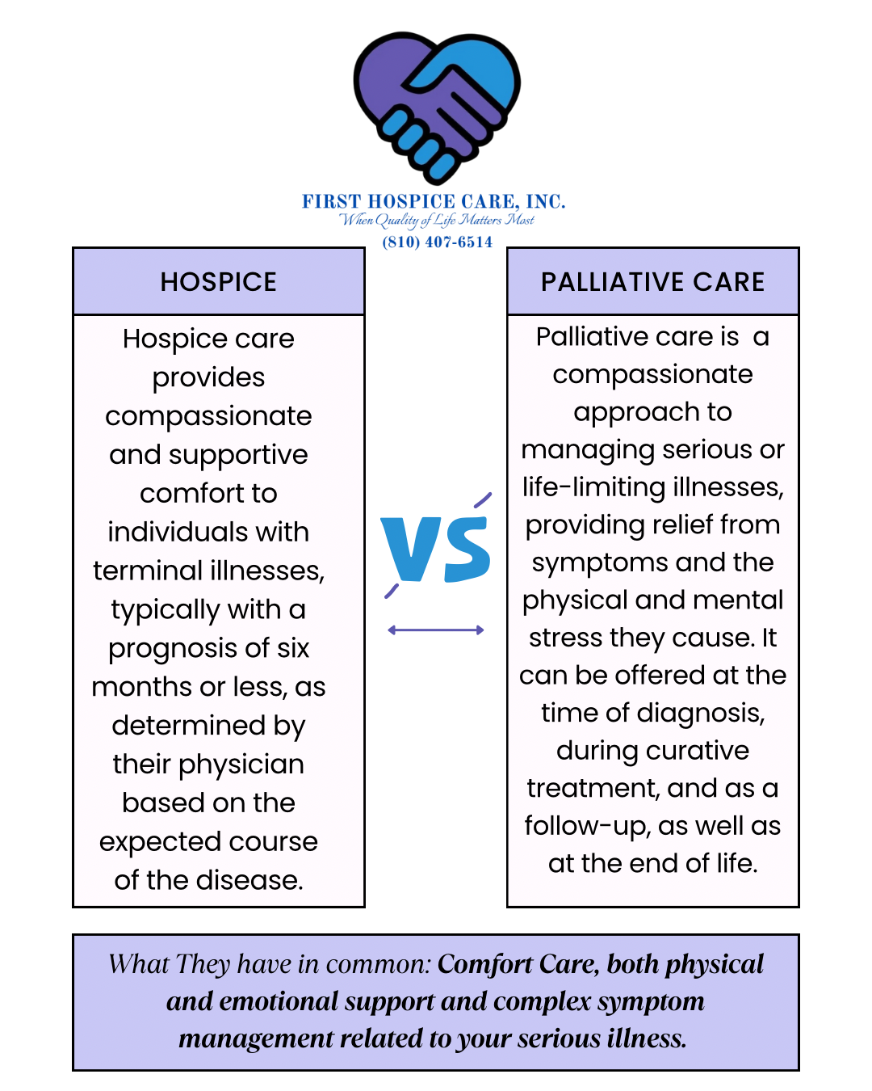

- Don't wait for a DNR or "six-month certainty"

- Hospice supports a range of diagnoses: CHF, COPD, dementia/Alzheimer’s, liver failure, etc.

- Hospice teams assist with goals of care and family education