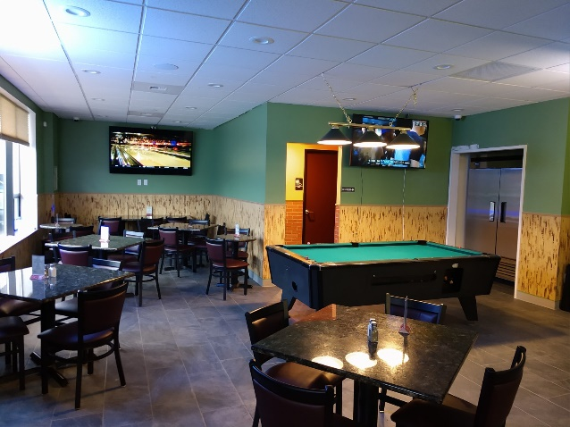
Pool Tables & TV

Pool Table to test your skill, 4 TVs to watch Sports & other viewing and table & chairs.

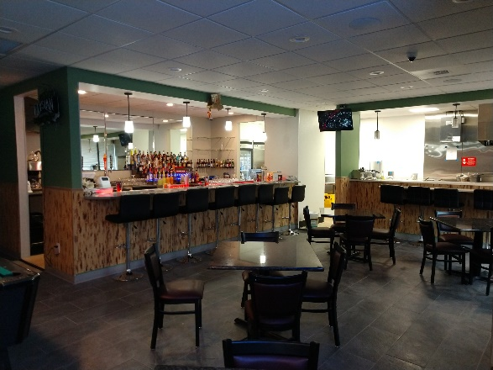
Drink, Food & Karaoke
A Well-Stocked Bar, Open kitchen to watch the chef work her magic, Karaoke & TV for tons of fun
Who We Are
About Us
Erawan Sports Bar & Grill is a small business (Family owned and operated). We just opened and are working to build our steady customers and patrons. We are looking forward to serving you and your friends.
We have dine in or takeout. No reservations
Contact Us
Phone:
(253) 267-1128
Manager Email:
jerry.theriault@gmail.com
Website:
www.Erawanbar.com
Online order:
https://erawanbar.smartonlineorder.com/
Address:
11620 Pacific HWY SW, STE C
Lakewood, WA, 98499
Reservations:
None / first come first served

Erawan
Sports Bar & Grill
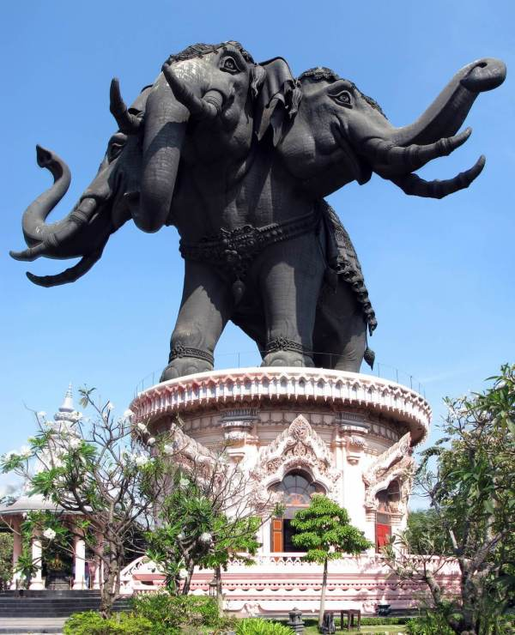

House Specials
Thai Food and Drinks
Bar open 11:00 AM to 02:00 AM
Grill open 11:00 AM To 8:00 PM
Come & dine in
Or
Order online, Call up & takeout
(253) 267-1128
11620 Pacific HWY SW, Ste C
Lakewood, WA, 98499

APPETIZERS
Offered from 11:00 AM to 01:00 AM
Ap1 French Fries in a Basket $4
Ap2 Fried Pot Stickers $8
Ap3 Steamed Pot Stickers $8
Ap4 Egg Rolls Vegetable $8
Chicken or Pork $9
Prawns $10
Ap5 Fresh Rolls Tofu or Vegetable $8
Chicken or Pork $9
Prawns $10
Ap6 Fried special in a Basket $17
Include: French Fries
Fried Pot Stickers 4
Egg rolls 4
Ap7 Fried Chicken Wings $10
Ap8 Chicken on a stick $10
Ap9 Deep Fried Meat $10
Ap10 Deep Fried Tofu $10
Sides
SI1 Bowl of White Rice $2
SI2 Sticky Rice $2
Desserts
Sold Separately
DS1 Mango & Sticky Rice $10
DS2 Black rice pudding $6
Main Dish
Offered from 11:00 AM to 9:00 PM
Spice Levels 0 to 5 available just speak with the person taking order
SOUP
So1 Hot and spicy soup
So2 coconut soup
SO Prices
Vegetable $10 Tofu $11
Chicken, or pork $12 Seafood $14
Beef, or prawns $13
So3 Wonton Soup $12

STIR Fried
ST1 PAD THAI (Thai Fried noodles)
ST2 PAD PAK (Vegetable Stir Fried)
St3 Khao Pad (THAI FRIED RICE)
St4 Pad Wun Sen (Stir FRIED Glass Noodles)
St5 Pad Mee Leung (Thai Egg Noodle)
St6 Pad Kee Mao (Drunken Noodles)
St7 Pad Kra Pao (Spicy Thai basil)
ST Prices
Vegetable $10 Tofu $11 chicken, or pork $12 crab $14
Beef, or prawns $13 Seafood $14
SALAD
Sa1 spicy seafood salad $15
Sa2 Thai Squid Salad $15
Sa3 Thai glass noodle salad $15
Sa4 Thai Beef Salad $15
SA5 Thai Spicy Lime Pork salad $13
Sa6 Grilled Pork salad $13
Sa7 PAPAYA Salad $13
Sa8 Minced meat
Chicken, or pork $13
Beef $14
CURRIES
Cu1 GREEN CURRY
Cu2 Red CURRY
Cu3 Yellow CURRY
CU Prices
Vegetable $10 Tofu $11 chicken, or pork $12 crab $14
Beef, or prawns $13 Seafood $14

Special of the day
Lunch Special includes Fountain Drink
SP1 Fried Chicken thigh & sticky rice $13
SP2 Grilled Squid $20
SP3 Deep Fried Meat Beef or Pork $20
SP4 Stirred Fried Asparagus $15
SP5 Stirred Fried Beef Broccoli $15
SP7 Hotdog & Fries in a Basket $7
SP9 Hotdog $3
Lunch Special
Offered from 11:00 AM to 1:00 PM
Choice of Chicken or Pork Only
Military Discount Lunch Special Only 10%
Lunch Special includes Fountain Drink

LS1 Pad Kra Pao, White rice, 2 egg rolls, 3 pot stickers $15
Ls2 Pad Thai, 2 egg rolls, 3 pot stickers $15
LS3 fried rice, 3 Satay, 2 egg rolls $15
LS4 red curry, White rice, 2 egg Rolls, 3 pot stickers $15
LS5 Green Curry, White rice, 2 egg rolls, 3 pot stickers $15
LS6 Fried rice, 3 Chicken Wings, 2 egg rolls $15
LS7 Som Tum, rice, 2 egg rolls, 3 pot stickers $15
Ls8 Fried Chicken thigh, French Fries in a Basket $15
LS9 Chicken wings, French Fries in a Basket $15
Drinks
SODA (Can) $1
Coke, Diet Coke, Pepsi, Diet Pepsi, Mountain Dew, Diet Mountain Dew, lemonade, lemonade Light
Thai Ice Tea $3 House Special
Thai Ice Coffee $3 House Special
Coffee $2 Ice Tea $2
Hot Tea $2 Green Tea $3
Bottle Water $1
Fountain
Free refills Except Orange Juice
Soda $2
Coke, Diet Coke, Sprite, Ginger Ale,
Tonic Water, Soda Water,
Orange Juice $3
Cranberry Juice $3

