**Erawan   
Sports Bar & Grill**

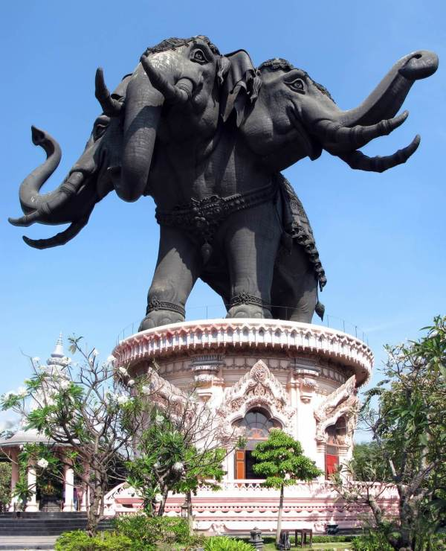

Takeout Menu

**Thai Food**

**Bar open 11:00 AM to 11:00 PM**

**Grill open 11:00 AM To 09:00 PM**

**Closed Tuesday**

**Come & dine in**

**Or**

**Call up & takeout**

**(253) 267-1128**

**11620 Pacific HWY SW, Ste C**

**Lakewood, WA, 98499**

**Who We Are**

**About Us**

**Erawan Sports Bar & Grill** is a small business (Family owned and operated). We Opened in 2019 and working to build our steady customers and patrons. We are looking forward to serving you and your friends.

**Delivery available**

Mon, Wed – Fri 5:00 PM – 8:50 PM

Weekends and holiday

1:00 PM to 8:50 PM

Minimum $25.00

Check website for area and cost

https://erawanbar.smartonlineorder.com/

**Contact Us**

**Phone:**

[**(253) 267-1128**](https://www.google.com/search?source=hp&ei=zbykXO2uMMXksAXoioqQBg&q=erawan+Sports+Par+and+Grill&btnK=Google+Search)

**Email:**

**jerry.theriault@gmail.com**

**Web:**

**ErawanBar.com**

**Address:**

**11620 Pacific HWY SW, STE C**

**Lakewood, WA, 98499**

**Reservations:**

**None / first come first served**

**APPETIZERS**

**Offered from 11:00 AM to 09:00 PM**

**Ap01 French Fries มันฝรั่งทอด $4**

**Ap02 Fried Pot Stickers เกี๊ยวทอด Chicken or Pork $9**

**Ap03 Steamed Pot Stickers เกี๊ยวนึ่ง Chicken or Pork $9**

**Ap04 Egg Rolls ปอเปี๊ยะทอด Vegetable $9**

**Chicken or Pork $11 Prawns $12**

**Ap05 Fresh Rolls ปอเปี๊ยะสด**

**Tofu or Vegetable $11**

**BBQ Pork $11**

**Prawns $12**

**Ap06 Fried special** **ทอดพิเศษ $20**

**Include:**

**French Fries มันฝรั่งทอด**

**Chicken wings 4 ปีกไก่ทอด**

**Egg rolls 4 ปอเปี๊ยะทอด**

**Fried Pot Stickers 4 เกี๊ยวทอด**

**Ap07 Deep Fried Chicken Wings ปีกไก่ทอด $12**

**Ap08 Satay สะเต๊ะ (Chicken on a stick) $12**

**Ap09 tod ½ Size ทอด (Deep Fried Meat) $12**

**Thai Beef jerky เนื้อทอด**

**Thai Pork jerky หมูทอด**

**Ap10 Deep Fried Tofu เต้าหู้ทอด $12**

**AP11 Crunchy Coconut Shrimp**

**กุ้งมะพร้าวกรุบ $13**

**AP12 Calamari แหวนคาลามารี $13**

**AP13 Fish Cakes เค้กปลา $13**

**AP14 Deep Fried Cod and Fries**

**ปลาคอดและมันฝรั่งทอด $13**

**Sides**

**SI01 ChAm k̄HAw k̄hAw ขาว้สวย (Bowl of White Rice) $3**

**SI02 Khao Niao ข้าวเหนียว (Sticky Rice) $3**

**SI03 Sweet Sticky Rice**

**ขาว้เหืนยวมูล $4**

**SI04 Egg ไข่ (1 each) $3**

**SI05 Peanut Sauce Large ซอสถั่ว $5**

**SI06 Double Bowl of Rice White**

**ข้าวขาว $6**

**Desserts**

**DS01 Mango & sweet Sticky Rice ข้าวเหนียวมะม่วง & หวาน $12**

**DS02 Black rice pudding พุดดิ้งข้าวสีดำ $7**

**DS03 toasted sticky rice ข้าวเหนียวปิ้ง (Each) $3**

**Spice Levels 0 to 5 available just speak with the person taking order**



**STIR Fried**

**ST01 PAD THAI ผัดไทย (Thai Fried noodles)**

**See below for meats and Prices**

**ST02 PAD PAK ผัดผัก (Vegetable Stir Fried)**

**- Serve with rice See below for meats and Prices**

**St03 Khao Pad ข้าวผัด (THAI FRIED RICE)**

**See below for meats and Prices**

**St04 Pad Wun Sen ผัดวุ้นเส้น (Stir FRIED Glass Noodles)**

**See below for meats and Prices**

**St05 Pad Mee Leung ผัดหมี่เหลือง (Thai Egg Noodle)**

***See below for meats and Prices***

**St06 Pad Kee Mao ผัดขี้เมา (Drunken Noodles)**

***See below for meats and Prices***

**St07 Pad Kra Pao ผัดกะเพรา (Spicy Thai basil)**

**(we Use Ground Chicken, Pork or Beef) (all other meats chunked)**

**see below for meats and Prices**

**St08 Cashew nuts ผัดเม็ดมะม่วงหิมพานต์**

**(Stirred Fried Cashews)**

**- serve with** **rice See below for meats and Prices**

**ST10 Khao Pad Muang ข้าวผัดมะม่วง (Mango Fried Rice) Add $2**

**See below for meats and Prices**

**ST11 Khao Pad Kee Moa ข้าวผัดขี้เมา (Drunken Fried Rice)**

**See below for meats and Prices**

**ST12 Pad See Ew ผัด ซีอิ้ว (Wide Rice Noodles)**

**See below for meats and Prices**

**ST Prices**

**ผัก Vegetable $13 เต้าหู้ Tofu $13**

**ไก่หรือหมู chicken, or Pork $14**

**เนื้อหรือกุ้ง Beef, or Prawns $15**

**อาหารทะเล Seafood ปู crab $16**

**St09 Crispy Garlic Chicken**

**ไก่กระเทียมกรอบ $14**

**- Serve with rice**

**CURRIES**

**Cu01 Kaeng k̄heiy whwan แกงเขียวหวาน (GREEN CURRY)**

**- Serve with rice. See below for meats and Prices**

**Cu02 kaeng phed แกงแดง-แกงดผ็ด (Red CURRY)**

**- Serve with rice. See below for meats and Prices**

**Cu03 kaeng lueang แกงเหลือง (Yellow CURRY) *- Served with Rice. See below for meats and Prices***

**CU Prices**

**ผัก Vegetable $13 เต้าหู้ Tofu $13**

**ไก่หรือหมู chicken, or Pork $14**

**เนื้อหรือกุ้ง Beef, or Prawns $15**

**อาหารทะเล Seafood ปู crab $16**

**CU04 Kaeng phanaeng แกงพะแนง (Panang Curry)**

**– Served with Rice**

**ผัก Vegetable $13 เต้าหู้ Tofu $13**

**ไก่ chicken $14 หมู Pork $15**

**เนื้อ Beef $16**

**SOUP**

**So01 TOM YUM Small / Large ต้มยำ (Hot and spicy soup)**

**– serve with rice/-served with Two Rice. See below for meats and Prices**

**So02 TOM KHA Small / Large ต้มข่า (coconut soup)**

**– Served with Rice/-served with Two Rice. See below for meats and Prices**

**Soup Meat Prices**

**ผัก Vegetable $13/$18 เต้าหู้ Tofu $13/$19**

**ไก่หรือหมู Chicken, or pork $13/$20**

**เนื้อหรือกุ้ง Beef, or prawns $14/$20**

**อาหารทะเล Seafood $15/$21**

**ปู crab $15/$21**

**So03 Wonton Soup ซุปเกี๊ยว (Wonton Soup) $14**

**SALAD**

**Offered from 11:00 AM to 09:00 PM**

**Sa01 YUM THALE ROD DED ยำทะเลรสเด็ด (spicy seafood salad) $17**

**Sa02 YUM PLA MEUK ยำปลาหมึก (Thai Squid Salad) $16**

**Sa03 YUM WUN SEN ยำวุ้นเส้น (Thai glass noodle salad) $16**

**Sa04 YUM NEUA ROD DED ยำเนื้อ (Thai Beef Salad) $16**

**SA05 Moo MANAO หมูมะนาว $15 (Thai Spicy Lime Pork salad)**

**Sa07 Som tum ส้มตำกุ้งสด (PAPAYA SALAD) $16**

**Sa08 LARB ลาบ (Ground meat)**

**ไก่หรือหมู chicken, or pork $16**

**อวัว Beef $17**

**Combination Platter**

**Choice of Chicken or Pork Only**

**Offered from 11:00 AM to 09:00 PM**

**LS01 Ground Thai basil Meat, rice, Sunny Side Up Egg, 3 pot stickers $16**

**LS02 Thai Fried noodles, 2 egg rolls, 3 pot stickers $16**

**LS04 red curry, rice, 2 egg Rolls, 3 pot stickers $16**

**LS05 Green Curry, rice, 2 egg rolls, 3 pot stickers $16**

**LS06 Fried rice, 4 Chicken Wings, 2 egg rolls $16**

**LS08 Fried Chicken thigh, French Fries $16**

**LS09 Chicken wings, French Fries $16**

**LS10 Yellow Curry, rice, 2 egg rolls, 3 pot stickers $16**

**LS11 Mango Fried rice, 2 egg rolls, 3 pot stickers $18**

**LS12 Drunken Noodles, 2 egg rolls, 3 pot stickers $16**

**LS13 Thai Egg Noodles, 2 egg rolls, 3 pot stickers $16**

**LS14 Pad See Ew, 2 egg rolls, 3 pot stickers $16**

**LS15 Cashew Nuts, 2 egg rolls, 3 pot stickers $16**

**LS16 Drunken Fried Rice, 2 egg rolls, 3 pot stickers $16**

**Combination Platter Chicken or Pork Only**

**Special of the day**

**Offered from 11:00 AM to 09:00 PM**

**SP01 Khai hat yai หาดใหญ่ (Fried Chicken thigh & sticky rice) $18**

**SP02 Pla Muek Yang ปลาหมึกย่าง (Grilled Squid) $25**

**SP03 tod ทอด (Deep Fried Meat) Thai Beef jerky เนื้อทอด $25**

**Thai Pork jerky หมูทอด $25**

**SP04 Fried Asparagus หน่อไม้ฝรั่งผัด**

**(Stirred Fried Asparagus) $17**

**- Severed with Rice**

**SP05 Fried Beef Broccoli บร็อคโคลี่ผัดเนื้อ $17**

**(Stirred Fried Beef Broccoli)**

**. – Served with Rice**

**SP07 Hotdog & Fries $7**

**SP09 Hotdog $4**

**SP10 Sweet & Sour Fish ปลาเปรี้ยวหวาน (Sweet & Sour Fish)**

**Whole Fish only – Served with Rice $35**

**ปลากะพงแดงฮาวาย Hawaiian Red Snapper Fish**

**ปลาเก๋า Grouper Fish $35**

**SP12 Deep Fried Tilapia ปลานิลทอด**

**Whole Fish only – Served with Rice**

**ปลานิล Tilapia Fish $20**