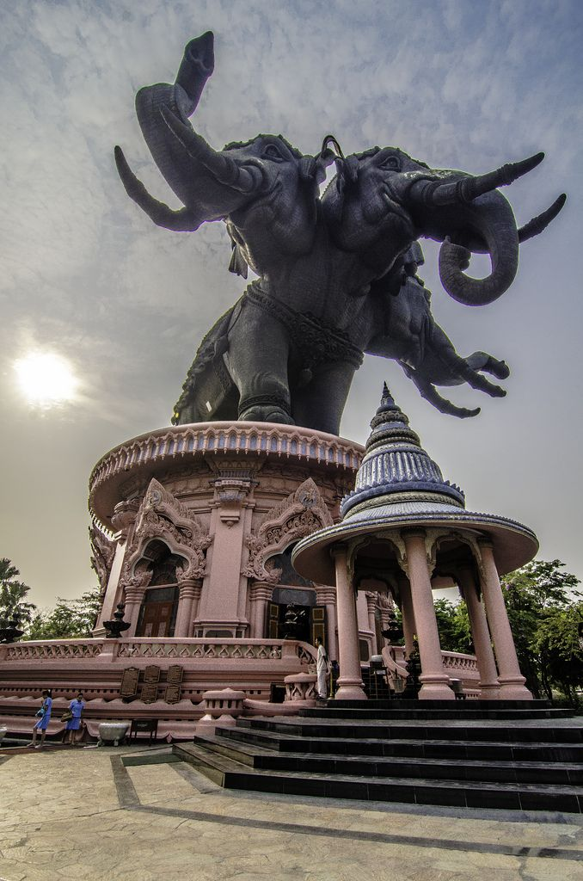

Erawan
Sports Bar and Grill

Erawan Thai: เอราวัณ, Sanskrit is one of the Thai names of
Airaavatha. It is depicted as a huge elephant with three heads
god known for his kindness, mercy, sympathy and impartiality
APPETIZERS
Military Personnel in uniform Discount 10%
Offered from 11:00 AM to 09:00 PM

Ap01 French Fries มันฝรั่งทอด $4
Ap02 Fried Pot Stickers เกี๊ยวทอด Chicken or Pork $9
Ap03 Steamed Pot Stickers เกี๊ยวนึ่ง Chicken or Pork $9
Ap04 Egg Rolls ปอเปี๊ยะทอด Vegetable $9
Chicken or Pork $11
Prawns $12
Ap05 Fresh Rolls ปอเปี๊ยะสด Tofu or Vegetable $11
Chicken or Pork $11
Crab Sticks or Prawns $12
Ap06 Fried special ทอดพิเศษ $20
Include:
French Fries มันฝรั่งทอด
Chicken wings 4 ปีกไก่ทอด
Egg rolls 4 ปอเปี๊ยะทอด
Fried Pot Stickers 4 เกี๊ยวทอด
Choice of Chicken or Pork Only
Ap07 Deep Fried Chicken Wings ปีกไก่ทอด $12
Ap08 Satay สะเต๊ะ (Chicken on a stick) $12
Ap09 tod Half Size ทอด (Deep Fried Meat) $12
Thai Beef jerky เนื้อทอด
Thai Pork jerky หมูทอด
Ap10 Deep Fried Tofu เต้าหู้ทอด (Deep Fried Tofu) $12
AP11 Crunchy Coconut Shrimp กุ้งมะพร้าวกรุบ $13
AP12 Calamari Rings แหวนคาลามารี $13
AP13 Fish Cakes เค้กปลา $13
AP14 Deep Fried Cod and Fries ปลาคอดและมันฝรั่งทอด $13
Sides
SI01 ChAm k̄HAw k̄hAw ขาว้สวย (Bowl of White Rice) $3 SI02 Khao Niao ข้าวเหนียว (Sticky Rice) $3
SI03 Sweet Sticky Rice ข้าวเหนียวหวาน $4
SI04 Fried Egg ไข่ดาว (1 each) $3
SI05 Peanut Sauce Large ซอสถั่วลิสงขนาดใหญ่ $5
SI06 Double Bowl of White Rice ข้าวขาวสองชาม $6

Desserts
Sold Separately
DS01 Mango & sweet Sticky Rice ข้าวเหนียวมะม่วง & หวาน $12
DS02 Black rice pudding พุดดิ้งข้าวสีดำ $7
DS03 toasted sticky rice ข้าวเหนียวปิ้ง (Each) $3

Main Dish
Military Personnel in uniform Discount 10%
Offered from 11:00 AM to 09:00 PM
Spice Levels 0 to 5 available just speak with the person taking order
STIR Fried
ST01 PAD THAI ผัดไทย (Thai Fried noodles)
Rice noodle, white and Green onion, egg, bean sprout, Peanuts and LIME slice on the side. See below for meats and Prices
ST02 PAD PAK ผัดผัก (Vegetable Stir Fried)
Garlic, Mushrooms, Bok choy, snow peas, Broccoli, Green Beans, Baby Corn, Bean Sprouts, and tomato. - Serve with rice See below for meats and Prices
St03 Khao Pad ข้าวผัด (THAI FRIED RICE)
Rice, White and Green onion, Broccoli, egg, Tomato. See below for meats and Prices
St04 Pad Wun Sen ผัดวุ้นเส้น (Stir FRIED Glass Noodles)
Snow Peas, Celery, Baby Corn, Green Onion, Green Beans, Broccoli, Carrots, Egg. See below for meats and Prices
St05 Pad Mee Leung ผัดหมี่เหลือง (Thai Egg Noodle)
Egg Noodles, Broccoli, Carrots, Snow Peas, Green Beans, Green Onion, Celery, Pineapple, Cashews. See below for meats and Prices
St06 Pad Kee Mao ผัดขี้เมา (Drunken Noodles)
Fresh Noodles, Egg, Broccoli, Carrots, Green Beans, Baby Corn, Bamboo Shoots, Tomato, Sweet Basil, and red and Green Bell Peppers. See below for meats and Prices
St07 Pad Kra Pao ผัดกะเพรา (Spicy Thai basil)
Green Beans, Green and Red Bell Peppers, White Onions, Sweet Basil - Serve with rice See below for meats and Prices (Use ground Chicken or Pork) (All other meats Chunked)

St08 Cashew nuts ผัดเม็ดมะม่วงหิมพานต์ (Stirred Fried Cashews)
Cashew nuts, Green & White onions, carrots, Green and Red Bell Peppers, - serve with rice See below for meats and Prices

ST10 Khao Pad Muang ข้าวผัดมะม่วง (Mango Fried Rice) Add $2
Rice, Mango, Egg, Broccoli, Sweet Basil, Red & Green Bell Peppers. See below for meats and Prices
ST11 Khao Pad Kee Moa ข้าวผัดขี้เมา (Drunken Fried Rice)
Rice, Egg, Tomato, Broccoli, Carrots, Onion, Sweet Basil, Red & Green Bell Peppers, Bamboo Shoots. See below for meats and Prices
ST12 Pad See Ew ผัด ซีอิ้ว (Wide Rice Noodles)
Fresh Noodles, Egg, Broccoli, Carrots, Baby Corn and Bok Choy. See below for meats and Prices
Stir Fry Meat Prices
ผัก Vegetable $13 เต้าหู้ Tofu $13
ไก่หรือหมู chicken, or pork $14 เนื้อหรือกุ้ง Beef, or prawns $15
อาหารทะเล Seafood $16 ปู crab $16
St09 Crispy Garlic Chicken ไก่กระเทียมกรอบ $14
Yellow, Red, and Green Bell Peppers, Yellow and Green Onions.
- serve with rice

Main Dish
Military Personnel in uniform Discount 10%
Offered from 11:00 AM to 9:00 PM
Spice Levels 0 to 5 available just speak with the person taking order
CURRIES

Cu01 Kaeng k̄heiy whwan แกงเขียวหวาน (GREEN CURRY)
Green curry paste, coconut milk, Bamboo Shoots, green beans, Zucchini eggplant, Red and Green Bell Peppers, and Sweet Basil. Serve with rice. See below for meats and Prices
Cu02 kaeng phed แกงแดง-แกงดผ็ด (Red CURRY)
Red curry paste, coconut milk, Bamboo Shoots, green beans, Zucchini eggplant, Red and Green Bell Peppers, and Sweet Basil. Serve with rice. See below for meats and Prices
Cu03 kaeng lueang แกงเหลือง (Yellow CURRY)
Yellow curry paste, Potato, Pineapple, Carrot, and Onion. Served with Rice. See below for meats and Prices
CU Prices
ผัก Vegetable $13 เต้าหู้ Tofu $13
ไก่หรือหมู chicken, or pork $14 เนื้อหรือกุ้ง Beef, or prawns $15
อาหารทะเล Seafood $16 ปู crab $16
CU04 Kaeng Panang แกงพะแนง (Panang Curry)
Panang Paste, Sweet Basil, Kaffir Lime Leaves, red & Green Bell Peppers.
– Served with Rice
ผัก Vegetable $13 เต้าหู้ Tofu $13
ไก่ chicken $14 หมู Pork $15 เนื้อ Beef $16

SOUP

So01 TOM YUM Small / Large Bowl ต้มยำ (Hot and spicy soup)
Tom Yum Paste, Mushrooms, Green and White Onion, Tomato, Cilantro. – serve with rice / – serve with Two rice. See below for meats and Prices
So02 TOM KHA Small / Large Bowl ต้มข่า (coconut soup)
Tom Kha Paste, Coconut Milk, Mushrooms, Green and White Onion, Cilantro, Tomato – Served with Rice / – serve with Two rice. See below for meats and Prices
Soup Meat Prices
ผัก Vegetable $13/$18 เต้าหู้ Tofu $13/$19
ไก่หรือหมู chicken, or pork $13/$20 เนื้อหรือกุ้ง Beef, or prawns $14/$20
อาหารทะเล Seafood $15/$21 ปู crab $15/$21
So03 Wonton Soup ซุปเกี๊ยว (Wonton Soup) $14
Dumplings Pork, BBQ Pork, Egg Noodles, Bok Choy, Green Onions, Fried Garlic, Fried, Fried Cilantro.

Main Dish
Military Personnel in uniform Discount 10%
Offered from 11:00 AM to 9:00 PM
Spice Levels 0 to 5 available just speak with the person taking order

SALAD

Sa01 YUM THALE ROD DED ยำทะเลรสเด็ด (spicy seafood salad) $16
Prawns, mussels, squid, crab, Clams, Scallops, Celery, Green and White Onion, and house Sauce.
Sa02 YUM PLA MEUK ยำปลาหมึก (Thai Squid Salad) $16
Squid, onion, celery, ginger, Mint and house Sauce.
Sa03 YUM WUN SEN ยำวุ้นเส้น (Thai glass noodle salad) $16
Clear noodle, prawns, squid ground pork, tomato, green and White onion, Cashews, cilantro, with house sauce.
Sa04 YUM NEUA ROD DED ยำเนื้อ (Thai Beef Salad) $16
Slice beef, Green and White Onion, Tomato, Cucumber and House Sauce.
SA05 Moo MANAO หมูมะนาว (Thai Spicy Lime Pork salad) $15
Slice pork, thin slice of lime, House Sauce.
Sa07 Som tum ส้มตำกุ้งสด (PAPAYA SALAD) $16
Papaya, stream prawns, Tomato. Long Beans, Carrots, Peanuts and Cabbage on the side
Sa08 LARB ลาบ (Minced meat)
Red onion, crush chili pepper, ground roasted rice, Mint, Green and White Onions.
ไก่หรือหมู chicken, or pork $16
เนื้อวัว Beef $17
Combination Platters
Offered from 11:00 AM to 09:00 PM
Choice of Chicken or Pork Only

LS01 Spicy Thai basil Meat, rice, Fried egg, 3 pot stickers $16
LS02 Pad Thai, 2 egg rolls, 3 pot stickers $16
LS04 red curry, rice, 2 egg Rolls, 3 pot stickers $16
LS05 Green Curry, rice, 2 egg rolls, 3 pot stickers $16
LS06 Thai Fried rice, 4 Chicken Wings, 2 egg rolls $16
LS08 Fried Chicken thigh, French Fries $16
LS09 Chicken wings, French Fries $16
LS10 Yellow Curry, rice, 2 egg rolls, 3 pot stickers $16
LS11 Mango Fried rice, 2 egg rolls, 3 pot stickers $18
LS12 Drunken Noodles, 2 egg rolls, 3 pot stickers $16
LS13 Thai Egg Noodles, 2 egg rolls, 3 pot stickers $16
LS14 Pad See Ew, 2 egg rolls, 3 pot stickers $16
LS15 Cashew Nuts, 2 egg rolls, 3 pot stickers $16
LS16 Drunken Fried Rice, 2 egg rolls, 3 pot stickers $16

Special and drinks
Military Personnel in uniform Discount 10%

Specials
Offered from 11:00 AM to 09:00 PM
SP01 Khai hat yai หาดใหญ่ (Fried Chicken thigh & sticky rice) $18
SP02 Pla Muek Yang ปลาหมึกย่าง (Grilled Squid) $25
SP03 tod ทอด (Deep Fried Meat) $25
Thai Beef jerky เนื้อทอด
Thai Pork jerky หมูทอด
SP04 Fried Asparagus หน่อไม้ฝรั่งผัด (Stirred Fried Asparagus) $17
White Onion, Prangs, Scallops, Asparagus, Garlic, Red and Green Bell Peppers.
- Severed with Rice
SP05 Fried Beef Broccoli บร็อคโคลี่ผัดเนื้อ (Stirred Fried Beef Broccoli) $17
Beef, Broccoli, White Onion, Garlic. – Served with Rice
SP07 Hotdog & Fries ฮอทดอกและมันฝรั่งทอด $7
SP09 Hotdog ฮอทดอก $4
SP10 Sweet & Sour Fish ปลาเปรี้ยวหวาน (Sweet & Sour Fish)
White & Green onions, Red & Green Bell Peppers, Pineapple, and Carrots See below for Fish and Prices Whole Fish only
ปลากะพงแดงฮาวาย Hawaiian Red Snapper Fish $35
ปลาเก๋า Grouper Fish $35
SP12 Deep Fried Tilapia ปลานิลทอด Whole Fish only – Served with Rice
ปลานิล Tilapia Fish $20
Drinks

SODA (Can) $2 Coke, Diet Coke, Pepsi, Diet Pepsi, Mountain Dew, Diet
Mountain Dew, Root Beer, 7UP, Sprite, Ginger Ale, lemonade, lemonade Light
Ginger Beer $4
Thai Ice Tea $3.50 House Special
Thai Ice Coffee $3.50 House Special
Coffee $2
Hot Tea $2
Ice Tea $2
Green Tea $3
Bottle Water $2
Coconut Water $3
Can Juices $2 Apple, Cranberry, Orange, Pineapple, Tomato,
White Grapefruit, and V8

Beer Options
Offered from 11:00 AM to 12:00 AM

On Tap
Troll Tap $5 PTCH $19
Stella Artois Tap $4 PTCH $17
Shocktop Tap $4 PTCH $17
Elysian IPA Tap $5 PTCH $19
Pitchers three or more persons

Non-Alcoholic
Coors Amber $3.50 O'Doul's amber $3.50
O'Doul's green $3.50

Bottles
Bud light $3.50 Budweiser $3.50
Coors light $3.50 Genuine Draft $3.50
Michelob Ultra $3.50 Corona $4.50
Heineken $4.50 Modelo $4.50
Moose Head $4.50 Alaskan Amber $5
Blue Moon $5 Elysian IPA $5
Guinness Draught $5 Guinness Special Export $5
Hefe $5 Hite $5
OB $5 Vailima $5
Chang $5 Leo $5
Singha $5

Pabst Blue Ribbon (PBR) $3 Local House Special (while they last)

Wines
Sold by glass or bottle (two or more people)
California root House Wine $5 / $25
Chardonnay, Sauvignon Blanc, Pinot Grigio, Moscato, Rose, Cabernet, Sangria, Red Blend
Zinfandel $6 / $35
Merlot $6 / $35
Cabernet Sauvignon $7 / $40
Malbec $7 / $40

