

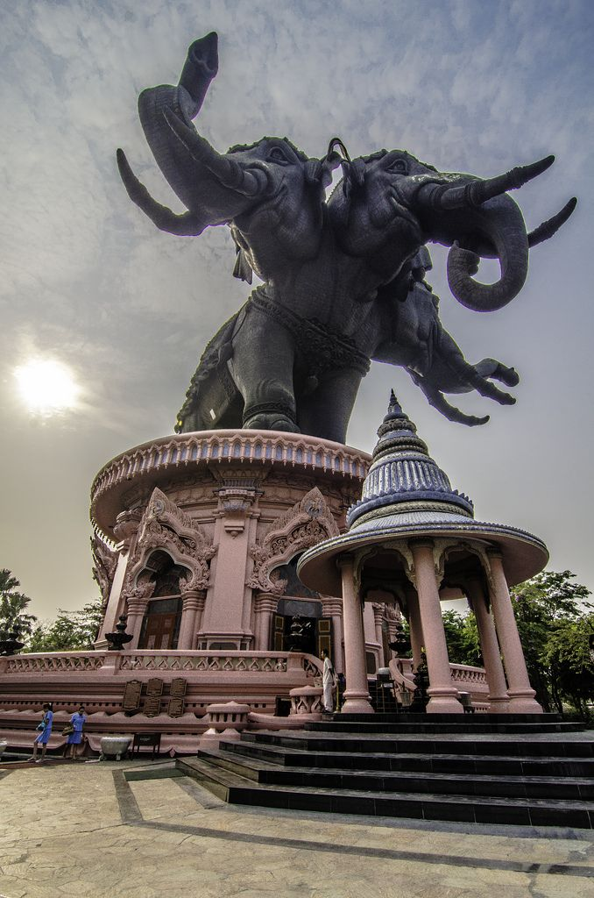

**Erawan**

**Sports Bar and Grill**

**Erawan** Thai: เอราวัณ, Sanskrit is one of the **Thai** names of

Airaavatha. It is depicted as a huge elephant with **three heads**

**god** known for his kindness, mercy, sympathy and impartiality







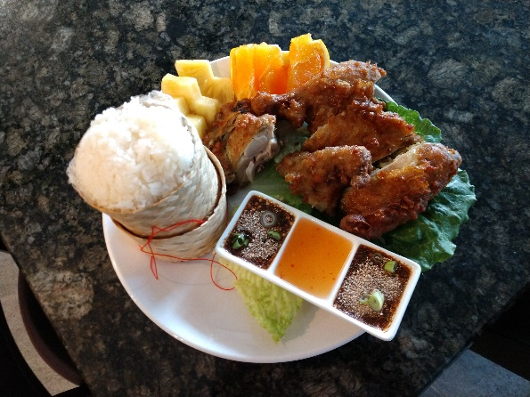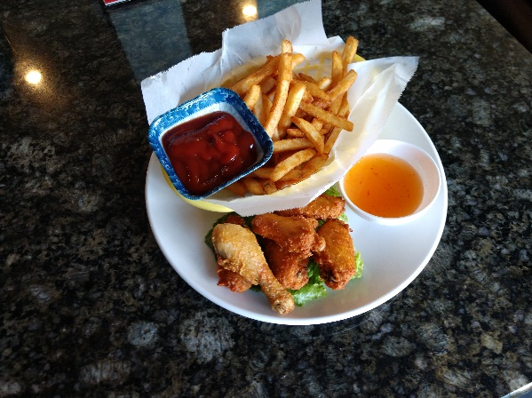

**LS9 Chicken Wings and Fries SP1 Khai hat yai**

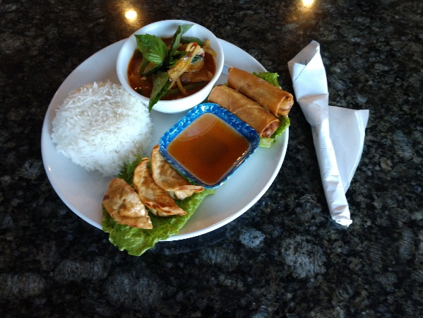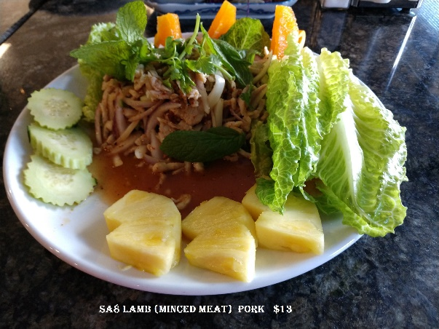

**LS4 red curry, rice, Sa8 LARB Minced meat**

**2 egg Rolls, 3 pot stickers**

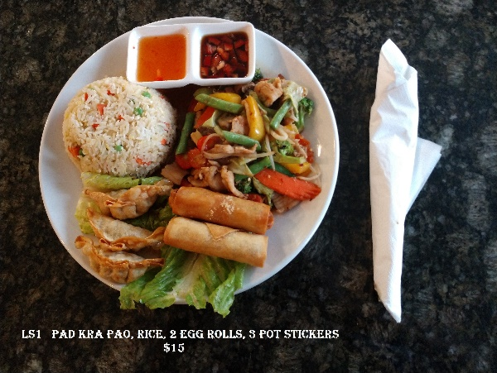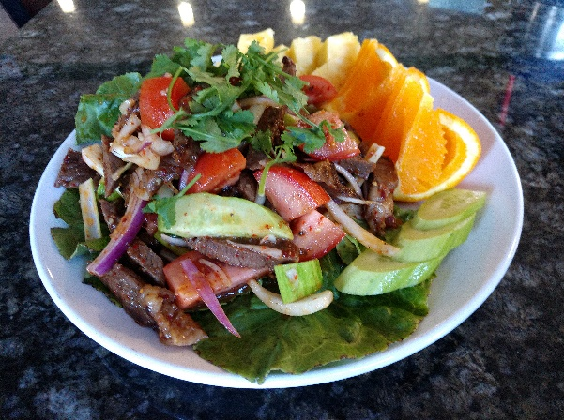

**LS1 Pad Kra Pao, Fried rice, Sa4 YUM NEUA ROD DED**

**2 egg rolls, 3 pot stickers Thai Beef Salad**



**APPETIZERS**

**Offered from 11:00 AM to 09:00 PM**

**Ap1 French Fries in a Basket มันฝรั่งทอดในตะกร้ $4**

**Ap2 Fried Pot Stickers เกี๊ยวทอด Chicken or Pork $8**

**Ap3 Steamed Pot Stickers เกี๊ยวนึ่ง Chicken or Pork $8**

**Ap4 Egg Rolls ปอเปี๊ยะทอด Vegetable $8**

**Chicken or Pork $9**

**Prawns $10**

**Ap5 Fresh Rolls ปอเปี๊ยะสด Tofu or Vegetable $8**

**Chicken or Pork $9**

**Prawns $10**

**Ap6 Fried special in a Basket ทอดพิเศษในจะกล้า $17**

**include:**

**French Fries มันฝรั่งทอด**

**Fried Pot Stickers 4 เกี๊ยวทอด**

**Egg rolls 4 ปอเปี๊ยะทอด**

**Ap7 Deep Fried Chicken Wings ปีกไก่ทอด $10**

**Ap8 Satay สะเต๊ะ (Chicken on a stick) $10**

**Ap9 NeaU tod ½ Size เนื้อทอด (Deep Fried Meat) $10**

**Beef or Pork**

**Ap10 Deep Fried Tofu เต้าหู้ทอด (Deep Fried Tofu) $10**

**Sides**

**SI1 ChAm k̄HAw k̄hAw ชามข้าวขาว (Bowl of White Rice) $2**

**SI2 Khao Niao ข้าวเหนียว (Sticky Rice) $2**

**Desserts**

**Sold Separately**

**DS1 Mango & sweet Sticky Rice ข้าวเหนียวมะม่วง & หวาน $10**

**DS2 Black rice pudding พุดดิ้งข้าวสีดำ $6**



**Main Dish**

**Offered from 11:00 AM to 9:00 PM**

**Spice Levels 0 to 5 available just speak with the person taking order**



**STIR Fried**

**ST1 PAD THAI ผัดไทย (Thai Fried noodles)**

Rice noodle, white and Green onion, egg, bean sprout, Peanuts and LIME slice on the side. *See below for meats and Prices*

**ST2 PAD PAK ผัดผัก (Vegetable Stir Fried)**

Bok choy, Chinese cabbage, carrot, snow peas, red and green bell pepper, tomato. *See below for meats and Prices*

**St3 Khao Pad ข้าวผัด (THAI FRIED RICE)**

Rice, White and Green onion, egg, Tomato. *See below for meats and Prices*

**St4 Pad Wun Sen ผัดวุ้นเส้น (Stir FRIED Glass Noodles)**

Snow Peas, Celery, Green Onion, Green Beans, Broccoli, Carrots, Egg. *See below for meats and Prices*

**St5 Pad Mee Leung ผัดหมี่เหลือง (Thai Egg Noodle)**

Egg Noodles, Broccoli, Carrots, Baby Corn, Snow Peas, Green Beans, Green Onion, Celery, Pineapple, Cashews. *See below for meats and Prices*

**St6 Pad Kee Mao ผัดขี้เมา (Drunken Noodles)**

Fresh Noodles, Bell Peppers, Carrots, Sweet Basil, Broccoli, Onion, Tomato, Egg. *See below for meats and Prices*

**St7 Pad Kra Pao ผัดกระเพราไก่ (Spicy Thai basil)**

Green Beans, Green and Red Bell Peppers, White Onions, Sweet Basil, *See below for meats and Prices*

**ST Prices**

**ผัก Vegetable $10 เตาฮู Tofu $11**

**ไก่หรือหมู chicken, or pork $12 เนื้อหรือกุ้ง Beef, or prawns $13**

**อาหารทะเล Seafood $14 ปู crab $14**



**Main Dish**

**Offered from 11:00 AM to 9:00 PM**

**Spice Levels 0 to 5 available just speak with the person taking order**



**CURRIES**

**Cu1 Kaeng k̄heiy whwan แกงเขียวหวาน (GREEN CURRY)**

Green curry paste, coconut milk, Bamboo Shoots, green beans, Zucchini eggplant, Red and Green Bell Peppers, and Sweet Basil. Serve with rice. *See below for meats and Prices*

**Cu2 kaeng phed แกงแดง-แกงดผ็ด (Red CURRY)**

Red curry paste, coconut milk, Bamboo Shoots, green beans, Zucchini eggplant, Red and Green Bell Peppers, and Sweet Basil. Serve with rice. *See below for meats and Prices*

**Cu3 kaeng lueang แกงเหลือง (Yellow CURRY)**

Yellow curry paste, Potato, Pineapple, Carrot, and Onion. Served with Rice. *See below for meats and Prices*

**CU Prices**

**ผัก Vegetable $10 เตาฮู Tofu $11**

**ไก่หรือหมู chicken, or pork $12 เนื้อหรือกุ้ง Beef, or prawns $13**

**อาหารทะเล Seafood $14 ปู crab $14**

**SOUP**

**So1 TOM YUM ต้มยำ (Hot and spicy soup)**

Tom Yum Paste, Mushrooms, Green and White Onion, Tomato, Cilantro. – serve with rice. *See below for meats and Prices*

**So2 TOM KHA ต้มข่า (coconut soup)**

Tom Kha Paste, Coconut Milk, Mushrooms, Green and White Onion, Cilantro, Tomato – Served with Rice. *See below for meats and Prices*

**SO Prices**

**ผัก Vegetable $10 เตาฮู Tofu $11**

**ไก่หรือหมู chicken, or pork $12 เนื้อหรือกุ้ง Beef, or prawns $13**

**อาหารทะเล Seafood $14 ปู crab $14**

**So3 Wonton Soup ซุปเกี๊ยว (Wonton Soup) $12**

Dumplings Pork, BBQ Pork, Egg Noodles, Bok Choy, Green Onions, Fried Garlic, Fried, Fried Cilantro. – serve with rice.



**Main Dish**

**Offered from 11:00 AM to 9:00 PM**

**Spice Levels 0 to 5 available just speak with the person taking order**



**SALAD**

**Sa1 YUM THALE ROD DED ยำทะเลรสเด็ด (spicy seafood salad) $15**

Prawns, mussels, squid, crab, Clams, Scallops, Celery, Green and White Onion, and house Sauce.

**Sa2 YUM PLA MEUK ยำปลามึง (Thai Squid Salad) $15**

Squid, onion, celery, ginger, Mint and house Sauce.

**Sa3 YUM WUN SEN ยำวุ้นเส้น (Thai glass noodle salad) $15**

Clear noodle, prawns, squid ground pork, tomato, green and White onion, Cashews, cilantro, with house sauce.

**Sa4 YUM NEUA ROD DED ยำเนื้อ (Thai Beef Salad) $15**

**S**lice beef, Green and White Onion, Tomato, Cucumber and House Sauce.

**SA5 Moo MANAO หมูมะนาว (Thai Spicy Lime Pork salad) $13**

Slice pork, thin slice of lime, House Sauce.

**Sa6 KHAW MU YANG KHA-NA KROB คอหมูย่างคะน้า (Grilled Pork salad) $13**

Grill pork, Vegetables, house sauce.

**Sa7 Som tum ส้มตำกุ้งสด (PAPAYA SALAD) $13**

Papaya, stream prawns, Tomato. Peanuts and Bean Sprouts on the side

**Sa8 LARB ลาบ (Minced meat)**

Red onion, crush chili pepper, ground roasted rice, Mint, Green and White Onions.

**ไก่หรือหมู chicken, or pork $13**

**เนื้อวัว Beef $14**



**Lunch Special**

**Offered from 11:00 AM to 1:00 PM**

**Choice of Chicken or Pork Only**

**Military Discount Lunch Special Only 10%**

**Lunch Special includes Fountain Drink**

**LS1 Thai basil chicken, rice, 2 egg rolls, 3 pot stickers $15**

**LS2 Thai Fried noodles, 2 egg rolls, 3 pot stickers $15**

**LS3 fried rice, 3 Satay, 2 egg rolls $15**

**LS4 red curry, rice, 2 egg Rolls, 3 pot stickers $15**

**LS5 Green Curry, rice, 2 egg rolls, 3 pot stickers $15**

**LS6 Fried rice, 4 Chicken Wings, 2 egg rolls $15**

**LS7 Som Tum, rice, 2 egg rolls, 3 pot stickers $15**

**LS8 Fried Chicken thigh, French Fries in a Basket $15**

**LS9 Chicken wings, French Fries in a Basket $15**

**Special of the day**

**Offered from 11:00 AM to 09:00 PM**

**SP1 Khai hat yai หาดใหญ่ (Fried Chicken thigh & sticky rice) $13**

**SP2 Pla Muek Yang ปลาหมึกย่าง (Grilled Squid) $20**

**SP3 NeaU tod เนื้อทอด (Deep Fried Meat) Beef or Pork $20**

**SP4 Fried Asparagus หน่อไม้ฝรั่งผัด (Stirred Fried Asparagus) $15**

**White Onion, Prangs, Scallops, Asparagus, Garlic, Red and Green Bell Peppers.**

**- Severed with Rice**

**SP5 Fried Beef Broccoli บร็อคโคลี่ผัดเนื้อ (Stirred Fried Beef Broccoli) $15**

**Beef, Broccoli, White Onion, Garlic. – Served with Rice**

**SP7 Hotdog & Fries in a basket $7**

**SP9 Hotdog $3**



**Drinks**

**SODA (Can) $1 Coke, Diet Coke, Pepsi, Diet Pepsi, Mountain Dew, Diet**

**Mountain Dew, lemonade, lemonade Light**

**Thai Ice Tea $3 House Special**

**Thai Ice Coffee $3 House Special**

**Coffee $2**

**Ice Tea $2**

**Hot Tea $2**

**Green Tea $3**

**Bottle Water $1**

**Fountain**

**Free refills Except Orange Juice**

**Soda $2 Coke, Diet Coke, Sprite, Ginger Ale, Tonic Water, Soda**

**Water**

**Orange Juice $3**

**Cranberry Juice $3**

**Wines**

**Sold by glass or bottle (two or more people)**

**California root House Wine $4 / $40**

**Chardonnay, Sauvignon Blanc, Pinot Grigio, Moscato, Rose, Cabernet, Sangria, Red Blend**

**Zinfandel $5 / $50**

**Merlot $5 / $50**

**Cabernet Sauvignon $6 / $70**

**Malbec $6 / $70**



**Beer Options**

**Offered from 11:00 AM to 01:30 AM**

**Happy Hour 4 PM to 6 PM Monday – Thursday $1.00 OFF**

**On Tap**

**Pacifica Tap $3 PTCH $14**

**Stella Artois Tap $4 PTCH $16**

**Shocktop Tap $4 PTCH $16**

**Elysian IPA Tap $5 PTCH $18**

**Pitchers three or more persons**

**Non-Alcoholic**

**Coors Amber $3 O'Doul's amber $3**

**O'Doul's green $3**

**Bottles**

**Bud light $3 Budweiser $3**

**Coors light $3 Genuine Draft $3**

**Michelob Ultra $3 Corona $4**

**Heineken $4 Modelo $4**

**Moose Head $4 Alaskan Amber $5**

**Blue Moon $5 Elysian IPA $5**

**Guinness Draught $5 Guinness Special Export $5**

**Hefe $5 Hite $5**

**OB $5 Vailima $5**

**Chang $5 Leo $5**

**Singha $5**

**Pabst Blue Ribbon (PBR) $2 Local House Special (while they last)**

