**Miner Division 2023-24** 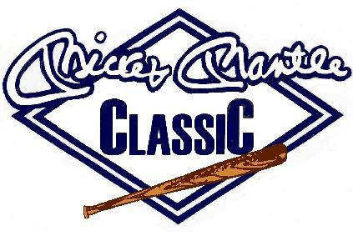

|  |  |  |
| --- | --- | --- |
| **Players** | **#** | **Team** |
| Liam McInturff |  | Neosho JV |
| HJ Earnest |  | Neosho JV |
| Sam Lollar | 11 | Fairland |
| Carson Renfro | 3 | Fairland |
| Carson Schertz | 10 | Fairland |
| Colt Kinsey | 22 | Fairland |
| Deighton Bellew | 1 | Welch |
| Mason Clinton | 15 | Welch |
| Khol Lynch | 5 | Welch |
| Zaden Pennington | 27 | Grove JV |
| Nolan Hausman | 2 | Grove JV |
| Trip May | 22 | Grove JV |
|  |  |  |
|  |  |  |

.