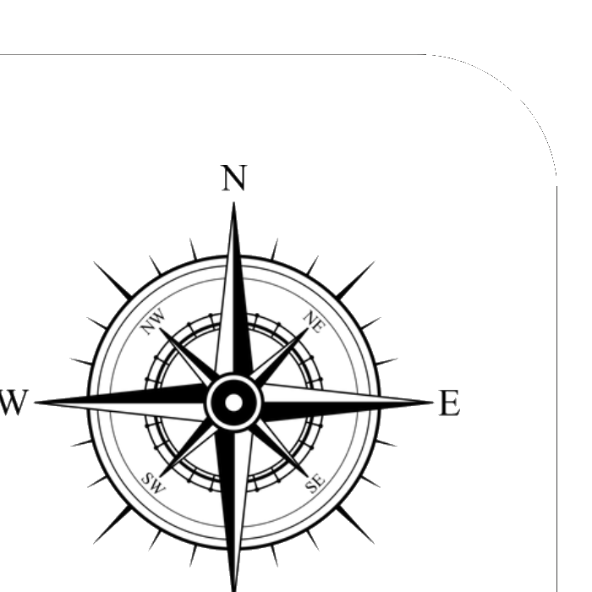 Regret -> Reflect
Summarize the situation

What could you have done differently?

What should you have done differently?

If the scenario presented itself again, what would you DO differently?

Reflection
Things to consider
What did you know at the time?

What was in your control vs. what wasn't?

What was your intention?

What are the signs to watch for in the future?

Reflection
What did you learn?

What would your advice be to others in the same scenario?

Look back to move forward

