TOWN COUNCIL MINUTES
The regular monthly meeting of the Town Council of Mitchell, Georgia, was called to order by Mayor Gail
Berry, on Monday, August 10, 2020, at 7:00 p.m. at Mitchell's City Hall.
Those present included:
Mayor Gail Berry

Council Members
Mayor Pro Tem Lewis Berry Councilwoman Amy Wallace
Councilman Jon Simmons
Councilman Allen Underwood
Clerk Sara Simmons
Mayor Pro Tem Berw rendered the invocation.
Following the reading of the minutes of the last regularly scheduled meeting held July 13, 2020,
Councilwoman Wallace made the motion to approve the minutes; Councilman Underwood second the motion.
Motion carried.

CITY HALL HOURS
Clerk Simmons requested to change City Hall's hours of operation to 8:00 a.m. - 2:30 p.m., Mondays, Tuesdays, and Wednesdays. The council agreed by consensus to make the change.

MITCHELL'S DEPOT SIGN
Clerk Simmons presented the council with emails from two local sign companies, each discussing the options for replacing the Depot sign. Councilman Simmons made a motion to table the discussion until the town could gather more information. Councilwoman Wallace second the motion. Motion carried.

2020 MILLAGE RATE
Mayor Berry addressed the Five-year Tax History advertisement published in the paper. Referencing the notice, the Mayor proposed the council continue the town's millage rate at 5.631. Mayor Pro Tem Berw made a motion to approve the 5.631 millage rate. Councilwoman Wallace second the motion. Motion carried.

2021 LIVIIG
Mayor Berry informed the council of the 2021 LMIG rate of $3,999.81. The council discussed various ideas for the 2021 LMIG project. The council agreed by consensus to revisit the project during the upcoming September meeting.
CARES FUNDING
Mayor Berry updated the council on the opportunity to obtain funds through the CARES act. The Mayor explained the town must allocate awarded funds before September 1, 2020. Councilman Simmons made a
motion to adopt a Resolution to Authorize the Execution of the Coronavirus Relief Fund (CRF), and to approve the receipt and usage of funds toward COVID-19 related expenses. Councilman Underwood second the motion.
Motion carried.
COVID-19 EFFORTS
Clerk Simmons updated the council on current COVID-19 statistics.
ADJOURNMENT
There being no further business, Mayor Pro Tem Berry made the motion to adjourn, second by
Councilman Underwood. Motion carried, and the meeting adjourned at 7:53 p.m.
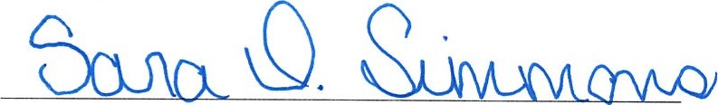
Sara Simmons, Clerk

