Vuzix M Series Quick Start Guide

M400
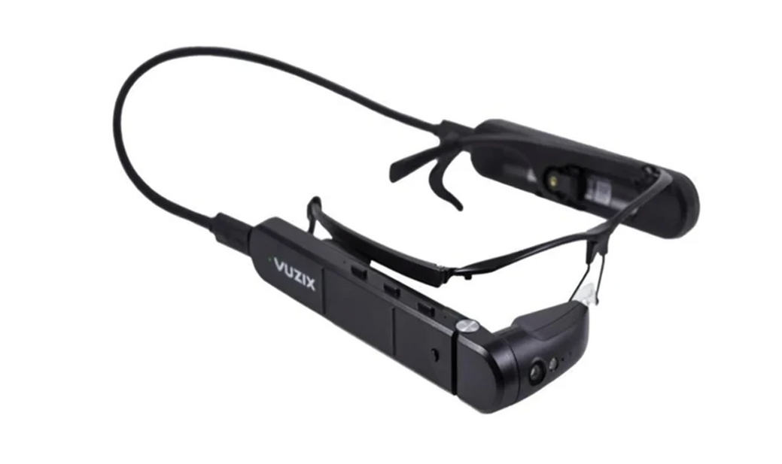
M4000
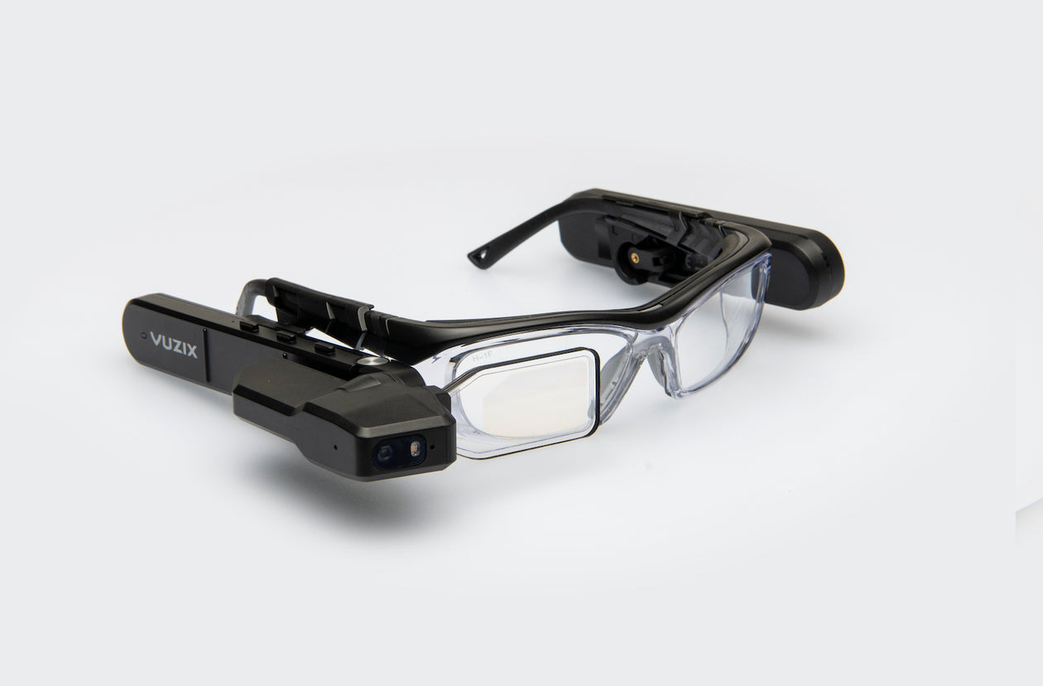

Contents
- Prepare
  - Creating a Mobile Hotspot
    - Android
    - Apple
  - Connecting to Wi-Fi
    - Android
    - Apple
- Voice Commands
- Help Lightning App
  - Making a Video Call

- Prepare
  - Creating a Mobile Hotspot
    - Android
- Open the Settings on your mobile device.
- Select Connections.
- Select Mobile Hotspot and Tethering.
- Select Mobile Hotspot.
- Select the Network name field and enter in what you would like your mobile hotspot to be known as, e.g. John Smith’s Wireless Hotspot.
- Enter in what you would like the password to be into the Password field.
- Press the Save button.
- At the top of the screen press where it says Off to turn the mobile hotspot On.
    - Apple
- Open the Settings on your mobile device.
- Select Cellular.
- Select Set Up Personal Hotspot.
- Follow the onscreen instructions.

Connecting to Wi-Fi

Android
On your mobile device
- Open the Settings on your mobile device.
- Select Connections.
- Select Mobile Hotspot and Tethering.
- Select Mobile Hotspot.
- At the bottom of the screen press QR code to generate a QR code.
On the Vuzix Blade
- Navigate to and open Scanner. The QR scanner will open on your Vuzix Smart Glasses.
- Move your head or phone, so that the QR code on your phone appears on the Vuzix Smart Glasses screen and hold it there until it has finished reading the QR code.

Apple
On your mobile device
- Open your web browser on your mobile device.
- Enter https://www.vuzix.com/pages/wifi-qr-generator into the address bar in your web browser.
- Enter in the WiFi hotspot name that you created on your mobile device into WIFI NAME.
- Enter in the WiFi hotspot password into PASSWORD.
- Press the GENERATE button to generate a QR code.
On the Vuzix Blade
- Navigate to and open Scanner. The QR scanner will open on your Vuzix Smart Glasses.
- Move your head or phone, so that the QR code on your phone appears on the Vuzix Smart Glasses screen and hold it there until it has finished reading the QR code.

Voice Commands
You can navigate your Vuzix smart glasses using voice commands. To start using voice commands on your smart glasses you say “Hello Vuzix” and then proceed to give voice commands to open apps and make video calls from your smart glasses.
Below is a list of voice commands that the Vuzix smart glasses recognise.
Voice Command | Action
Hello vuzix | Activates the listener
Go left | Basic directional navigation
Move left | Basic directional navigation
Go right | Basic directional navigation
Move right | Basic directional navigation
Go up | Basic directional navigation
Move up | Basic directional navigation
Go down | Basic directional navigation
Move down | Basic directional navigation
Pick this | Activates the item that currently has focus
Select this | Activates the item that currently has focus
Confirm | Activates the item that currently has focus
Okay | Activates the item that currently has focus
Open | Activates the item that currently has focus
Scroll down | Basic directional navigation
Scroll left | Basic directional navigation
Scroll right | Basic directional navigation
Scroll up | Basic directional navigation
Cancel | Navigates backward in the history stack
Close | Navigates backward in the history stack
Go back | Navigates backward in the history stack
Done | Navigates backward in the history stack
Go home | Triggers the Home action
Quit | Triggers the Home action
Exit | Triggers the Home action
Stop | Stops the scrolling action
Show menu | Brings up context menu for current UI screen
Next | Advances to the next item in an ordered collection of items
Previous | Goes backward by one item in an ordered collection of items
Go forward | Navigates forward in the history stack
Page up | Navigates up one page
Page down | Navigates down one page
Volume up | Increases volume by 5
Volume down | Decreases volume by 5
Speech settings | Opens Speech Settings menu
Speech commands | Opens the current Speech Command list
Command list | Opens the current Speech Command list
Start recording | Opens Camera app to the record function (to begin recording, use the 'Select This' or 'Pick This' command)
Take a picture | Opens Camera app to the picture function (to take a picture, use the 'Select This' or 'Pick This' command)
View notifications | Opens the Notification Manager
Open notifications | Opens the Notification Manager
Clear notifications | Clears all Notifications
Voice off | Stops the listener

Help Lightning App

Making a Video Call
- Say “Hello Vuzix” to start using voice commands.®
- Say “Go to scanner” to open the scanner.
- Scan the QR code of the person that you wish to video call.
- Say “Open” for the “Open Browser” button. You may have to say “Open” a few times for the QR code to open the Help Lightning app, if you have not selected for it to automatically open the Help Lightning app.
- Say “Go right” to highlight the “Always” button. Saying “Open” on the “Just Once” buttons means that you will have to do this every time you scan a QR code to call someone.
- Say “Select” to select the “Always” button.
- Once the Help Lightning app opens on your smart glasses, the video call is automatically made to the person.

