Quick Start Guide

Contents

Prepare

Creating a Mobile Hotspot

Android

Apple

Connecting to Wi-Fi

Android

Apple

Setting Up Mobile Device

Android

Apple

Setting up the Vuzix Companion App

Setting up the Help Lightning App

Navigation

Accessing the “Contacts”, “Calls”, “Messages”, “Workboxes”, and “Knowledge” areas at the bottom

Accessing the “Favorites”, “Team”, and “Directory” Tabs

Voice Commands

Making a Video Call

From Smart Glasses

From a Mobile Device

From a Computer

Control Smart Glasses from Mobile Device

Requirements

Displaying Smart Glasses Screen on Mobile Device

Vuzix Blade 2

Vuzix M400

Vuzix M4000

Troubleshooting

Common Issues

Prepare

Creating a Mobile Hotspot

Android
- Open the Settings on your mobile device.
- Select Connections.
- Select Mobile Hotspot and Tethering.
- Select Mobile Hotspot.
- Select the Network name field and enter in what you would like your mobile hotspot to be known as, e.g. John Smith’s Wireless Hotspot.
- Enter in what you would like the password to be into the Password field.
- Press the Save button.
- At the top of the screen press where it says Off to turn the mobile hotspot On.

Apple
- Open the Settings on your mobile device.
- Select Cellular.
- Select Set Up Personal Hotspot.
- Follow the onscreen instructions.

Connecting to Wi-Fi

1.2.1. Android
On your mobile device
- Open the Settings on your mobile device.
- Select Connections.
- Select Mobile Hotspot and Tethering.
- Select Mobile Hotspot.
- At the bottom of the screen press QR code to generate a QR code.
On the Vuzix Blade
- Navigate to and open Scanner. The QR scanner will open on your Vuzix Smart Glasses.
- Move your head or phone, so that the QR code on your phone appears on the Vuzix Smart Glasses screen and hold it there until it has finished reading the QR code.

1.2.2. Apple
On your mobile device
- Open your web browser on your mobile device.
- Enter https://www.vuzix.com/pages/wifi-qr-generator into the address bar in your web browser.
- Enter in the WiFi hotspot name that you created on your mobile device into WIFI NAME.
- Enter in the WiFi hotspot password into PASSWORD.
- Press the GENERATE button to generate a QR code.
On the Vuzix Blade
- Navigate to and open Scanner. The QR scanner will open on your Vuzix Smart Glasses.
- Move your head or phone, so that the QR code on your phone appears on the Vuzix Smart Glasses screen and hold it there until it has finished reading the QR code.

Setting Up Mobile Device

1.3.1. Android

Installing the Vuzix Companion App:
- Open the Play Store.
- Press Search.
- Enter in Vuzix Companion App.
- Download the Vuzix Companion App.

Installing the Help Lightning App:
- Open the Play Store.
- Press Search.
- Enter in Help Lightning App.
- Download the Help Lightning App.

1.3.2. Apple
Installing the Vuzix Companion App:
- Open the App Store.
- Press Search.
- Enter in Vuzix Companion App.
- Press Get and then press Install.
Installing the Help Lightning App:
- Open the App Store.
- Press Search.
- Enter in Help Lightning App.
- Press Get and then press Install.

1.3.3. Setting up the Vuzix Companion App
- Open the Vuzix Companion App on your mobile device.
- Press the LINK SMART GLASSES and the bottom of the screen.
- Press Agree to the Terms of Service.
- Press Allow and a QR code will be generated.
- On your Vuzix Smart Glasses navigate to and open Scanner. The QR scanner will open on your Vuzix Smart Glasses.
- Move your head or phone, so that the QR code on your phone appears on the Vuzix Smart Glasses screen and hold it there until it has finished reading the QR code.
- On your Vuzix Smart Glasses screen either tap the touch sensor or the button that is closest to the back of the glasses.
- On your phone press the OK button at the bottom right of the screen.
- Enter in a name that you would like the smart glasses to named and press Next.
- Press Next, as the smart glasses should already be connected to a wireless network.
- Press ENABLE LOCATION ACCESS and press While using the app.
- Press Next and the press Done.

1.3.4. Setting up the Help Lightning App
- Open the Help Lightning App.
- Enter in your email address and press Next.
- Enter in your password for Help Lightning and press Next.

Navigation
All steps mentioning using the touch sensor on the smart glasses are from the point of view of the smart glasses being over the person’s right eye. If the smart glasses are over the person’s left eye, then the up and down motions in the steps are reversed around on the smart glasses.

2.1. Accessing the “Contacts”, “Calls”, “Messages”, “Workboxes”, and “Knowledge” areas at the bottom
- When the list of names is completely highlighted slide your finger down the touch sensor on the glassed to be able to select one of the bottom areas.
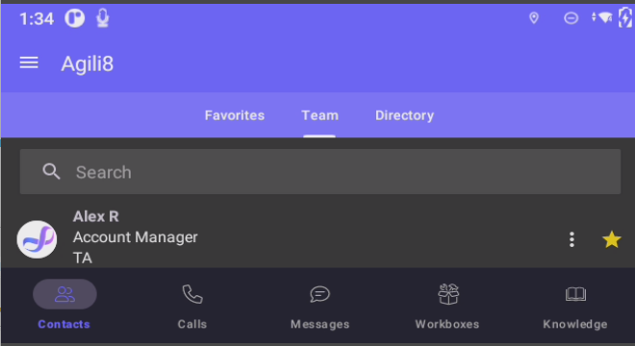
- Slide your finger either away or towards you on the glasses to select the area that you want and then press the button furthest away from the camera or tap the touch senor of the glasses.
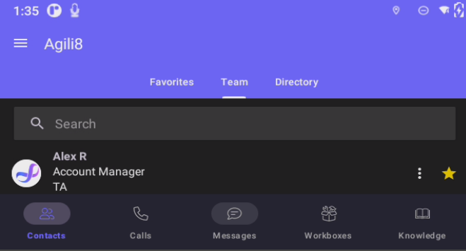

2.2. Accessing the “Favorites”, “Team”, and “Directory” Tabs
- Make sure that the first person in the contact list is highlighted.
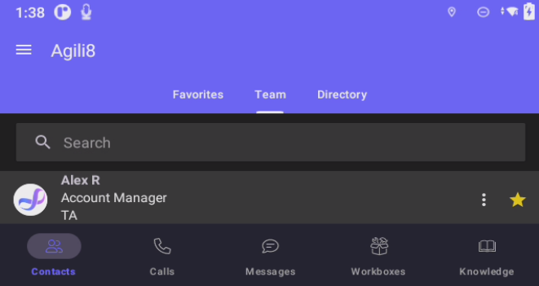
- Using the touch sensor, slide your finger up twice, make sure that after the first up motion that the first person is no longer highlighted on the screen.
- After the second up motion, you should see that one of the top areas is highlighted on the screen.
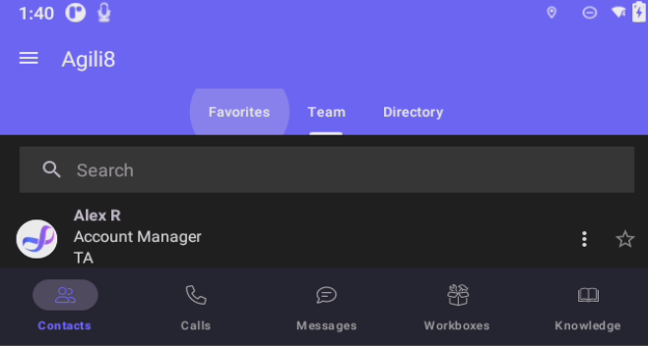
- Press the button furthest from the camera to select the section.

Voice Commands
You can navigate your Vuzix smart glasses using voice commands. To start using voice commands on your smart glasses you say “Hello Vuzix” and then proceed to give voice commands to open apps and make video calls from your smart glasses.
Below is a list of voice commands that the Vuzix smart glasses recognise.
Voice Command | Action
Hello vuzix | Activates the listener
Go left | Basic directional navigation
Move left | Basic directional navigation
Go right | Basic directional navigation
Move right | Basic directional navigation
Go up | Basic directional navigation
Move up | Basic directional navigation
Go down | Basic directional navigation
Move down | Basic directional navigation
Pick this | Activates the item that currently has focus
Select this | Activates the item that currently has focus
Confirm | Activates the item that currently has focus
Okay | Activates the item that currently has focus
Open | Activates the item that currently has focus
Scroll down | Basic directional navigation
Scroll left | Basic directional navigation
Scroll right | Basic directional navigation
Scroll up | Basic directional navigation
Cancel | Navigates backward in the history stack
Close | Navigates backward in the history stack
Go back | Navigates backward in the history stack
Done | Navigates backward in the history stack
Go home | Triggers the Home action
Quit | Triggers the Home action
Exit | Triggers the Home action
Stop | Stops the scrolling action
Show menu | Brings up context menu for current UI screen
Next | Advances to the next item in an ordered collection of items
Previous | Goes backward by one item in an ordered collection of items
Go forward | Navigates forward in the history stack
Page up | Navigates up one page
Page down | Navigates down one page
Volume up | Increases volume by 5
Volume down | Decreases volume by 5
Speech settings | Opens Speech Settings menu
Speech commands | Opens the current Speech Command list
Command list | Opens the current Speech Command list
Start recording | Opens Camera app to the record function (to begin recording, use the 'Select This' or 'Pick This' command)
Take a picture | Opens Camera app to the picture function (to take a picture, use the 'Select This' or 'Pick This' command)
View notifications | Opens the Notification Manager
Open notifications | Opens the Notification Manager
Clear notifications | Clears all Notifications
Voice off | Stops the listener

Making a Video Call

From Smart Glasses
- On your Vuzix Smart Glasses, scroll on touch pad to open the Help Lightning app.
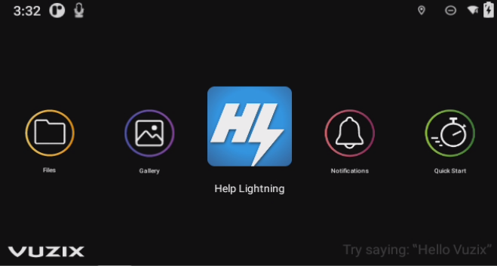
- Using the touch sensor on your smart glasses, slide your finger down the touch senor (slide your finger up if the smart glasses are over your left eye), which will highlight the list of names.
- Using the touch sensor slide your finger towards the camera, which will highlight the “star” icon.
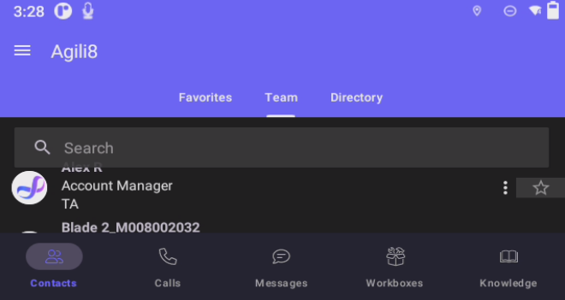
- Using the touch sensor slide your finger down (slide your finger up if the smart glasses are over your left eye) to scroll through the contacts until you find the one that you are looking for.
- Say “Hello Vuzix” to activate the voice commands on the smart glasses.
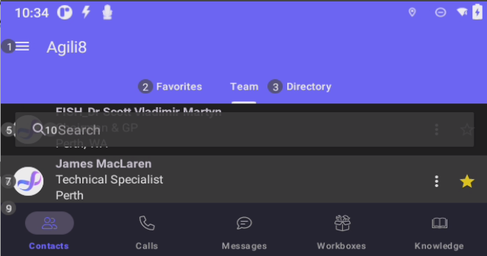
- Say “Select 7” to select the contact’s name.
- Say “Go Right” to highlight the star icon.
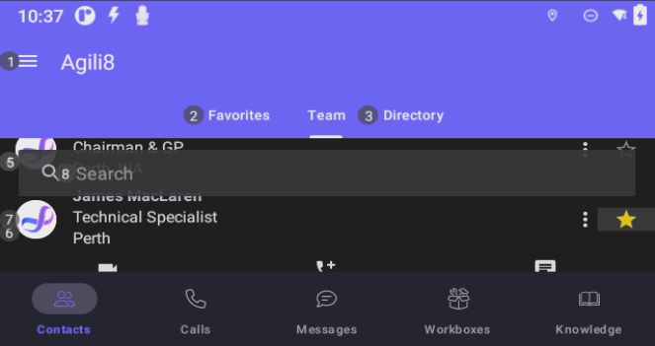
- Say “Go Down” to highlight Messaging.
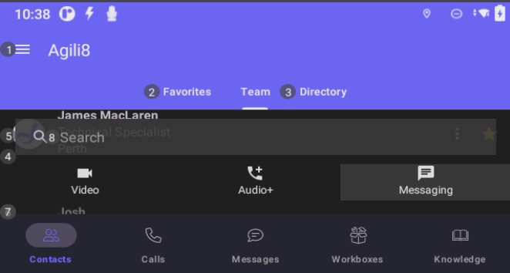
- Say “Go Left” twice to select Video.
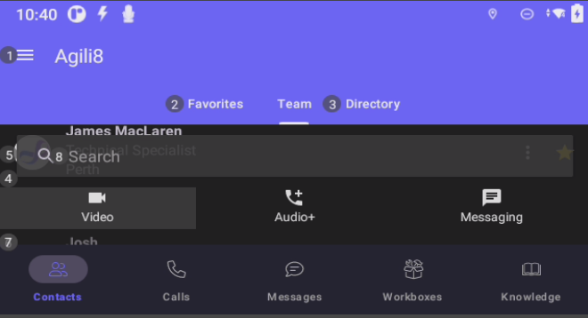
- Say “Open” to start a video call with that person.

From a Mobile Device
- Open the Help Lightning App on your mobile device.
- Log into Help Lightning using your email address and password for Help Lightning.
- Either scroll through the list of people or enter in the person’s name that you wish to video call into the search bar.
- Press the person's name and Video, Audio+, and Message will appear below the person's name.
- Press Video to start a video call with that person.

From a Computer
- In your web browser, enter in https://helplightning.net/ into the address bar at the top of the browser window.
- Log into Help Lightning using your email address and password for Help Lightning.
- Either scroll through the list of people or enter in the person’s name that you wish to video call into the search bar.
- Move your mouse over the person’s name and three options appear on the right-hand side of the screen: Video, Audio+, and Message.
- Click on Video and a video call with the person will start.

Control Smart Glasses from Mobile Device

Requirements
- Vuzix Smart Glasses.
- Vuzix Companion app installed on your mobile device.
- 1 x USB-C to USB-C cable, preferably about 1m in length (the length that comes when you buy a new phone).

Displaying Smart Glasses Screen on Mobile Device
Once the steps below have been completed, they will not have to be done again. As your mobile device will automatically display the smart glasses screen once the USB-C to USB-C cable has been plugged into both devices.
- Plug one end of the USB-C cable into your mobile device and the other end of the cable in the camera part of the smart glasses.
- Open the Vuzix Companion app on your mobile device.
- Press the More button, located at the bottom right of the screen.
- Press Vuzix View.
- Press GRANT PERMISSIONS.
- Press the circle button "Allow open Vuzix Companion when (insert device name) is connected" and then press OK.
- The phone will now display what is on the smart glasses and mobile device.

Vuzix Blade 2
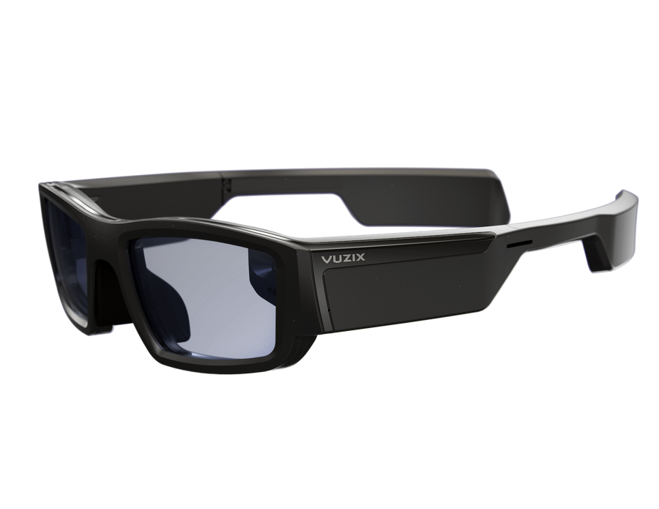

Vuzix M400
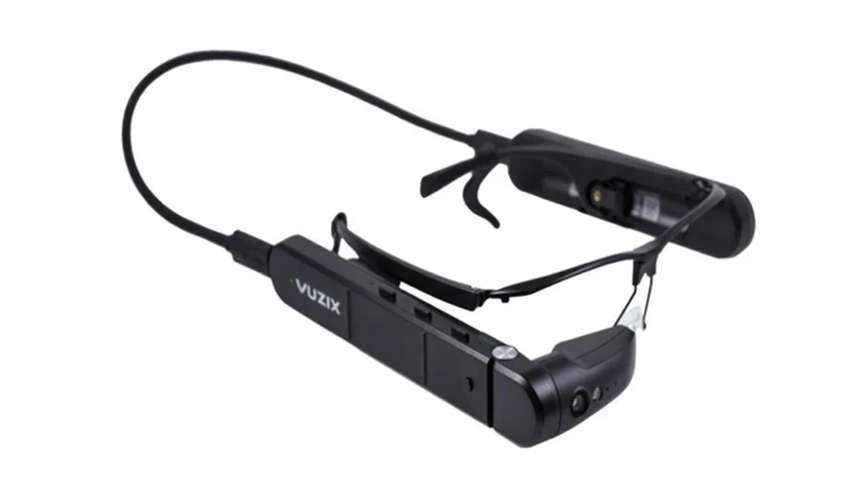

Vuzix M4000
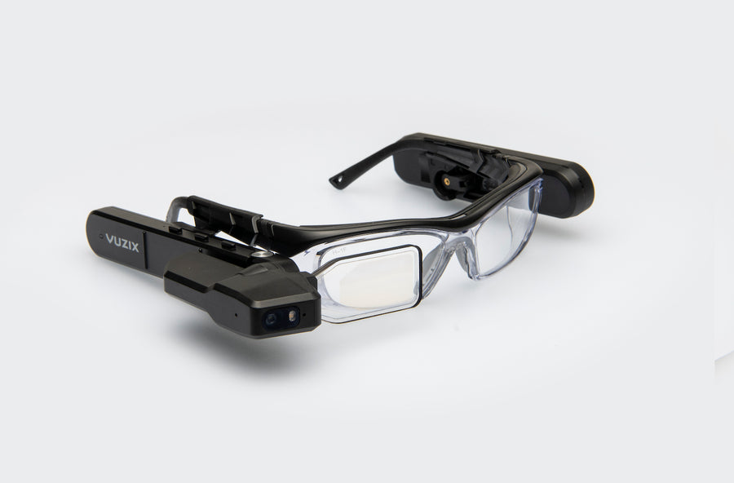

Troubleshooting

Common Issues
- Video called a person with my mobile phone attached to the smart glasses, and the person could not see through my camera.
Unfortunately, the video call does not work with a mobile device connected to the smart glasses.
- Are you able to adjust the sensitivity of the touch sensor on the smart glasses?
At the moment it you are unable to adjust the sensitivity of the touch sensor.
- Are you able to use voice commands on the smart glasses?
Yes, you can use voice commands on the smart glasses, by saying “Hello Vuzix, [insert command here]”.
- I have to wear prescription glasses, am I still able to use the smart glasses?
Yes, with the Vuzix M400 and M4000 models the smart glasses sit over the top of your glasses, allowing you to use the smart glasses. However, you cannot wear prescription glasses with the Vuzix Blade 2, as the display is built into the lenses.
- Am I able to use hand gestures with smart glasses?
At the moment you cannot use hand gestures to navigate the smart glasses.
- Can I still give voice commands while in a call?
Yes, you can still give voice commands while in a call, and it is an easy to view messages while in a video call, respond verbally to the question and then go back to the video call.

