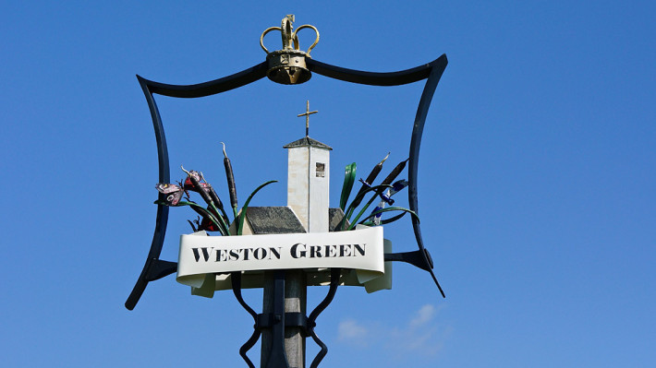

History

Our beautiful Church was consecrated on June 24th1939, just before the outbreak of the Second World War.

DESIGN
The church was designed by Edward Maufe (architect of Guildford Cathedral) and he described it as “a small English country Church, with no affectations of the town”. He admired “the lovely site embraced as it is with fine trees”.
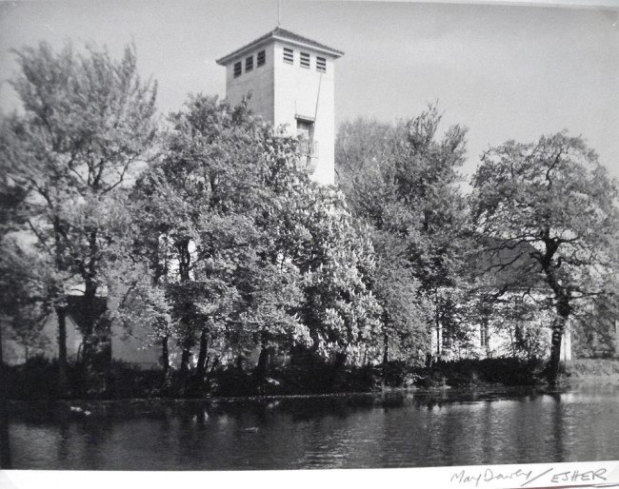
All Saints Church 1939
Weston Green was now far from the rural area that it had once been. It is documented in the Domesday Book as Westone, and its Manors passed through many different owners through the centuries. Until well into the twentieth century, it was essentially a farming community with extensive commons, two “greens”, and many ponds and streams.
http://en.wikipedia.org/wiki/Weston_Green
In 1928 the parish of Thames Ditton, (of which Weston Green was a part) was a scattered but self contained parish of 5,000 inhabitants. It was estimated that in the following ten years to 1938, the population had grown to 16,000, with the increase in house building and development of the area including Pound Farm Estate, Couchmore Farm Estate and Hinchley Wood.
There was now a need for a full parish Church and in 1934, the first step towards this was taken, and All Saints Weston became a Peel Parish, which is a full parish with a Vicar, but without an adequate Church building.
However, the history of All Saints starts well before there were any formal structures or buildings. In 1885 two ladies called Miss Charlotte Sillem and Miss Edith Went began to hold Sunday afternoon services in Weston Green. Miss Went trained and led the choir and played the harmonium. They held the services in a room called “Great Gates”, a coach house belonging to a large house called “The Elms”, and where Hampton Court Way is now. This was lent by Mrs Rowley Lambert who was a leading patron of social and religious work in Weston Green.
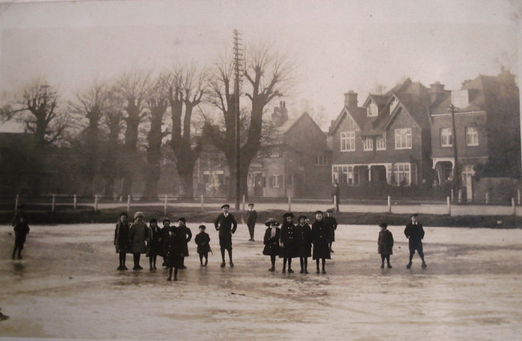
Milbourne Pond in 1916.
The trees and houses on the left in this photo were knocked down when Hampton Court Way was built in 1932.

These were the “three good women” as they were later referred to by the Vicar of St Nicholas, and who could truly be called the founders of All Saints.
They continued this work for thirteen years, when the clergy from St Nicholas took over the services, and plans were made for a Mission Church. Mr Samuel Went and his sister Miss Edith Went gave land in Weston Park, on condition that a permanent Church should be built. By July 1900, the sum of £900 was subscribed or promised, and so the building could be proceeded with at once. Miss Went died 3 days after the site was laid out in October 1900, just in time to hear of the fruition of much of her labour.
The ceremony for the laying of the foundation stone took place on 1st December 1900. The Clergy, Mr Style the architect, Church committee members, and the Choir, who had robed at The Elms, walked across the Green to the site of the Church singing the hymn ”We love the place, O God”. Miss Charlotte Sillem had been asked to perform the ceremony, and after the stone had been lowered into position, she gave it three taps with a mallet, and said with a clear voice “I declare this stone truly laid”.
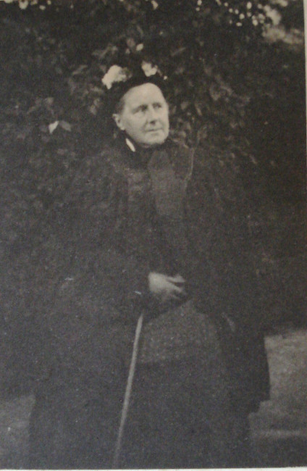
Miss Charlotte Sillem

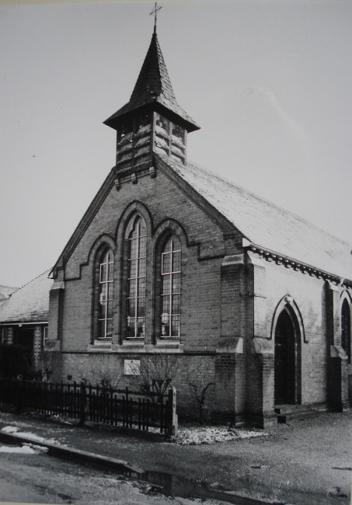
All Saints Mission Church, Weston Park
The Church was dedicated by the Vicar, Rev Waldegrave Bainbridge Bell, on Ascension Day May 16th 1901, assisted by the curates, Revs Boodle and Jameson and the choir of St Nicholas, who sang an evensong anthem “Send out thy Light”. The service was held earlier in the evening than originally intended, because the gas had not yet been laid on for the lighting.
The Vicar wrote in the parish magazine that “the new Church was to be called All Saints for two reasons, firstly because it was the name of the mother Church in Kingston which once embraced Thames Ditton, and secondly for reasons that connect it to the love and prayers of those who laboured for it, and have passed beyond the veil”
Rev R B Jameson was appointed as an additional priest “whose labours will be more connected with the new Mission Church”. “The place and function of All Saints was to be that of a daughter Church, a supplementary Church with identical ritual, with consultation and no rivalry between the two, and no one would be expected to transfer to either church”.

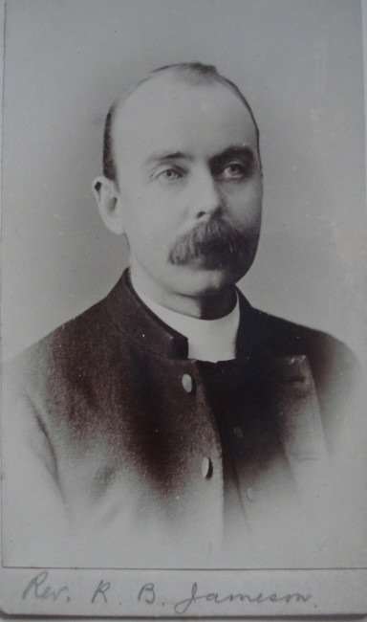
Rev R B Jameson Curate in Charge
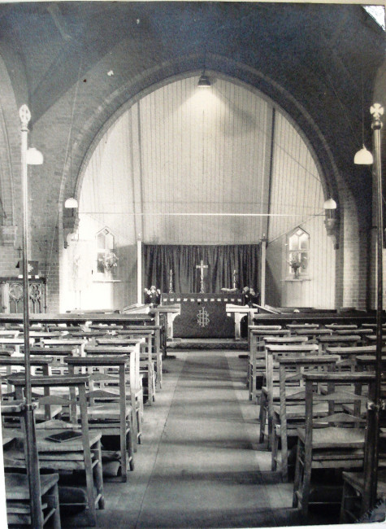
Interior of the first All Saints Church
By April 1902 it was noted that the new Church had soon become a busy centre of activity, and had inaugurated a strong forward movement in the Church life of the parish. In September 1902 the Vicar wrote that “the Church of All Saints is now equipped and paid for”
The Church was enlarged in 1909 by the addition of a new transept, but over time there was a drop in numbers. The next twenty years saw a progression of four successive vicars, and nine curates in charge looking after All Saints, which led to a lack of co-ordination and enthusiasm. During one spell of seven years there were 6 changes in the curate in charge.

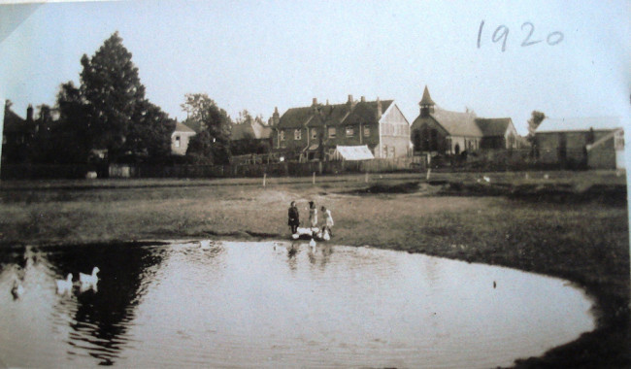
Weston Green in 1920 showing the first All Saints Church in Weston Park
In 1929 the Rev John Matthews arrived as Curate, and his energy and drive, and the growth of housing and population, led to the new parish being formed in 1934, and he was appointed as the first Vicar of All Saints, Weston.
In September 1935 the site was bought for the new Church near Marneys Pond for £900, as it was the most beautiful and central situation. This was just in time as the owner had been about to sell it for private houses. At this point there was no further money available for the new Church, but generous support came from parishioners and the Diocese in the form of gifts and loans and it was decided to proceed. Edward Maufe was appointed as architect. He was at the time busy designing Guildford Cathedral and one of the foremost architects of his time. http://en.wikipedia.org/wiki/Edward_Maufe
He presented his plans to the Parish at a crowded Thames Ditton Village Hall on 13th January 1938, and they were unanimously approved.
The foundation stone was laid by the Bishop of Guildford on October 9th 1938, attended by a large congregation of parishioners, and the Church was consecrated the following year on Saturday June 24th 1939.

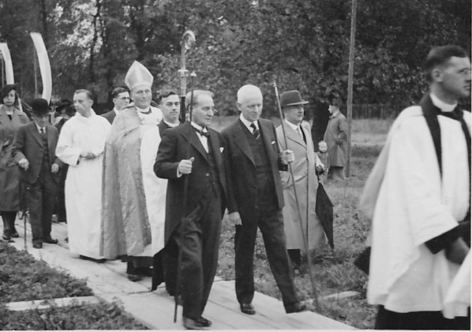
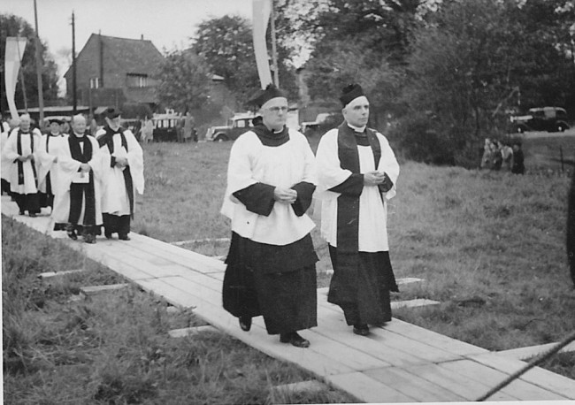
Laying the Foundation Stone October 9th 1938
Edward Maufe wrote that building All Saints had been a continuously happy experience for him, and he described his intention that “On entering there is nothing to interrupt our way to the altar, carried along by the rhythm of the arcades on each side of us”. He had sought to make it modern in character and a happy place to worship
On completion the Church had cost close on £10,000 including furnishing, reconstructing the organ, moving the font and other expenses.
The stone font was originally found lying in the garden of the vicarage in Churt, by the Rev B.H.Bosanquet when he moved there in 1924 from Thames Ditton. He offered it to All Saints and it was installed in the old Church in 1925, enabling baptisms to take place there. It was then moved again over to the newly built Church in 1939.
The victorian Henry Jones organ that was installed in 1929 at a cost of £400 was also moved over to the new Church.

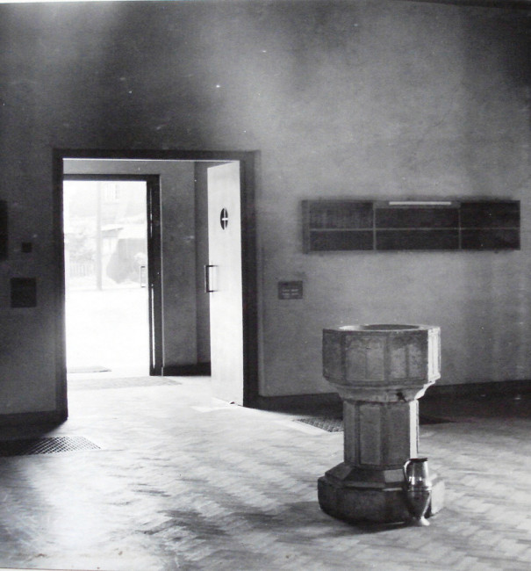
The font was moved to the newly built Church in 1939
It was an act of faith to build the Church, as war broke out shortly afterwards, and there had been much “uncertainty and anxiousness” for some time. Many men and women from the parish went to join the forces and take part in other war time work, including the Vicar, Rev. Victor Edwards who became a Royal Navy Chaplain for 3 years. Some homes were destroyed by bombs, and the Church Hall (the old Church) was damaged, but fortunately the new Church was spared, though there had been concerns about its high visibility from the air.
The War Memorial which was also designed by Edward Maufe, was unveiled in October 2nd 1948 with 44 names inscribed on it of those of the parish who had died as a result of enemy action, including civilians. The Garden of Remembrance was consecrated by the Bishop of Guildford on the same day.
The next fifty years saw the building of the vicarage in 1956, then the new Church Room and Choir Vestries at the time of the Silver Jubilee in 1964, The decision was made in 1994 to demolish the first Church in Weston Park, and then to mark the Diamond Anniversary in 1999 by enlarging and developing the Church Room into the present Church Hall, and creating the Narthex, Office and other facilities at the back of Church.
All Saints was Grade 11 Listed in 1997.
http://www.britishlistedbuildings.co.uk/en-466741-church-of-all-saints-surrey
The Church was also flooded twice, once in 1955 and again in 1968, alongside much of the local area, before a flood prevention scheme was put in place.

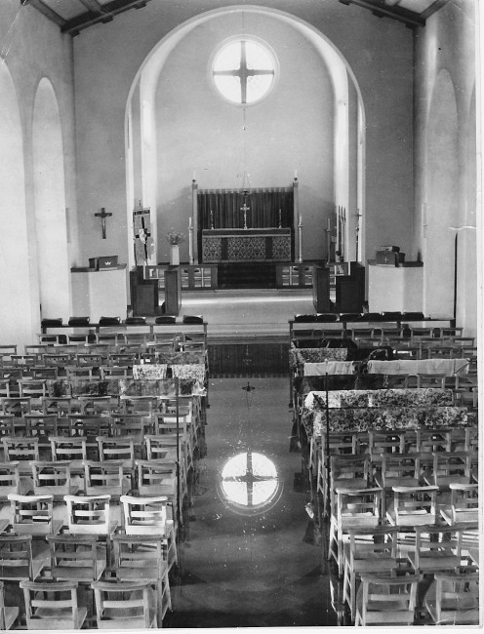
The flooded nave of the Church in 1955

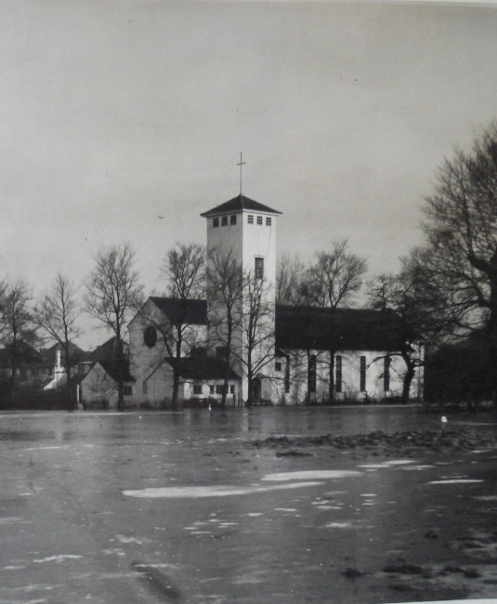
Flood waters surrounding the Church

The history of our Church is more about the people and community of Weston Green, than about the buildings. This continues to be the most important aspect of our Church life as we approach our 75th Anniversary in 2014.
In the words in 1949 of Col E.T. Rees who as Churchwarden did so much, with many others to bring the new Church into existence, “In looking back over the years, I feel we have every cause for thanking God for his many benefits towards us, and I hope that He will continue to pour His blessings on the people who worship in “The Church by the Pond”.

